Discoveries on the fifty database tables

DB.table: AustralianFootball.players – Sports – Type: Real
pid (id):
Primary Key format: All 1911 ID values are unique and valid, and thus suitable for use as a Primary Key.
Numeric range of values: (10001 : 11911))

dob (datetime):
Datetime format: All 1911 datetime values are valid in the YYYYMMDD format in the range 1963/10/23 00:00 to 1996/12/11 00:00.

first_name (name):
Name format: All 1911 first_name values are valid.

Frequency Distribution:
first_name Frequency
Matthew 52
Andrew 43
Ben 43
Tom 42
Daniel 41
Luke 36
Michael 36
Josh 33
Sam 33
Adam 32
... ...
Tory 1
Touk 1
Tristen 1
Viv 1
Wade 1
Warren 1
Winston 1
Zaine 1
Zak 1
Zephaniah 1

Range of Values: (Aaron to Zephaniah)

last_name (name):
Name format: Error(s) found:
DQI #15 (Domain Violation - Accuracy):
29 Capitalization/Format issue(s) at index(es): [(282, 'LeCras'), (310, 'OFarrell'), (311, 'OHanlon'), (318, 'OBrien'), (355, 'OShea'), (440, 'DellOlio'), (456, 'OBrien'), (524, 'OBrien'), (759, 'OMeara'), (809, 'OReilly'), ('...', '...'), (1504, 'OLoughlin'), (1512, 'AhMat'), (1562, 'OConnor'), (1563, 'OKeefe'), (1630, 'OKeeffe'), (1635, 'OhAilpin'), (1647, 'OBree'), (1702, 'OReilly'), (1765, 'OBrien'), (1902, 'OBrien')] (displaying only the first and last 10 items)

Frequency Distribution:
last_name Frequency
Smith 20
Johnson 15
Brown 13
Jones 12
White 12
Clarke 9
Williams 9
Campbell 8
Hall 8
OBrien 8
... ...
Yarran 1
Yeo 1
Yze 1
Zaharakis 1
Zantuck 1
Ziebell 1
Zorko 1
de Boer 1
de Goey 1
van Unen 1

Range of Values: (Ablett to van Unen)

height:
Numerical >=0 format: All 1911 values are numerical and greater or equal to 0 in the range (163:211).

weight:
Numerical >=0 format: All 1911 values are numerical and greater or equal to 0 in the range (63:120).

YDATA Profiling results: It just found out that the PK column 'pid' has unique values and is uniformly distributed:
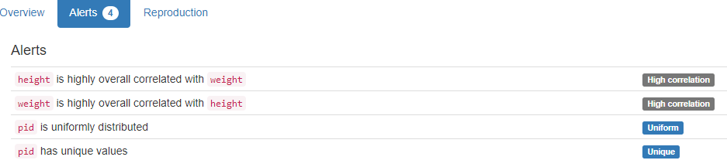

DB.table: AustralianFootball.matches – Sports – Type: Real
mid (id):
Primary Key format: All 3050 ID values are unique and valid, and thus suitable for use as a Primary Key.
Alphanumeric range of values: (2000_EF_102_118 : 2015_R23_115_117)

season:
All 3050 values are correctly categorical.

Categorical format with 16 unique values:
Category Frequency
2012 207
2013 207
2014 207
2015 197
2011 196
2010 186
2000 185
2001 185
2002 185
2003 185
2004 185
2005 185
2006 185
2007 185
2008 185
2009 185

round (varchar):
String format: All 3050 string values are valid.
String range (lexicographical): (EF : SF)

tid1 (id):
Foreign Key format: All 3050 ID values are valid for use as a Foreign Key, and duplicate values are allowed.
Numeric range of values: (101 : 117)
References: teams.tid

tid2 (id):
Foreign Key format: All 3050 ID values are valid for use as a Foreign Key, and duplicate values are allowed.
Numeric range of values: (102 : 118)
References: teams.tid

tid1_loc (location):
All 3050 values are correctly categorical.

Categorical format with 2 unique values:
Category Frequency
h 1527
a 1523

tid2_loc (location):
All 3050 values are correctly categorical.

Categorical format with 2 unique values:
Category Frequency
a 1527
h 1523

start_dt (datetime):
Datetime format: All 3050 datetime values are valid in the YYYYMMDD format in the range 2000/03/08 19:40 to 2015/09/06 15:20.

venue:
All 3050 values are correctly categorical.

Categorical format with 21 unique values:
Category Frequency
M.C.G. 784
Docklands 751
Subiaco 358
Football Park 325
Gabba 194
S.C.G. 147
Kardinia Park 122
Carrara 63
York Park 56
Stadium Australia 53
... ...
Princes Park 44
Manuka Oval 37
Sydney Showground 29
Marrara Oval 16
Bellerive Oval 9
W.A.C.A. 6
Cazaly's Stadium 5
Wellington 3
Traeger Park 2
Blacktown 1

att (integer):
Numerical format: All 3050 values are numerical in the range (4866:100016).

margin (integer):
Numerical format: All 3050 values are numerical in the range (0:186).

win_score (score):
Numerical >=0 format: All 3050 values are numerical and greater or equal to 0 in the range (48:233).

win_tid (integer):
Numerical format: All 3050 values are numerical in the range (100:118).

win_loc (location):
All 3050 values are correctly categorical.

Categorical format with 3 unique values:
Category Frequency
h 1756
a 1266
d 28

lose_score (score):
Numerical >=0 format: All 3050 values are numerical and greater or equal to 0 in the range (13:159).

lose_loc (location):
All 3050 values are correctly categorical.

Categorical format with 3 unique values:
Category Frequency
a 1756
h 1266
d 28

lose_tid (integer):
Numerical format: All 3050 values are numerical in the range (100:118).

h_tid (integer):
Numerical format: All 3050 values are numerical in the range (101:118).

h_score (score):
Numerical format: All 3050 values are numerical in the range (21:233).

h_q1g (integer):
Numerical format: All 3050 values are numerical in the range (0:15).

h_q2g (integer):
Numerical format: All 3050 values are numerical in the range (0:20).

h_q3g (integer):
Numerical format: All 3050 values are numerical in the range (1:28).

h_q4g (integer):
Numerical format: All 3050 values are numerical in the range (3:37).

h_etg (integer):
Numerical format: All 3050 values are numerical in the range (0:10).

h_q1b (integer):
Numerical format: All 3050 values are numerical in the range (0:17).

h_q2b (integer):
Numerical format: All 3050 values are numerical in the range (1:24).

h_q3b (integer):
Numerical format: All 3050 values are numerical in the range (2:27).

h_q4b (integer):
Numerical format: All 3050 values are numerical in the range (4:118).

h_etb (integer):
Numerical format: All 3050 values are numerical in the range (0:222).

a_tid (integer):
Numerical format: All 3050 values are numerical in the range (0:118).

a_score (score):
Numerical >=0 format: All 3050 values are numerical and greater or equal to 0 in the range (0:164).

a_q1g (integer):
Numerical format: All 3050 values are numerical in the range (0:29).

a_q2g (integer):
Numerical format: All 3050 values are numerical in the range (1:35).

a_q3g (integer):
Numerical format: All 3050 values are numerical in the range (0:20).

a_q4g (integer):
Numerical format: All 3050 values are numerical in the range (0:26).

a_etg (integer):
Numerical format: All 3050 values are numerical in the range (0:21).

a_q1b (integer):
Numerical format: All 3050 values are numerical in the range (0:25).

a_q2b (integer):
Numerical format: Error(s) found:
DQI #1 (Missing Data - Completeness):
2914 Blank/Empty/Null/Missing value(s) at index(es): [(7, 'NULL'), (8, 'NULL'), (9, 'NULL'), (10, 'NULL'), (11, 'NULL'), (12, 'NULL'), (13, 'NULL'), (14, 'NULL'), (15, 'NULL'), (16, 'NULL'), ('...', '...'), (3040, 'NULL'), (3041, 'NULL'), (3042, 'NULL'), (3043, 'NULL'), (3044, 'NULL'), (3045, 'NULL'), (3046, 'NULL'), (3047, 'NULL'), (3048, 'NULL'), (3049, 'NULL')] (displaying only the first and last 10 items)

Range of values: (1.0:11.0).

a_q3b (integer):
Numerical format: Error(s) found:
DQI #1 (Missing Data - Completeness):
2914 Blank/Empty/Null/Missing value(s) at index(es): [(7, 'NULL'), (8, 'NULL'), (9, 'NULL'), (10, 'NULL'), (11, 'NULL'), (12, 'NULL'), (13, 'NULL'), (14, 'NULL'), (15, 'NULL'), (16, 'NULL'), ('...', '...'), (3040, 'NULL'), (3041, 'NULL'), (3042, 'NULL'), (3043, 'NULL'), (3044, 'NULL'), (3045, 'NULL'), (3046, 'NULL'), (3047, 'NULL'), (3048, 'NULL'), (3049, 'NULL')] (displaying only the first and last 10 items)

Range of values: (1.0:16.0).

a_q4b (integer):
Numerical format: Error(s) found:
DQI #1 (Missing Data - Completeness):
2914 Blank/Empty/Null/Missing value(s) at index(es): [(7, 'NULL'), (8, 'NULL'), (9, 'NULL'), (10, 'NULL'), (11, 'NULL'), (12, 'NULL'), (13, 'NULL'), (14, 'NULL'), (15, 'NULL'), (16, 'NULL'), ('...', '...'), (3040, 'NULL'), (3041, 'NULL'), (3042, 'NULL'), (3043, 'NULL'), (3044, 'NULL'), (3045, 'NULL'), (3046, 'NULL'), (3047, 'NULL'), (3048, 'NULL'), (3049, 'NULL')] (displaying only the first and last 10 items)

Range of values: (2.0:19.0).

a_etb (integer):
Numerical format: Error(s) found:
DQI #1 (Missing Data - Completeness):
2914 Blank/Empty/Null/Missing value(s) at index(es): [(7, 'NULL'), (8, 'NULL'), (9, 'NULL'), (10, 'NULL'), (11, 'NULL'), (12, 'NULL'), (13, 'NULL'), (14, 'NULL'), (15, 'NULL'), (16, 'NULL'), ('...', '...'), (3040, 'NULL'), (3041, 'NULL'), (3042, 'NULL'), (3043, 'NULL'), (3044, 'NULL'), (3045, 'NULL'), (3046, 'NULL'), (3047, 'NULL'), (3048, 'NULL'), (3049, 'NULL')] (displaying only the first and last 10 items)

Range of values: (0.0:15.0).

target:
All 3050 values are correctly categorical.

Categorical format with 2 unique values:
Category Frequency
0 1529
- 1521

YDATA Profiling results: It found the same 4 Missing values columns because they contain ALL NULLs. It also found that the PK column 'mid' is unique.
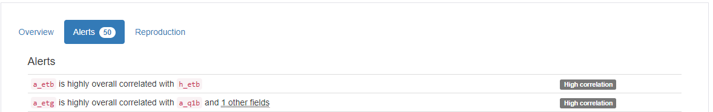
…
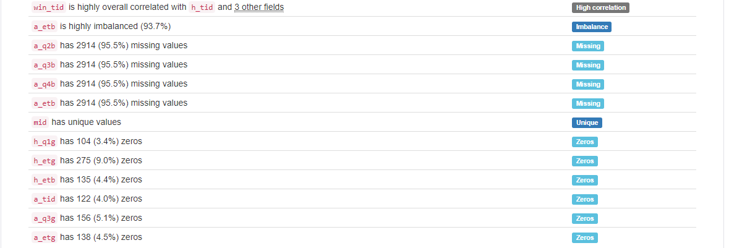

DB.table: Biodegradability.molecule – Medicine – Type: Real
Start of Analysis on: 2024-09-03 12:05:24
molecule_id (id):
Primary Key format: All 328 ID values are unique and valid, and thus suitable for use as a Primary Key.
Alphanumeric range of values: (i100_02_7i : i99_65_0i)

activity (float):
Numerical format: All 328 values are numerical in the range (2.14007:11.2742).

logp (float):
Numerical format: All 328 values are numerical in the range (-3.81:12.11).

mweight (weight):
Numerical >=0 format: All 328 values are numerical and greater or equal to 0 in the range (27.0259:1019.64).
YDATA Profiling results: It just found out that the PK column 'molecule_id' has unique values:

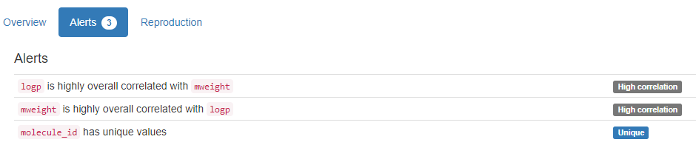

DB.table: ccs.transactions_1k – Finance – Type: Real
Start of Analysis on: 2024-09-03 14:45:14
TransactionID (id):
Primary Key format: All 1000 ID values are unique and valid, and thus suitable for use as a Primary Key.
Numeric range of values: (1 : 1000)

Date:
Date format: All 1000 date values are valid in the YYYYMMDD format in the range 2012-08-23 to 2012-08-26.

Time:
Time format: All 1000 time values are valid in the range 00:07:00 to 23:20:00.

CustomerID (id):
Foreign Key format: All 1000 ID values are valid for use as a Foreign Key, and duplicate values are allowed.
Numeric range of values: (96 : 49838)
References: customers.CustomerID

CardID (id):
ID column format: Error(s) found:
DQI #9 (Duplicates - Uniqueness):
182 Duplicate value(s) at index(es): [[1, 550134], [2, 550134], [7, 729387], [8, 729387], [25, 753582], [26, 753582], [47, 664247], [48, 664247], [54, 688291], [55, 688291], ('...', '...'), [951, 483052], [952, 483052], [959, 626787], [960, 626787], [965, 442969], [966, 199529], [975, 523936], [976, 523936], [977, 501247], [978, 501247]] (displaying only the first and last 10 items)

DQI #19 (Uniqueness Violation - Uniqueness):
98 Uniqueness violation(s) at index(es): [(2, 550134), (8, 729387), (26, 753582), (48, 664247), (55, 688291), (78, 450132), (84, 568944), (85, 568944), (86, 568944), (95, 660091), ('...', '...'), (877, 562088), (906, 199431), (915, 418233), (943, 65851), (952, 483052), (960, 626787), (965, 442969), (966, 199529), (976, 523936), (978, 501247)] (displaying only the first and last 10 items)

Numeric range of values: (26228 : 775970)

GasStationID (id):
Foreign Key format: All 1000 ID values are valid for use as a Foreign Key, and duplicate values are allowed.
Numeric range of values: (48 : 5481)
References: gasstations.GasStationID

ProductID (id):
Foreign Key format: All 1000 ID values are valid for use as a Foreign Key, and duplicate values are allowed.
Numeric range of values: (2 : 352)
References: products.ProductID
Amount:
Numerical format: All 1000 values are numerical in the range (0:264).

Price:
Numerical format: All 1000 values are numerical in the range (1.76:5762.49).

YDATA Profiling results: It just found out that the PK column 'TransactionID' has unique values and is uniformly distributed. It also shows that cannot support columns Time and Price.

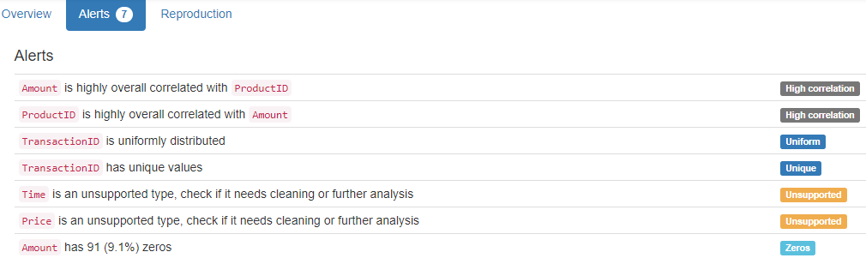

DB.table: classicmodels.customers – Retail – Type: Synth
customerNumber (id):
Primary Key format: All 122 ID values are unique and valid, and thus suitable for use as a Primary Key.
Numeric range of values: (103 : 496)

customerName (name):
Name format: Error(s) found:
DQI #5 (Extraneous Data - Consistency, Uniqueness):
2 Extraneous data value(s) at index(es): [(35, 'Toys4GrownUps.com'), (84, 'Gifts4AllAges.com')]

DQI #15 (Domain Violation - Accuracy):
6 Capitalization/Format issue(s) at index(es): [(0, 'Atelier graphique'), (23, "La Corne D'abondance, Co."), (46, 'giftsbymail.co.uk'), (82, 'GiftsForHim.com'), (92, "L'ordine Souveniers"), (108, 'FunGiftIdeas.com')]

Frequency Distribution:
customerName Frequency
ANG Resellers 1
AV Stores, Co. 1
Alpha Cognac 1
American Souvenirs Inc 1
Amica Models & Co. 1
Anna's Decorations, Ltd 1
Anton Designs, Ltd. 1
Asian Shopping Network, Co 1
Asian Treasures, Inc. 1
Atelier graphique 1
... ...
Toms Spezialitäten, Ltd 1
Toys of Finland, Co. 1
Toys4GrownUps.com 1
UK Collectables, Ltd. 1
Vida Sport, Ltd 1
Vitachrome Inc. 1
Volvo Model Replicas, Co 1
Warburg Exchange 1
West Coast Collectables Co. 1
giftsbymail.co.uk 1

Range of Values: (ANG Resellers to giftsbymail.co.uk)

contactLastName (name):
Name format: All 122 contactLastName values are valid.

Frequency Distribution:
contactLastName Frequency
Young 4
Brown 3
Frick 3
Franco 2
Hernandez 2
King 2
Murphy 2
Nelson 2
Taylor 2
Thompson 2
... ...
Sommer 1
Suominen 1
Tamuri 1
Tonini 1
Tseng 1
Urs 1
Victorino 1
Walker 1
Yoshido 1
de Castro 1

Range of Values: (Accorti to de Castro)

contactFirstName (name):
Name format: All 122 contactFirstName values are valid.

Frequency Distribution:
contactFirstName Frequency
Julie 4
Alexander 2
Juri 2
Leslie 2
Michael 2
Mike 2
Steve 2
Sue 2
Valarie 2
Adrian 1
... ...
Tony 1
Veysel 1
Violeta 1
Wales 1
Wendy 1
William 1
Wing 1
Yoshi 1
Yu 1
Zbyszek 1

Range of Values: (Adrian to Zbyszek )

phone:
Phone format: Error(s) found:
DQI #15 (Domain Violation - Accuracy):
11 Incorrect telephone number format issue(s) at index(es): [(0, '40.32.2555'), (3, '40.67.8555'), (13, '78.32.5555'), (22, '20.16.1555'), (23, '(1) 42.34.2555'), (37, '88.60.1555'), (47, '61.77.6555'), (51, '30.59.8555'), (79, '91.24.4555'), (80, '26.47.1555'), (94, '(1) 47.55.6555')]

addressLine1 (address):
Street format: Error(s) found:
DQI #15 (Domain Violation - Accuracy):
11 Capitalization/Format issue(s) at index(es): [(4, 'Erling Skakkes gate 78'), (6, 'ul. Filtrowa 68'), (21, 'Estrada da saúde n. 58'), (22, '184, chaussée de Tournai'), (23, '265, boulevard Charonne'), (37, '24, place Kléber'), (51, "67, avenue de l'Europe"), (56, 'Via Ludovico il Moro 22'), (80, "59 rue de l'Abbaye"), (86, 'Jardim das rosas n. 32'), (109, 'c/ Gobelas, 19-1 Urb. La Florida')]

addressLine2 (address):
Street format: Error(s) found:
DQI #1 (Missing Data - Completeness):
100 Blank/Empty/Null/Missing value(s) at index(es): [(0, NULL), (1, NULL), (3, NULL), (4, NULL), (5, NULL), (6, NULL), (7, NULL), (8, NULL), (9, NULL), (10, NULL), ('...', '...'), (112, NULL), (113, NULL), (114, NULL), (115, NULL), (116, NULL), (117, NULL), (118, NULL), (119, NULL), (120, NULL), (121, NULL)] (displaying only the first and last 10 items)
DQI #15 (Domain Violation - Accuracy):
1 Capitalization/Format issue(s) at index(es): [(91, 'NatWest Center #13-03')]

city:
City format: Error(s) found:
DQI #15 (Domain Violation - Accuracy):
2 Capitalization/Format issue(s) at index(es): [(26, 'Kita-ku'), (93, 'Minato-ku')]

Frequency Distribution (showing top and bottom 10 of 96 cities):
City Frequency
Madrid 5
NYC 5
Brickhaven 3
Paris 3
Singapore 3
Auckland 2
Boston 2
Cambridge 2
Frankfurt 2
Glendale 2
... ...
Stuttgart 1
Torino 1
Toulouse 1
Tsawassen 1
Vancouver 1
Versailles 1
Warszawa 1
Wellington 1
White Plains 1
Århus 1

state:
State format: Error(s) found:
DQI #1 (Missing Data - Completeness):
73 Blank/Empty/Null/Missing value(s) at index(es): [(0, NULL), (3, NULL), (4, NULL), (6, NULL), (7, NULL), (10, NULL), (11, NULL), (12, NULL), (13, NULL), (14, NULL), ('...', '...'), (106, NULL), (107, NULL), (109, NULL), (111, NULL), (113, NULL), (114, NULL), (115, NULL), (116, NULL), (119, NULL), (121, NULL)] (displaying only the first and last 10 items)

Frequency Distribution (showing top and bottom 10 of 19 states/provinces):
State Frequency
NULL 73
CA 11
MA 9
NY 6
CT 4
PA 3
BC 2
NSW 2
Victoria 2
Co. Cork 1
Isle of Wight 1
NH 1
NJ 1
NV 1
Osaka 1
Pretoria 1
Queensland 1
Québec 1
Tokyo 1

postalCode:
Postal Code format: Error(s) found:
DQI #1 (Missing Data - Completeness):
7 Blank/Empty/Null/Missing value(s) at index(es): [(38, NULL), (69, NULL), (78, NULL), (82, NULL), (96, NULL), (111, NULL), (121, NULL)]

DQI #15 (Domain Violation - Accuracy):
1 Short length alphanumeric value(s) at index(es): [(30, '2')]

country:
Country format: All 122 country values are valid.
Frequency Distribution (showing top and bottom 10 of 27 countries):
Country Frequency
USA 36
Germany 13
France 12
Spain 7
Australia 5
UK 5
Italy 4
New Zealand 4
Canada 3
Finland 3
... ...
Japan 2
Portugal 2
Sweden 2
Hong Kong 1
Israel 1
Netherlands 1
Philippines 1
Poland 1
Russia 1
South Africa 1

salesRepEmployeeNumber (id):
Foreign Key format: Error(s) found:
DQI #1 (Missing Data - Completeness):
22 Blank/Empty/Null/Missing value(s) at index(es): [(6, NULL), (21, NULL), (36, NULL), (41, NULL), (44, NULL), (48, NULL), (54, NULL), (59, NULL), (62, NULL), (63, NULL), ('...', '...'), (81, NULL), (83, NULL), (86, NULL), (95, NULL), (99, NULL), (107, NULL), (109, NULL), (113, NULL), (114, NULL), (115, NULL)] (displaying only the first and last 10 items)

Note: This is a Foreign Key, so duplicate values are allowed.
Numeric range of values: (1165.0 : 1702.0)
References: employees.employeeNumber

creditLimit (credit):
Numerical format: All 122 values are numerical in the range (0.0:227600.0).

YDATA Profiling results: It found the same 4 Missing values columns because they contain ALL NULLs. It also found that the PK column 'customerNumber' is Unique.

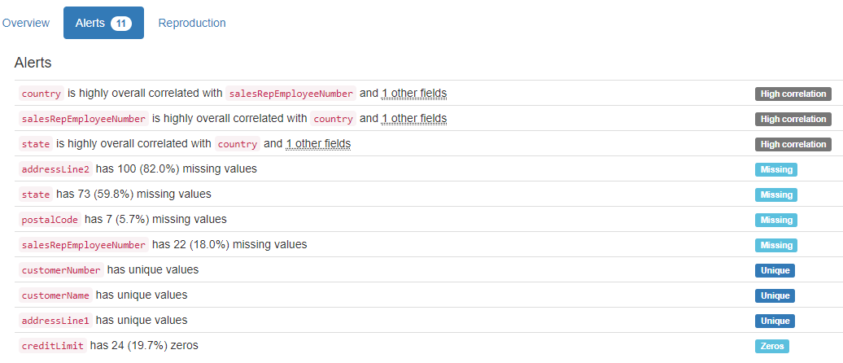

DB.table: Countries.Metadata – Countries – Geography – Type: Real
Country Code (id):
Primary Key format: All 247 ID values are unique and valid, and thus suitable for use as a Primary Key.
Alphanumeric range of values: (ABW : ZWE)

Country Name (country):
Country format: Error(s) found:
DQI #15 (Domain Violation - Accuracy):
25 Capitalization/Format issue(s) at index(es): [(39, "Côte d'Ivoire"), (47, 'Caribbean small states'), (60, 'East Asia & Pacific (all income levels)'), (62, 'Europe & Central Asia (all income levels)'), (65, 'Euro area'), (71, 'Fragile and conflict affected situations'), (91, 'High income'), (94, 'Heavily indebted poor countries (HIPC)'), (125, 'Latin America & Caribbean (all income levels)'), (126, 'Least developed countries: UN classification'), ('...', '...')]

Frequency Distribution (showing top and bottom 10 of 247 countries):
Country Frequency
Afghanistan 1
Albania 1
Algeria 1
American Samoa 1
Andorra 1
Angola 1
Antigua and Barbuda 1
Arab World 1
Argentina 1
Armenia 1
... ...
Uzbekistan 1
Vanuatu 1
Venezuela, RB 1
Vietnam 1
Virgin Islands (U.S.) 1
West Bank and Gaza 1
World 1
Yemen, Rep. 1
Zambia 1
Zimbabwe 1

Region:
Categorical format: Error(s) found:
DQI #1 (Missing Data - Completeness):
33 Blank/Empty/Null/Missing value(s) at index(es): [(5, NULL), (34, NULL), (47, NULL), (59, NULL), (60, NULL), (61, NULL), (62, NULL), (65, NULL), (70, NULL), (71, NULL), ('...', '...'), (171, NULL), (172, NULL), (174, NULL), (187, NULL), (193, NULL), (204, NULL), (206, NULL), (207, NULL), (232, NULL), (241, NULL)] (displaying only the first and last 10 items)
Categorical format with 8 unique values:
Category Frequency
Europe & Central Asia 57
Sub-Saharan Africa 48
Latin America & Caribbean 41
East Asia & Pacific 36
NULL 33
Middle East & North Africa 21
South Asia 8
North America 3

IncomeGroup (group):
Categorical format: Error(s) found:
DQI #1 (Missing Data - Completeness):
33 Blank/Empty/Null/Missing value(s) at index(es): [(5, NULL), (34, NULL), (47, NULL), (59, NULL), (60, NULL), (61, NULL), (62, NULL), (65, NULL), (70, NULL), (71, NULL), ('...', '...'), (171, NULL), (172, NULL), (174, NULL), (187, NULL), (193, NULL), (204, NULL), (206, NULL), (207, NULL), (232, NULL), (241, NULL)] (displaying only the first and last 10 items)
Categorical format with 6 unique values:
Category Frequency
Upper middle income 55
Lower middle income 50
High income: nonOECD 44
Low income 34
NULL 33
High income: OECD 31

SpecialNotes (note):
String format: Error(s) found:
DQI #1 (Missing Data - Completeness):
86 Blank/Empty/Null/Missing value(s) at index(es): [(3, NULL), (4, NULL), (7, NULL), (8, NULL), (9, NULL), (14, NULL), (16, NULL), (17, NULL), (21, NULL), (23, NULL), ('...', '...'), (214, NULL), (217, NULL), (221, NULL), (225, NULL), (227, NULL), (229, NULL), (231, NULL), (235, NULL), (237, NULL), (238, NULL)] (displaying only the first and last 10 items)

String range (lexicographical): (2013 national accounts estimates are based on IMF reports. Based on official government statistics, value added is measured at producer prices through 1997 and at basic prices from 1998 onward. : World aggregate.)

YDATA Profiling results: It found the same 3 Missing values columns because they contain ALL NULLs. It also found that the PK column 'Country Code' is Unique.
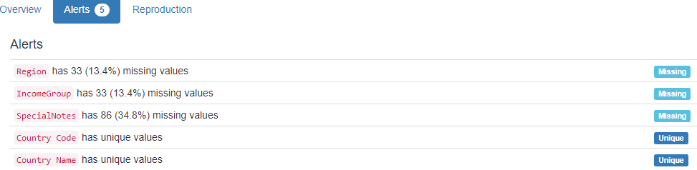

DB.table: Credit.charge – Retail – Type: Synth
1600000 lines in less than 10 minutes
charge_no (id):
Primary Key format: All 1600000 ID values are unique and valid, and thus suitable for use as a Primary Key.
Numeric range of values: (1 : 2000000)

member_no (id):
Foreign Key format: All 1600000 ID values are valid for use as a Foreign Key, and duplicate values are allowed.
Numeric range of values: (63 : 10000)
References: member.member_no

provider_no (id):
Foreign Key format: All 1600000 ID values are valid for use as a Foreign Key, and duplicate values are allowed.
Numeric range of values: (24 : 500)
References: provider.provider_no

category_no (id):
Foreign Key format: All 1600000 ID values are valid for use as a Foreign Key, and duplicate values are allowed.
Numeric range of values: (1 : 10)
References: category.category_no

charge_dt (datetime):
Datetime format: All 1600000 datetime values are valid in the YYYYMMDD format in the range 1999/06/15 10:45 to 1999/10/13 10:51.

charge_amt (charge):
Numerical format: All 1600000 values are numerical in the range (1.0:5001.0).
statement_no (integer):
Numerical format: All 1600000 values are numerical in the range (0:30000).

charge_code (code):
Categorical format: Error(s) found:
DQI #1 (Missing Data - Completeness):
NULL values (0): []
Non-NULL values (1600000): [(0, 'Empty'), (1, 'Empty'), (2, 'Empty'), (3, 'Empty'), (4, 'Empty'), (5, 'Empty'), (6, 'Empty'), (7, 'Empty'), (8, 'Empty'), (9, 'Empty'), ('...', '...'), (1599990, 'Empty'), (1599991, 'Empty'), (1599992, 'Empty'), (1599993, 'Empty'), (1599994, 'Empty'), (1599995, 'Empty'), (1599996, 'Empty'), (1599997, 'Empty'), (1599998, 'Empty'), (1599999, 'Empty')]

Categorical format with 1 unique value(s):
Category Frequency
Empty 1600000

YDATA Profiling results: It did not find the Missing values in charge_code because they are not NULLs. They were described as Constant due to the ""(Empty) value. It also found that the PK column 'charge_no' is Unique.

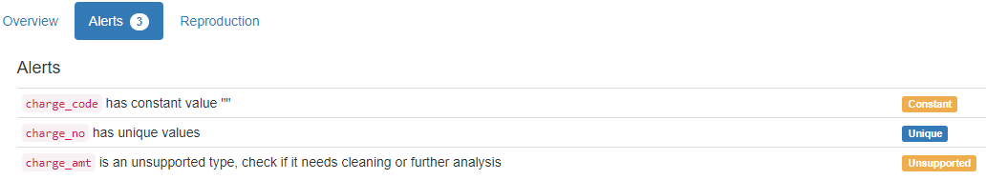

DB.table: financial.trans – Finance – Type: Real
Over 1 million lines analysed!
trans_id (id):
Primary Key format: All 1056320 ID values are unique and valid, and thus suitable for use as a Primary Key.
Numeric range of values: (1 : 3682987)

account_id (id):
Foreign Key format: All 1056320 ID values are valid for use as a Foreign Key, and duplicate values are allowed.
Numeric range of values: (1 : 11382)
References: account.account_id

date:
Date format: All 1056320 date values are valid in the YYYYMMDD format in the range 1993-01-01 to 1998-12-31.

type:
All 1056320 values are correctly categorical.

Categorical format with 3 unique values:
Category Frequency
VYDAJ 634571
PRIJEM 405083
VYBER 16666

operation:
Categorical format: Error(s) found:
DQI #1 (Missing Data - Completeness):
183114 Blank/Empty/Null/Missing value(s) at index(es): [(871629, NULL), (871630, NULL), (871631, NULL), (871632, NULL), (871633, NULL), (871634, NULL), (871635, NULL), (871636, NULL), (871637, NULL), (871638, NULL), ('...', '...'), (1056310, NULL), (1056311, NULL), (1056312, NULL), (1056313, NULL), (1056314, NULL), (1056315, NULL), (1056316, NULL), (1056317, NULL), (1056318, NULL), (1056319, NULL)] (displaying only the first and last 10 items)
Categorical format with 6 unique values:
Category Frequency
VYBER 434918
PREVOD NA UCET 208283
NULL 183114
VKLAD 156743
PREVOD Z UCTU 65226
VYBER KARTOU 8036

amount:
Numerical format: All 1056320 values are numerical in the range (0:87400).

balance:
Numerical format: All 1056320 values are numerical in the range (-41126:209637).

k_symbol (symbol):
String format: Error(s) found:
DQI #1 (Missing Data - Completeness):
NULL values (481881): [(0, 'NULL'), (1, 'NULL'), (2, 'NULL'), (3, 'NULL'), (4, 'NULL'), (5, 'NULL'), (6, 'NULL'), (7, 'NULL'), (8, 'NULL'), (9, 'NULL'), ('...', '...'), (871619, 'NULL'), (871620, 'NULL'), (871621, 'NULL'), (871622, 'NULL'), (871623, 'NULL'), (871624, 'NULL'), (871625, 'NULL'), (871626, 'NULL'), (871627, 'NULL'), (871628, 'NULL')]
Non-NULL values (53433): [(634, 'Blank'), (635, 'Blank'), (636, 'Blank'), (637, 'Blank'), (638, 'Blank'), (639, 'Blank'), (640, 'Blank'), (641, 'Blank'), (642, 'Blank'), (643, 'Blank'), ('...', '...'), (871323, 'Blank'), (871324, 'Blank'), (871325, 'Blank'), (871326, 'Blank'), (871327, 'Blank'), (871328, 'Blank'), (871329, 'Blank'), (871330, 'Blank'), (871331, 'Blank'), (871332, 'Blank')]

String range (lexicographical): (DUCHOD : UVER)
Frequency Distribution:
k_symbol Frequency
NULL 481881
UROK 183114
SLUZBY 155832
SIPO 118065
Blank 53433
DUCHOD 30338
POJISTNE 18500
UVER 13580
SANKC. UROK 1577

bank:
Name format: Error(s) found:
DQI #1 (Missing Data - Completeness):
782812 Blank/Empty/Null/Missing value(s) at index(es): [(0, NULL), (86, NULL), (87, NULL), (88, NULL), (89, NULL), (90, NULL), (91, NULL), (92, NULL), (93, NULL), (94, NULL), ('...', '...'), (1056310, NULL), (1056311, NULL), (1056312, NULL), (1056313, NULL), (1056314, NULL), (1056315, NULL), (1056316, NULL), (1056317, NULL), (1056318, NULL), (1056319, NULL)] (displaying only the first and last 10 items)

Frequency Distribution:
bank Frequency
NULL 782812
QR 22285
AB 21720
ST 21711
YZ 21582
GH 21499
EF 21293
KL 21234
UV 21167
OP 21094
IJ 20525
WX 20178
MN 19623
CD 19597

Range of Values: (AB to YZ)

account (integer):
Numerical format: Error(s) found:
DQI #1 (Missing Data - Completeness):
760931 Blank/Empty/Null/Missing value(s) at index(es): [(0, NULL), (86, NULL), (87, NULL), (88, NULL), (89, NULL), (90, NULL), (91, NULL), (92, NULL), (93, NULL), (94, NULL), ('...', '...'), (1056310, NULL), (1056311, NULL), (1056312, NULL), (1056313, NULL), (1056314, NULL), (1056315, NULL), (1056316, NULL), (1056317, NULL), (1056318, NULL), (1056319, NULL)] (displaying only the first and last 10 items)

Range of values: (0.0:99994199.0).

YDATA Profiling results: It found 3 of the 4 Missing values columns because they contain ALL NULLs. However, it did not find all the Missing values for column 'k_symbol'. It just found 481881 cases of 535314 found by our system, because there are 53433 Blank values: ' '. It also found that the PK column 'trans_id' is Unique.

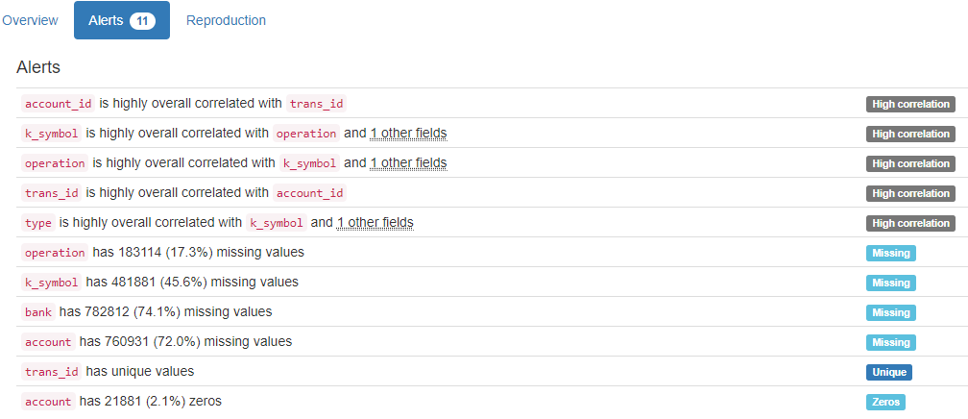

DB.table: ftp.session – Retail – Type: Synth

session_id (id):
Primary Key format: All 30000 ID values are unique and valid, and thus suitable for use as a Primary Key.
Alphanumeric range of values: (u10001 : u40000)

start_time (datetime):
Datetime format: All 30000 datetime values are valid in the YYYYMMDD format in the range 2014/11/14 00:02 to 2014/12/22 23:58.

end_time (datetime):
Datetime format: All 30000 datetime values are valid in the YYYYMMDD format in the range 2014/11/14 00:02 to 2014/12/22 23:58.

gender:
Categorical format: Error(s) found:
DQI #1 (Missing Data - Completeness):
15000 Blank/Empty/Null/Missing value(s) at index(es): [(15000, NULL), (15001, NULL), (15002, NULL), (15003, NULL), (15004, NULL), (15005, NULL), (15006, NULL), (15007, NULL), (15008, NULL), (15009, NULL), ('...', '...'), (29990, NULL), (29991, NULL), (29992, NULL), (29993, NULL), (29994, NULL), (29995, NULL), (29996, NULL), (29997, NULL), (29998, NULL), (29999, NULL)] (displaying only the first and last 10 items)
Categorical format with 3 unique values:
Category Frequency
NULL 15000
female 11703
male 3297

YDATA Profiling results: It found the same 1 Missing values column because they contain ALL NULLs. It also found that the PK column 'session_id' is Unique.

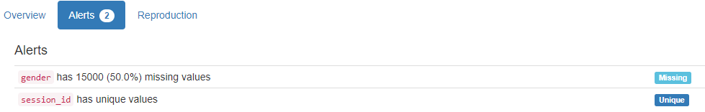

DB.table: Hepatitis_std.dispat – Medicine – Type: Real
m_id (id):
Primary Key format: All 500 ID values are unique and valid, and thus suitable for use as a Primary Key.
Numeric range of values: (1 : 500)

sex:
All 500 values are correctly categorical.

Categorical format with 2 unique values:
Category Frequency
0 355
1 145

age:
Age format: All 500 values are numerical and valid in the range [0, 130].
Actual range of values: (0 : 6)

Type:
All 500 values are correctly categorical.

Categorical format with 2 unique values:
Category Frequency
1 294
- 206

YDATA Profiling results: It just found out that the PK 'm_id' has unique values and is uniformly distributed:
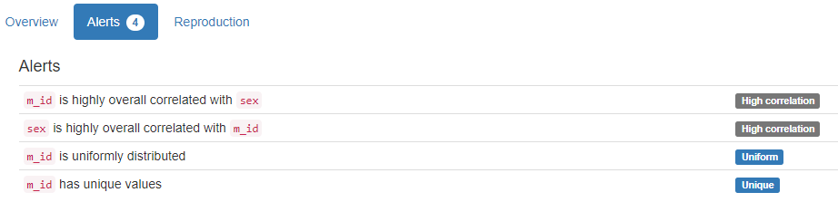

DB.table: Hockey.Master – Sport – Type: Real
playerID (id):
ID column format: Error(s) found:
DQI #1 (Missing Data - Completeness):
241 Blank/Empty/Null/Missing value(s) at index(es): [(22, 'NULL'), (31, 'NULL'), (38, 'NULL'), (40, 'NULL'), (41, 'NULL'), (66, 'NULL'), (152, 'NULL'), (172, 'NULL'), (214, 'NULL'), (243, 'NULL'), ('...', '...'), (7447, 'NULL'), (7456, 'NULL'), (7499, 'NULL'), (7597, 'NULL'), (7615, 'NULL'), (7616, 'NULL'), (7680, 'NULL'), (7695, 'NULL'), (7702, 'NULL'), (7739, 'NULL')] (displaying only the first and last 10 items)

Alphanumeric range of values: (aaltoan01 : zyuzian01)

coachID (id):
Foreign Key format: Error(s) found:
DQI #1 (Missing Data - Completeness):
7366 Blank/Empty/Null/Missing value(s) at index(es): [(0, 'NULL'), (1, 'NULL'), (2, 'NULL'), (3, 'NULL'), (4, 'NULL'), (5, 'NULL'), (6, 'NULL'), (8, 'NULL'), (9, 'NULL'), (10, 'NULL'), ('...', '...'), (7751, 'NULL'), (7752, 'NULL'), (7753, 'NULL'), (7754, 'NULL'), (7755, 'NULL'), (7756, 'NULL'), (7757, 'NULL'), (7758, 'NULL'), (7759, 'NULL'), (7760, 'NULL')] (displaying only the first and last 10 items)

Note: This is a Foreign Key, so duplicate values are allowed.
Alphanumeric range of values: (abelsi01c : youngwe02c)
References: Coaches.coachID

hofID (id):
ID column format: Error(s) found:
DQI #1 (Missing Data - Completeness):
7395 Blank/Empty/Null/Missing value(s) at index(es): [(0, 'NULL'), (1, 'NULL'), (2, 'NULL'), (3, 'NULL'), (4, 'NULL'), (5, 'NULL'), (6, 'NULL'), (8, 'NULL'), (9, 'NULL'), (10, 'NULL'), ('...', '...'), (7751, 'NULL'), (7752, 'NULL'), (7753, 'NULL'), (7754, 'NULL'), (7755, 'NULL'), (7756, 'NULL'), (7757, 'NULL'), (7758, 'NULL'), (7759, 'NULL'), (7760, 'NULL')] (displaying only the first and last 10 items)

Alphanumeric range of values: (abelsi01h : ziegljo01h)

firstName (name):
Name format: Error(s) found
DQI #1 (Missing Data - Completeness):
13 Blank/Empty/Null/Missing value(s) at index(es): [(407, 'NULL'), (779, 'NULL'), (790, 'NULL'), (1102, 'NULL'), (2582, 'NULL'), (2598, 'NULL'), (2717, 'NULL'), (3526, 'NULL'), (3879, 'NULL'), (4311, 'NULL'), (4346, 'NULL'), (5687, 'NULL'), (6106, 'NULL')]

DQI #15 (Domain Violation - Accuracy):
1 Capitalization/Format issue(s) at index(es): [(1357, "D'arcy")]

Frequency Distribution:
firstName Frequency
Mike 193
Bob 142
John 136
Bill 130
Jim 114
Dave 105
Steve 103
Brian 84
Paul 83
Chris 79
... ...
Yanic 1
Yevgeny 1
Yutaka 1
Zarley 1
Zbynek 1
Zellio 1
Zenith 1
Zenon 1
Ziggy 1
Zinetul 1

Range of Values: (Aaron to Zinetul)

lastName (name):
Name format: Error(s) found:
DQI #15 (Domain Violation - Accuracy):
46 Capitalization/Format issue(s) at index(es): [(1569, 'DeBlois'), (1570, 'DeBoer'), (1572, 'DeBrusk'), (1575, 'DeFauw'), (1578, 'DeGray'), (1581, 'DeJordy'), (1583, 'DelGuidice'), (1597, 'DeMarco'), (1598, 'DeMarco'), (1612, 'DePalma'), ('...', '...'), (3957, 'LeBrun'), (3960, 'LeClair'), (3961, 'LeClair'), (3972, 'LeDuc'), (4029, 'LeNeveu'), (4045, 'LeSueur'), (4152, 'LoPresti'), (4153, 'LoPresti'), (7267, 'Van der Gulik'), (7270, 'VandenBussche')] (displaying only the first and last 10 items)

Frequency Distribution:
lastName Frequency
Smith 69
Brown 32
Wilson 31
Johnson 27
Murray 26
Stewart 22
Miller 20
Anderson 19
Martin 17
Jackson 14
... ...
Zubarev 1
Zubrus 1
Zuccarello 1
Zucker 1
Zuk 1
Zuke 1
Zunich 1
Zyuzin 1
de Haan 1
de Vries 1

Range of Values: (Aalto to de Vries)

nameNote (name):
Name format: Error(s) found:
DQI #1 (Missing Data - Completeness):
7743 Blank/Empty/Null/Missing value(s) at index(es): [(0, 'NULL'), (1, 'NULL'), (2, 'NULL'), (3, 'NULL'), (4, 'NULL'), (5, 'NULL'), (6, 'NULL'), (7, 'NULL'), (8, 'NULL'), (9, 'NULL'), ('...', '...'), (7751, 'NULL'), (7752, 'NULL'), (7753, 'NULL'), (7754, 'NULL'), (7755, 'NULL'), (7756, 'NULL'), (7757, 'NULL'), (7758, 'NULL'), (7759, 'NULL'), (7760, 'NULL')] (displaying only the first and last 10 items)

Frequency Distribution:
nameNote Frequency
NULL 7743
also known as Bellehumeur 1
also known as Block 1
also known as Bowcher 1
also known as Bremberg 1
also known as Burmeister 1
also known as Coleman 1
also known as Couture 1
also known as Desrivieres 1
also known as Kahibaitche 1
also known as Kessler 1
also known as Landiak 1
also known as Linton Muldoon Tracey 1
also known as Mike Jefferson 1
also known as Wochy 1
also listed as Bourdginon 1
born Bodnarchuk 1
born Guoth 1
born Tselios 1

Range of Values: (also known as Bellehumeur to born Tselios)

nameGiven (name):
Name format: Error(s) found:
DQI #1 (Missing Data - Completeness):
1776 Blank/Empty/Null/Missing value(s) at index(es): [(4, 'NULL'), (9, 'NULL'), (17, 'NULL'), (18, 'NULL'), (23, 'NULL'), (34, 'NULL'), (35, 'NULL'), (38, 'NULL'), (45, 'NULL'), (62, 'NULL'), ('...', '...'), (7740, 'NULL'), (7741, 'NULL'), (7743, 'NULL'), (7744, 'NULL'), (7745, 'NULL'), (7748, 'NULL'), (7751, 'NULL'), (7752, 'NULL'), (7755, 'NULL'), (7756, 'NULL')] (displaying only the first and last 10 items)

DQI #15 (Domain Violation - Accuracy):
9 Capitalization/Format issue(s) at index(es): [(805, 'Neal LaMoy'), (1357, "D'arcy John"), (2507, 'Harrison LeRoy'), (2540, 'MIchael James'), (3290, 'Edward LaVern'), (3687, 'JArda'), (3992, 'CLaude'), (4420, 'Albert LeRoy'), (5909, 'Robert DeHart')]

Frequency Distribution:
nameGiven Frequency
NULL 1776
Michael 62
Robert 49
John 43
James 36
Daniel 35
David 35
Peter 31
Steven 26
William 26
Paul 25
... ...
Yvan Joseph Rene 1
Yvan Serge 1
Yvon Jean 1
Yvon Jules 1
Yvon Pierre 1
Zarley Bennett 1
Zdeno 1
Zellio Louis Peter 1
Zenith 1
Zigmund 1

Range of Values: (A.B. to Zigmund)

nameNick (name):
Name format: Error(s) found:
DQI #1 (Missing Data - Completeness):
6455 Blank/Empty/Null/Missing value(s) at index(es): [(0, 'NULL'), (1, 'NULL'), (3, 'NULL'), (4, 'NULL'), (6, 'NULL'), (8, 'NULL'), (9, 'NULL'), (10, 'NULL'), (11, 'NULL'), (13, 'NULL'), ('...', '...'), (7751, 'NULL'), (7752, 'NULL'), (7753, 'NULL'), (7754, 'NULL'), (7755, 'NULL'), (7756, 'NULL'), (7757, 'NULL'), (7758, 'NULL'), (7759, 'NULL'), (7760, 'NULL')] (displaying only the first and last 10 items)

DQI #5 (Extraneous Data - Consistency, Uniqueness):
1 Extraneous data value(s) at index(es): [(1364, '7-11')]

DQI #15 (Domain Violation - Accuracy):
6 Capitalization/Format issue(s) at index(es): [(307, 'Goal-a-Game'), (1942, 'X-et'), (2004, 'FedEx'), (2202, 'CoCo'), (5089, 'Sweet Lou from the Soo'), (7043, 'Larry/Half-n-Half')]

Frequency Distribution:
nameNick Frequency
NULL 6455
Red 24
Moose 13
Bill 7
Chief 7
Doc 7
Killer 7
Rocky 7
Duke 6
Bam Bam 5
Cowboy 5
... ...
Wolfman 1
Woodsy 1
Wrecker/Herc 1
X-et 1
Yank 1
Yug 1
Zabrda 1
Zacky 1
Zeus 1
Zholi 1

Range of Values: (7-11 to Zholi)

height:
Numerical >=0 format: Error(s) found:
DQI #1 (Missing Data - Completeness):
427 Blank/Empty/Null/Missing value(s) at index(es): [(17, 'NULL'), (20, 'NULL'), (22, 'NULL'), (31, 'NULL'), (38, 'NULL'), (40, 'NULL'), (41, 'NULL'), (45, 'NULL'), (66, 'NULL'), (116, 'NULL'), ('...', '...'), (7502, 'NULL'), (7574, 'NULL'), (7579, 'NULL'), (7597, 'NULL'), (7615, 'NULL'), (7616, 'NULL'), (7680, 'NULL'), (7695, 'NULL'), (7702, 'NULL'), (7739, 'NULL')] (displaying only the first and last 10 items)

Range of values: (63:81).

weight:
Numerical >=0 format: Error(s) found:
DQI #1 (Missing Data - Completeness):
425 Blank/Empty/Null/Missing value(s) at index(es): [(17, 'NULL'), (20, 'NULL'), (22, 'NULL'), (31, 'NULL'), (38, 'NULL'), (40, 'NULL'), (41, 'NULL'), (45, 'NULL'), (66, 'NULL'), (116, 'NULL'), ('...', '...'), (7502, 'NULL'), (7574, 'NULL'), (7579, 'NULL'), (7597, 'NULL'), (7615, 'NULL'), (7616, 'NULL'), (7680, 'NULL'), (7695, 'NULL'), (7702, 'NULL'), (7739, 'NULL')] (displaying only the first and last 10 items)

Range of values: (125:265).

shootCatch (category):
Categorical format: Error(s) found:
DQI #1 (Missing Data - Completeness):
713 Blank/Empty/Null/Missing value(s) at index(es): [(17, 'NULL'), (18, 'NULL'), (22, 'NULL'), (31, 'NULL'), (38, 'NULL'), (40, 'NULL'), (41, 'NULL'), (45, 'NULL'), (64, 'NULL'), (66, 'NULL'), ('...', '...'), (7680, 'NULL'), (7685, 'NULL'), (7695, 'NULL'), (7702, 'NULL'), (7737, 'NULL'), (7739, 'NULL'), (7748, 'NULL'), (7751, 'NULL'), (7755, 'NULL'), (7756, 'NULL')]
Categorical format with 4 unique value(s):
Category Frequency
L 4604
R 2443
NULL 713
B 1

legendsID (id):
ID column format: Error(s) found:
DQI #1 (Missing Data - Completeness):
1184 Blank/Empty/Null/Missing value(s) at index(es): [(1, 'NULL'), (10, 'NULL'), (15, 'NULL'), (17, 'NULL'), (18, 'NULL'), (20, 'NULL'), (32, 'NULL'), (38, 'NULL'), (42, 'NULL'), (45, 'NULL'), ('...', '...'), (7713, 'NULL'), (7733, 'NULL'), (7737, 'NULL'), (7742, 'NULL'), (7748, 'NULL'), (7750, 'NULL'), (7751, 'NULL'), (7755, 'NULL'), (7756, 'NULL'), (7758, 'NULL')] (displaying only the first and last 10 items)

Alphanumeric range of values: (10002 : P200904)

ihdbID (id):
ID column format: Error(s) found:
DQI #1 (Missing Data - Completeness):
636 Blank/Empty/Null/Missing value(s) at index(es): [(17, 'NULL'), (18, 'NULL'), (22, 'NULL'), (31, 'NULL'), (40, 'NULL'), (41, 'NULL'), (64, 'NULL'), (66, 'NULL'), (100, 'NULL'), (116, 'NULL'), ('...', '...'), (7616, 'NULL'), (7680, 'NULL'), (7685, 'NULL'), (7702, 'NULL'), (7737, 'NULL'), (7739, 'NULL'), (7748, 'NULL'), (7751, 'NULL'), (7755, 'NULL'), (7756, 'NULL')] (displaying only the first and last 10 items)

Alphanumeric range of values: (100 : 9999)

hrefID (id):
ID column format: Error(s) found:
DQI #1 (Missing Data - Completeness):
304 Blank/Empty/Null/Missing value(s) at index(es): [(20, 'NULL'), (22, 'NULL'), (31, 'NULL'), (40, 'NULL'), (41, 'NULL'), (66, 'NULL'), (94, 'NULL'), (99, 'NULL'), (152, 'NULL'), (167, 'NULL'), ('...', '...'), (7500, 'NULL'), (7502, 'NULL'), (7574, 'NULL'), (7579, 'NULL'), (7585, 'NULL'), (7606, 'NULL'), (7615, 'NULL'), (7616, 'NULL'), (7702, 'NULL'), (7739, 'NULL')] (displaying only the first and last 10 items)

Alphanumeric range of values: (aaltoan01 : zyuzian01)

firstNHL (first):
String format: Error(s) found:
DQI #1 (Missing Data - Completeness):
910 Blank/Empty/Null/Missing value(s) at index(es): [(1, 'NULL'), (10, 'NULL'), (15, 'NULL'), (17, 'NULL'), (20, 'NULL'), (22, 'NULL'), (31, 'NULL'), (32, 'NULL'), (38, 'NULL'), (40, 'NULL'), ('...', '...'), (7640, 'NULL'), (7668, 'NULL'), (7680, 'NULL'), (7689, 'NULL'), (7695, 'NULL'), (7702, 'NULL'), (7739, 'NULL'), (7742, 'NULL'), (7750, 'NULL'), (7758, 'NULL')] (displaying only the first and last 10 items)

String range (lexicographical): (1917 : 2011)

lastNHL (last):
String format: Error(s) found:
DQI #1 (Missing Data - Completeness):
910 Blank/Empty/Null/Missing value(s) at index(es): [(1, 'NULL'), (10, 'NULL'), (15, 'NULL'), (17, 'NULL'), (20, 'NULL'), (22, 'NULL'), (31, 'NULL'), (32, 'NULL'), (38, 'NULL'), (40, 'NULL'), ('...', '...'), (7640, 'NULL'), (7668, 'NULL'), (7680, 'NULL'), (7689, 'NULL'), (7695, 'NULL'), (7702, 'NULL'), (7739, 'NULL'), (7742, 'NULL'), (7750, 'NULL'), (7758, 'NULL')] (displaying only the first and last 10 items)

String range (lexicographical): (1917 : 2011)

firstWHA (first):
String format: Error(s) found:
DQI #1 (Missing Data - Completeness):
6858 Blank/Empty/Null/Missing value(s) at index(es): [(0, 'NULL'), (2, 'NULL'), (3, 'NULL'), (4, 'NULL'), (5, 'NULL'), (6, 'NULL'), (7, 'NULL'), (9, 'NULL'), (12, 'NULL'), (13, 'NULL'), ('...', '...'), (7748, 'NULL'), (7749, 'NULL'), (7751, 'NULL'), (7752, 'NULL'), (7753, 'NULL'), (7754, 'NULL'), (7755, 'NULL'), (7756, 'NULL'), (7759, 'NULL'), (7760, 'NULL')] (displaying only the first and last 10 items)

String range (lexicographical): (1972 : 1978)

lastWHA (last):
String format: Error(s) found:
DQI #1 (Missing Data - Completeness):
6858 Blank/Empty/Null/Missing value(s) at index(es): [(0, 'NULL'), (2, 'NULL'), (3, 'NULL'), (4, 'NULL'), (5, 'NULL'), (6, 'NULL'), (7, 'NULL'), (9, 'NULL'), (12, 'NULL'), (13, 'NULL'), ('...', '...'), (7748, 'NULL'), (7749, 'NULL'), (7751, 'NULL'), (7752, 'NULL'), (7753, 'NULL'), (7754, 'NULL'), (7755, 'NULL'), (7756, 'NULL'), (7759, 'NULL'), (7760, 'NULL')] (displaying only the first and last 10 items)

String range (lexicographical): (1972 : 1978)

pos (position):
Categorical format: Error(s) found:
DQI #1 (Missing Data - Completeness):
314 Blank/Empty/Null/Missing value(s) at index(es): [(17, 'NULL'), (22, 'NULL'), (31, 'NULL'), (38, 'NULL'), (40, 'NULL'), (41, 'NULL'), (45, 'NULL'), (66, 'NULL'), (116, 'NULL'), (152, 'NULL'), ('...', '...'), (7378, 'NULL'), (7456, 'NULL'), (7500, 'NULL'), (7574, 'NULL'), (7615, 'NULL'), (7616, 'NULL'), (7680, 'NULL'), (7695, 'NULL'), (7702, 'NULL'), (7739, 'NULL')]
Categorical format with 19 unique value(s):
Category Frequency
D 2218
C 1605
L 1450
R 1348
G 761
NULL 314
F 43
R/C 5
C/D 3
C/L 2
C/R 2
D/L 2
L/C 2
D/C 1
D/R 1
L/D 1
R/D 1
R/L 1
W 1

birthYear (year):
Year format: Error(s) found:
DQI #1 (Missing Data - Completeness):
218 Blank/Empty/Null/Missing value(s) at index(es): [(17, 'NULL'), (20, 'NULL'), (45, 'NULL'), (116, 'NULL'), (211, 'NULL'), (246, 'NULL'), (248, 'NULL'), (352, 'NULL'), (389, 'NULL'), (391, 'NULL'), ('...', '...'), (7328, 'NULL'), (7334, 'NULL'), (7347, 'NULL'), (7348, 'NULL'), (7375, 'NULL'), (7502, 'NULL'), (7574, 'NULL'), (7579, 'NULL'), (7702, 'NULL'), (7747, 'NULL')] (displaying only the first and last 10 items)

Actual range of values: (1841 : 1993)

birthMon (varchar):
String format: Error(s) found:
DQI #1 (Missing Data - Completeness):
255 Blank/Empty/Null/Missing value(s) at index(es): [(17, 'NULL'), (20, 'NULL'), (45, 'NULL'), (116, 'NULL'), (211, 'NULL'), (246, 'NULL'), (248, 'NULL'), (282, 'NULL'), (352, 'NULL'), (389, 'NULL'), ('...', '...'), (7348, 'NULL'), (7375, 'NULL'), (7378, 'NULL'), (7403, 'NULL'), (7502, 'NULL'), (7574, 'NULL'), (7579, 'NULL'), (7606, 'NULL'), (7702, 'NULL'), (7747, 'NULL')] (displaying only the first and last 10 items)

String range (lexicographical): (1 : 9)

birthDay (day):
Day format: Error(s) found:
DQI #1 (Missing Data - Completeness):
257 Blank/Empty/Null/Missing value(s) at index(es): [(17, 'NULL'), (20, 'NULL'), (45, 'NULL'), (116, 'NULL'), (211, 'NULL'), (246, 'NULL'), (248, 'NULL'), (282, 'NULL'), (352, 'NULL'), (389, 'NULL'), ('...', '...'), (7348, 'NULL'), (7375, 'NULL'), (7378, 'NULL'), (7403, 'NULL'), (7502, 'NULL'), (7574, 'NULL'), (7579, 'NULL'), (7606, 'NULL'), (7702, 'NULL'), (7747, 'NULL')] (displaying only the first and last 10 items)

Actual range of values: (1 : 31)

birthCountry (country):
Country format: Error(s) found:
DQI #1 (Missing Data - Completeness):
365 Blank/Empty/Null/Missing value(s) at index(es): [(17, 'NULL'), (20, 'NULL'), (45, 'NULL'), (64, 'NULL'), (100, 'NULL'), (116, 'NULL'), (124, 'NULL'), (174, 'NULL'), (186, 'NULL'), (211, 'NULL'), ('...', '...'), (7485, 'NULL'), (7502, 'NULL'), (7527, 'NULL'), (7574, 'NULL'), (7579, 'NULL'), (7685, 'NULL'), (7702, 'NULL'), (7737, 'NULL'), (7748, 'NULL'), (7756, 'NULL')] (displaying only the first and last 10 items)

Frequency Distribution (showing top and bottom 10 of 50 countries):
Country Frequency
Canada 5328
USA 994
NULL 365
Sweden 233
Czech Republic 206
Russia 172
Finland 164
Slovakia 64
Germany 28
England 25
... ...
Netherlands 1
Nigeria 1
Northern Ireland 1
Paraguay 1
Slovenia 1
South Africa 1
South Korea 1
South Wales 1
Taiwan 1
Tanzania 1

birthState (state):
State format: Error(s) found:
DQI #1 (Missing Data - Completeness):
1437 Blank/Empty/Null/Missing value(s) at index(es): [(0, 'NULL'), (10, 'NULL'), (11, 'NULL'), (17, 'NULL'), (20, 'NULL'), (23, 'NULL'), (34, 'NULL'), (35, 'NULL'), (37, 'NULL'), (45, 'NULL'), ('...', '...'), (7744, 'NULL'), (7745, 'NULL'), (7748, 'NULL'), (7751, 'NULL'), (7752, 'NULL'), (7753, 'NULL'), (7754, 'NULL'), (7755, 'NULL'), (7756, 'NULL'), (7760, 'NULL')] (displaying only the first and last 10 items)

Frequency Distribution (showing top and bottom 10 of 58 states/provinces):
State Frequency
ON 2365
NULL 1437
QC 898
AB 570
SK 527
MB 414
BC 357
MN 240
MA 186
MI 140
... ...
County Wexford 1
DE 1
IA 1
KS 1
MT 1
NC 1
NE 1
WY 1
YT 1
Yorkshire 1

birthCity (city):
City format: Error(s) found:
DQI #1 (Missing Data - Completeness):
373 Blank/Empty/Null/Missing value(s) at index(es): [(17, 'NULL'), (20, 'NULL'), (40, 'NULL'), (45, 'NULL'), (64, 'NULL'), (100, 'NULL'), (116, 'NULL'), (124, 'NULL'), (174, 'NULL'), (186, 'NULL'), ('...', '...'), (7485, 'NULL'), (7502, 'NULL'), (7527, 'NULL'), (7574, 'NULL'), (7579, 'NULL'), (7685, 'NULL'), (7702, 'NULL'), (7737, 'NULL'), (7748, 'NULL'), (7756, 'NULL')] (displaying only the first and last 10 items)

DQI #5 (Extraneous Data - Consistency, Uniqueness):
2 Extraneous data value(s) at index(es): [(4886, '100 Mile House'), (6021, '100 Mile House')]

DQI #15 (Domain Violation - Accuracy):
44 Capitalization/Format issue(s) at index(es): [(168, 'Portage la Prairie'), (192, "Val d'Or"), (193, 'Cap-de-la-Madeleine'), (354, 'Pointe-aux-Trembles'), (399, 'Portage la Prairie'), (401, 'Portage la Prairie'), (648, "Val d'Or"), (653, 'Notre-Dame-du-Lac'), (866, 'Usti nad Labem'), (976, 'Usti nad Labem'), ('...', '...'), (5743, 'Lac la Tortue'), (5851, 'LaSalle'), (6031, 'Cap-de-la-Madeleine'), (6175, "Val d'Or"), (6231, 'St.-Gabriel-de-Bran.'), (6793, 'LaSalle'), (6964, 'Cap del la Madeleine'), (6989, 'Saint-Methode-de-Fro'), (7161, 'Pointe-aux-Trembles'), (7504, 'WInnipeg')] (displaying only the first and last 10 items)

Frequency Distribution (showing top and bottom 10 of 1914 cities):
City Frequency
Toronto 439
NULL 373
Montreal 322
Winnipeg 203
Edmonton 186
Ottawa 173
Calgary 117
Regina 92
Sudbury 75
Saskatoon 72
... ...
Yonkers 1
Young 1
Youngstown 1
Zabrize 1
Zaria 1
Zilina 1
Ziln 1
Zranjanin 1
Zug 1
Zweibrucken 1

deathYear (year):
Year format: Error(s) found:
DQI #1 (Missing Data - Completeness):
6441 Blank/Empty/Null/Missing value(s) at index(es): [(0, 'NULL'), (1, 'NULL'), (2, 'NULL'), (3, 'NULL'), (4, 'NULL'), (6, 'NULL'), (8, 'NULL'), (9, 'NULL'), (10, 'NULL'), (11, 'NULL'), ('...', '...'), (7750, 'NULL'), (7751, 'NULL'), (7752, 'NULL'), (7753, 'NULL'), (7754, 'NULL'), (7755, 'NULL'), (7756, 'NULL'), (7757, 'NULL'), (7758, 'NULL'), (7760, 'NULL')] (displaying only the first and last 10 items)

DQI #15 (Domain Violation - Accuracy):
93 Value(s) outside range [1800, 2100] at index(es): [(88, '9999'), (397, '9999'), (430, '9999'), (674, '9999'), (750, '9999'), (792, '9999'), (822, '9999'), (897, '9999'), (901, '9999'), (916, '9999'), ('...', '...'), (6701, '9999'), (6743, '9999'), (6758, '9999'), (6799, '9999'), (6864, '9999'), (6909, '9999'), (7057, '9999'), (7060, '9999'), (7159, '9999'), (7606, '9999')] (displaying only the first and last 10 items)

Actual range of values: (1907 : 9999)

deathMon (varchar):
String format: Error(s) found:
DQI #1 (Missing Data - Completeness):
6588 Blank/Empty/Null/Missing value(s) at index(es): [(0, 'NULL'), (1, 'NULL'), (2, 'NULL'), (3, 'NULL'), (4, 'NULL'), (6, 'NULL'), (8, 'NULL'), (9, 'NULL'), (10, 'NULL'), (11, 'NULL'), ('...', '...'), (7750, 'NULL'), (7751, 'NULL'), (7752, 'NULL'), (7753, 'NULL'), (7754, 'NULL'), (7755, 'NULL'), (7756, 'NULL'), (7757, 'NULL'), (7758, 'NULL'), (7760, 'NULL')] (displaying only the first and last 10 items)

String range (lexicographical): (1 : 9)

deathDay (day):
Day format: Error(s) found:
DQI #1 (Missing Data - Completeness):
6593 Blank/Empty/Null/Missing value(s) at index(es): [(0, 'NULL'), (1, 'NULL'), (2, 'NULL'), (3, 'NULL'), (4, 'NULL'), (6, 'NULL'), (8, 'NULL'), (9, 'NULL'), (10, 'NULL'), (11, 'NULL'), ('...', '...'), (7750, 'NULL'), (7751, 'NULL'), (7752, 'NULL'), (7753, 'NULL'), (7754, 'NULL'), (7755, 'NULL'), (7756, 'NULL'), (7757, 'NULL'), (7758, 'NULL'), (7760, 'NULL')] (displaying only the first and last 10 items)

Actual range of values: (1 : 31)

deathCountry (country):
Country format: Error(s) found:
DQI #1 (Missing Data - Completeness):
7263 Blank/Empty/Null/Missing value(s) at index(es): [(0, 'NULL'), (1, 'NULL'), (2, 'NULL'), (3, 'NULL'), (4, 'NULL'), (6, 'NULL'), (8, 'NULL'), (9, 'NULL'), (10, 'NULL'), (11, 'NULL'), ('...', '...'), (7751, 'NULL'), (7752, 'NULL'), (7753, 'NULL'), (7754, 'NULL'), (7755, 'NULL'), (7756, 'NULL'), (7757, 'NULL'), (7758, 'NULL'), (7759, 'NULL'), (7760, 'NULL')] (displaying only the first and last 10 items)

Frequency Distribution:
Country Frequency
NULL 7263
Canada 343
USA 128
Russia 11
Czech Republic 3
Germany 2
Sweden 2
Switzerland 2
Belarus 1
Belgium 1
France 1
Holland 1
Italy 1
Norway 1
Turkey 1

deathState (state):
State format: Error(s) found:
7290 Blank/Empty/Null/Missing value(s) at index(es): [(0, 'NULL'), (1, 'NULL'), (2, 'NULL'), (3, 'NULL'), (4, 'NULL'), (6, 'NULL'), (8, 'NULL'), (9, 'NULL'), (10, 'NULL'), (11, 'NULL'), ('...', '...'), (7751, 'NULL'), (7752, 'NULL'), (7753, 'NULL'), (7754, 'NULL'), (7755, 'NULL'), (7756, 'NULL'), (7757, 'NULL'), (7758, 'NULL'), (7759, 'NULL'), (7760, 'NULL')] (displaying only the first and last 10 items)

Frequency Distribution (showing top and bottom 10 of 45 states/provinces):
State Frequency
NULL 7290
ON 197
QC 40
BC 29
AB 26
MB 24
SK 18
MN 15
FL 14
CA 12
... ...
MS 1
NC 1
ND 1
NL 1
NT 1
NV 1
OR 1
PE 1
RI 1
TN 1

deathCity (city):
City format: Error(s) found:
DQI #1 (Missing Data - Completeness):
7278 Blank/Empty/Null/Missing value(s) at index(es): [(0, 'NULL'), (1, 'NULL'), (2, 'NULL'), (3, 'NULL'), (4, 'NULL'), (6, 'NULL'), (8, 'NULL'), (9, 'NULL'), (10, 'NULL'), (11, 'NULL'), ('...', '...'), (7751, 'NULL'), (7752, 'NULL'), (7753, 'NULL'), (7754, 'NULL'), (7755, 'NULL'), (7756, 'NULL'), (7757, 'NULL'), (7758, 'NULL'), (7759, 'NULL'), (7760, 'NULL')] (displaying only the first and last 10 items)

DQI #15 (Domain Violation - Accuracy):
2 Capitalization/Format issue(s) at index(es): [(1004, 'Salaberry-de-Valleyfield'), (5616, 'Ile du Pas')]

Frequency Distribution (showing top and bottom 10 of 240 cities):
City Frequency
NULL 7278
Toronto 45
Ottawa 30
Winnipeg 19
Montreal 16
Calgary 11
Vancouver 10
Yaroslavl 9
Sudbury 8
Edmonton 7
... ...
Vernon 1
Victoriaville 1
Viking 1
Westfield 1
Westlake 1
Weyburn 1
White Rock 1
Wyandotte 1
Yellowknife 1
Zurich 1

YDATA Profiling results: It found the same 30 Missing values columns because they contain ALL NULLs. This table has no Primary Key, just one Foreign Key defined.
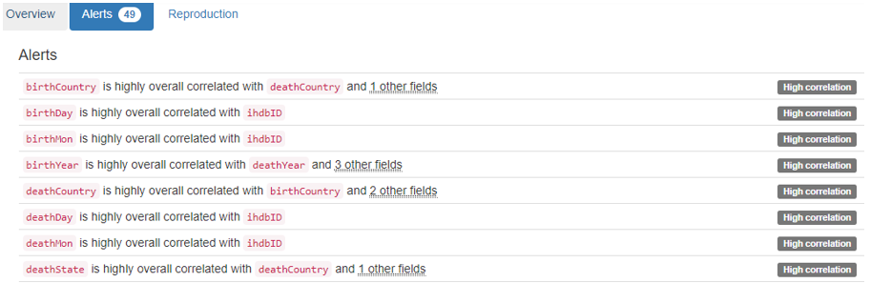
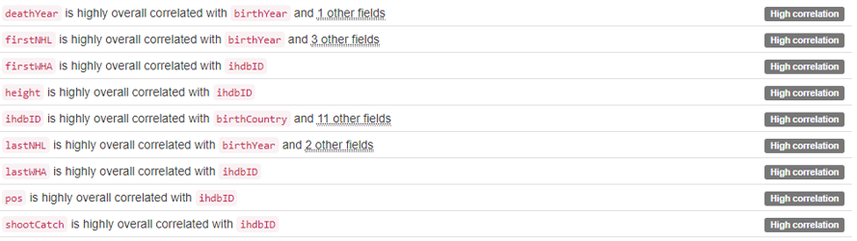
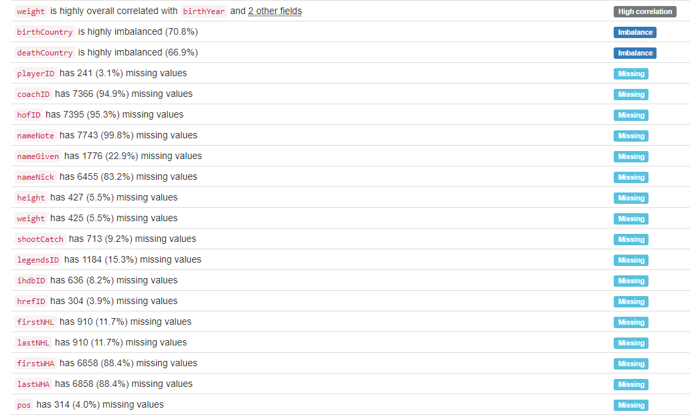
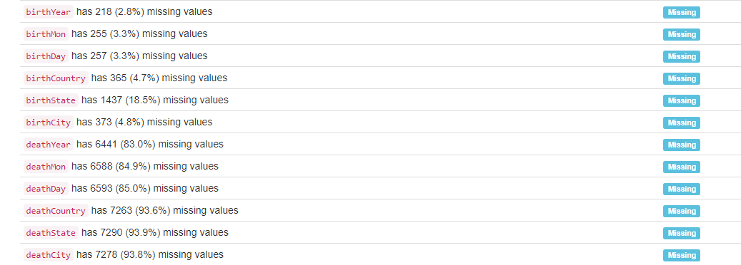

DB.table: imdb_full.actors – Entertainment – Type: Real
actorid (id):
Primary Key format: All 98690 ID values are unique and valid, and thus suitable for use as a Primary Key.
Numeric range of values: (4 : 2749386)

name:
Name format: Error(s) found:
DQI #5 (Extraneous Data - Consistency, Uniqueness):
14 Extraneous data value(s) at index(es): [(4452, 'Berg, Dav!d'), (5058, 'Bird No. 9'), (15039, "Demitro, Michael '2-Smoove'"), (17032, 'E-40'), (18209, 'Fab 5 Freddy'), (36455, 'Mack 10'), (42646, 'N!xau'), (43661, "No's. 1 to 84"), (43748, 'Nooney Rickett 4, The'), (60264, 'UB40'), (65794, '7 Year Bitch'), (65795, '7, Lucky'), (76160, 'Fuschia!'), (98305, 'Y?N-Vee')]

DQI #15 (Domain Violation - Accuracy):
692 Capitalization/Format issue(s) at index(es): [(0, '$hort, Too'), (103, "Abossolo M'bo, Emile"), (529, 'al-Assad, Hafez'), (886, 'Allen, LeRoy'), (2230, 'AuCoin, Kelly'), (2921, "Banai, Ya'ackov"), (5808, "Bonds, De'aundre"), (5892, 'Bookwalter, DeVeren'), (8124, 'Burton, LeVar'), (8395, 'Bôle du Chaumont, Gérard'), ('...', '...'), (96632, 'von der Heyde, Nicole'), (96968, 'Ward, LaToya'), (97668, 'Willette, JoAnn'), (97709, 'Williams, JoBeth'), (97754, "Williams, Swa'vet"), (97787, 'Willis, JoAnne C.'), (97796, 'Willis, Scout LaRue'), (97873, 'Wilson, PaSean'), (98154, "Woolfolk, A'da Alison"), (98240, 'Wu, Chien-lien')] (displaying only the first and last 10 items)

Frequency Distribution:
name Frequency
Deroche, Craig 2
DuBois, Diane 2
McKinney, Bill (I) 2
de la Torre, Antonio (I) 2
$hort, Too 1
'Bear'Boyd, Steven 1
'Dead End' Kids, The 1
7 Year Bitch 1
7, Lucky 1
Aaby, Kristian 1
... ...
Ôtsuka, Akio 1
Ôtsuka, Kunio 1
Ôtsuki, Shûji 1
Öhrstedt, Pekka 1
Öldutúnsskóla, Kór 1
Örnólfsdóttir, Álfrún 1
Öss, Eniko 1
Øby, Kalle 1
Øksnes, Erik 1
Überzone 1

Range of Values: ($hort, Too to Überzone)

sex:
Categorical format: All 98690 values are correctly categorical.

Categorical format with 2 unique value(s):
Category Frequency
M 65794
F 32896

YDATA Profiling results: It just found out that the PK 'actorid' has unique values:

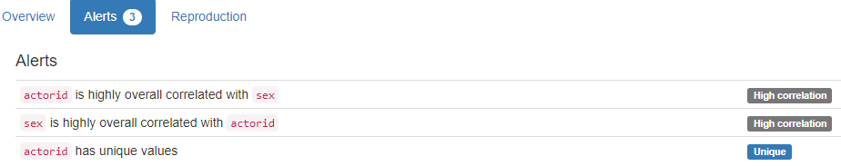

DB.table: imdb_full.movies – Entertainment – Type: Real
movieid (id):
Primary Key format: All 3832 ID values are unique and valid, and thus suitable for use as a Primary Key.
Numeric range of values: (1672052 : 2593313)

title:
Categorical format: Error(s) found:
DQI #10 (Structural Conflicts - Consistency, Uniqueness):
Data seems not categorical or has too many categories (> 100).
Categorical format with 3832 unique value(s):
Category Frequency
'Breaker' Morant (1980) 1
'Crocodile' Dundee II (1988) 1
'Til There Was You (1997) 1
'night, Mother (1986) 1
...And Justice for All (2014) 1
1-2-3-4 ou Les collants noirs (1961) 1
1-900 (1996) 1
10 Things I Hate About You (1999) 1
101 Dalmatians (1996) 1
12 Angry Men (1957) 1
... ...
Zbogum na dvaesetiot vek (1998) 1
Zerkalo (1975) 1
Zero Effect (1998) 1
Zeus and Roxanne (1997) 1
Zone 39 (1996) 1
eXistenZ (1999) 1
¡Three Amigos! (1986) 1
À nous la liberté (1931) 1
Á köldum klaka (1995) 1
Átame! (1990) 1

year:
Year format: All 3832 values are numerical and valid in the range [1800, 2100].
Actual range of values: (1898 : 2014)

YDATA Profiling results: It just found out that the PK column 'movieid' has unique values:
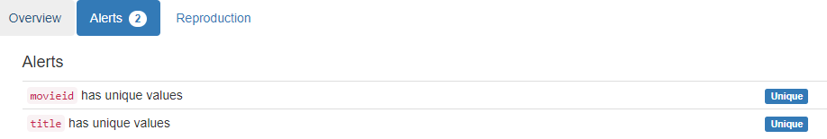

DB.table: imdb_full.movies2actors – Entertainment – Type: Real
movieid|actorid (Composite Primary Key):
Composite Primary Key format: All 138349 ID values are unique and valid, and thus suitable for use as a Primary Key.
Alphanumeric range of values: (1672052|1045133 : 2593313|947005)

as_character (char):
String format: Error(s) found:
NULL values (0): []
Non-NULL values (857): [(312, 'Empty'), (339, 'Empty'), (1200, 'Empty'), (2283, 'Empty'), (3081, 'Empty'), (4488, 'Empty'), (4994, 'Empty'), (5412, 'Empty'), (5798, 'Empty'), (8141, 'Empty'), ('...', '...'), (137963, 'Empty'), (137964, 'Empty'), (137965, 'Empty'), (137971, 'Empty'), (137973, 'Empty'), (137976, 'Empty'), (138083, 'Empty'), (138085, 'Empty'), (138089, 'Empty'), (138096, 'Empty')]

String range (lexicographical): ((also archive footage) [Babe' Hanson] <5> : [úttörõtanár] <6>)
Frequency Distribution:
as_character Frequency
Empty 857
[Himself] 336
(archive footage) (uncredited) [Himself] 219
(archive footage) [Himself] 189
(archive footage) 134
[Herself] 102
[Extra] 67
<20> 48
<23> 47
<26> 47
... ...
[Élisabeth] <3> 1
[Émile] <1> 1
[Émilia] <7> 1
[Émilie Savignard] <5> 1
[Éponine] <27> 1
[Étienne Lantier] <2> 1
[Étienne, adulte] <14> 1
[Étienne] <4> 1
[Ügyelõ] <15> 1
[úttörõtanár] <6> 1

leading (lead):
Numerical format: All 138349 values are numerical in the range (0:307).

YDATA Profiling results: It just found out that the composite PK movieid|actorid has unique values. It did not find the 857 Empty cases in the as_character column:

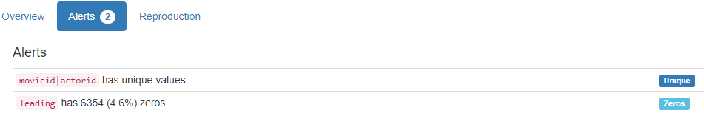

DB.table: imdb_MovieLens.users – Entertainment – Type: Real
userid (id):
Primary Key format: All 6039 ID values are unique and valid, and thus suitable for use as a Primary Key.
Numeric range of values: (1 : 6040)

age:
Age format: All 6039 values are numerical and valid in the range [0, 130].
Actual range of values: (1 : 56)

u_gender (gender):
Categorical format: All 6039 values are correctly categorical.

Categorical format with 2 unique value(s):
Category Frequency
M 4331
F 1708

occupation:
Categorical format: All 6039 values are correctly categorical.

Categorical format with 5 unique value(s):
Category Frequency
2 1614
5 1453
1 1132
4 1051
3 789

YDATA Profiling results: It just found out that the PK column 'userid' has unique values and is uniformly distributed:: 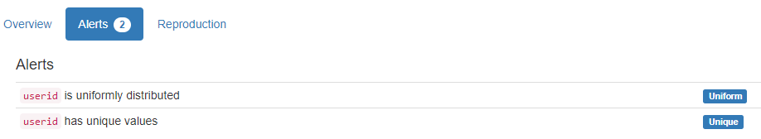

DB.table: imdb_MovieLens.movies – Entertainment – Type: Real
movieid (id):
Primary Key format: All 3832 ID values are unique and valid, and thus suitable for use as a Primary Key.
Numeric range of values: (1672052 : 2593313)

year:
Year format: Error(s) found:
DQI #15 (Domain Violation - Accuracy):
3832 Value(s) outside range [1800, 2100] at index(es): [(0, 3), (1, 4), (2, 4), (3, 4), (4, 4), (5, 3), (6, 4), (7, 4), (8, 4), (9, 3), ('...', '...'), (3822, 4), (3823, 3), (3824, 4), (3825, 4), (3826, 4), (3827, 4), (3828, 4), (3829, 2), (3830, 4), (3831, 4)] (displaying only the first and last 10 items)

Actual range of values: (1 : 4)

isEnglish (enum):
Categorical format: All 3832 values are correctly categorical.

Categorical format with 2 unique value(s):
Category Frequency
T 3411
F 421

country:
Country format: Error(s) found:
DQI #15 (Domain Violation - Accuracy):
531 Capitalization/Format issue(s) at index(es): [(0, 'other'), (1, 'other'), (21, 'other'), (40, 'other'), (51, 'other'), (61, 'other'), (65, 'other'), (67, 'other'), (96, 'other'), (106, 'other'), ('...', '...')]

Frequency Distribution:
Country Frequency
USA 2725
other 531
UK 384
France 192

runningtime (integer):
Numerical format: All 3832 values are numerical in the range (0:3).

YDATA Profiling results: It just found out that the PK column 'movieid' has unique values:

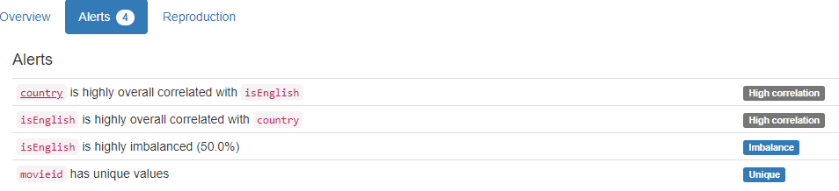

DB.table: imdb_MovieLens.u2base – Entertainment – Type: Real
Almost 1 million lines

userid|movieid (Composite Primary Key):
Composite Primary Key format: All 996159 ID values are unique and valid, and thus suitable for use as a Primary Key.
Alphanumeric range of values: (1000|1674388 : 9|2577314)

rating:
Categorical format: All 996159 values are correctly categorical.

Categorical format with 5 unique value(s):
Category Frequency
4 348150
3 260180
5 225108
2 107114
1 55607

YDATA Profiling results: It just found out that the Composite PK userid|movieid has unique values:
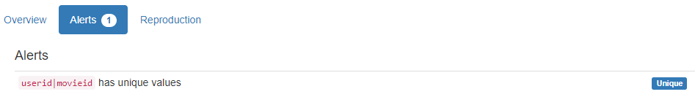

DB.table: lahman_2014.halloffame – Sport – Type: Real
hofID|yearID (Composite Primary Key):
Composite Primary Key format: All 3883 ID values are unique and valid, and thus suitable for use as a Primary Key.
Alphanumeric range of values: (aaronha01h|1982 : ziskri01h|1989)

votedBy (varchar):
String format: All 3883 string values are valid.
String range (lexicographical): (BBWAA : Veterans)

ballots (integer):
Numerical format: Error(s) found:
DQI #1 (Missing Data - Completeness):
169 Blank/Empty/Null/Missing value(s) at index(es): [(51, 'NULL'), (61, 'NULL'), (63, 'NULL'), (96, 'NULL'), (105, 'NULL'), (130, 'NULL'), (146, 'NULL'), (150, 'NULL'), (153, 'NULL'), (173, 'NULL'), ('...', '...'), (3727, 'NULL'), (3749, 'NULL'), (3750, 'NULL'), (3757, 'NULL'), (3789, 'NULL'), (3802, 'NULL'), (3827, 'NULL'), (3840, 'NULL'), (3848, 'NULL'), (3874, 'NULL')] (displaying only the first and last 10 items)

Range of values: (78.0:581.0).

needed (integer):
Numerical format: Error(s) found:
DQI #1 (Missing Data - Completeness):
251 Blank/Empty/Null/Missing value(s) at index(es): [(7, 'NULL'), (51, 'NULL'), (61, 'NULL'), (63, 'NULL'), (77, 'NULL'), (96, 'NULL'), (105, 'NULL'), (125, 'NULL'), (130, 'NULL'), (134, 'NULL'), ('...', '...'), (3750, 'NULL'), (3757, 'NULL'), (3789, 'NULL'), (3802, 'NULL'), (3814, 'NULL'), (3827, 'NULL'), (3840, 'NULL'), (3848, 'NULL'), (3863, 'NULL'), (3874, 'NULL')] (displaying only the first and last 10 items)

Range of values: (59.0:436.0).

votes (integer):
Numerical format: Error(s) found:
DQI #1 (Missing Data - Completeness):
169 Blank/Empty/Null/Missing value(s) at index(es): [(51, 'NULL'), (61, 'NULL'), (63, 'NULL'), (96, 'NULL'), (105, 'NULL'), (130, 'NULL'), (146, 'NULL'), (150, 'NULL'), (153, 'NULL'), (173, 'NULL'), ('...', '...'), (3727, 'NULL'), (3749, 'NULL'), (3750, 'NULL'), (3757, 'NULL'), (3789, 'NULL'), (3802, 'NULL'), (3827, 'NULL'), (3840, 'NULL'), (3848, 'NULL'), (3874, 'NULL')] (displaying only the first and last 10 items)

Range of values: (0.0:537.0).

inducted (varchar):
String format: All 3883 string values are valid.
String range (lexicographical): (N : Y)

category:
Categorical format: All 3883 values are correctly categorical.

Categorical format with 4 unique value(s):
Category Frequency
Player 3765
Manager 69
Pioneer/Executive 39
Umpire 10

YDATA Profiling results: It found the same 3 Missing values columns because they contain ALL NULLs. It also found that the composite PK column 'hof_id|yearID' is Unique.
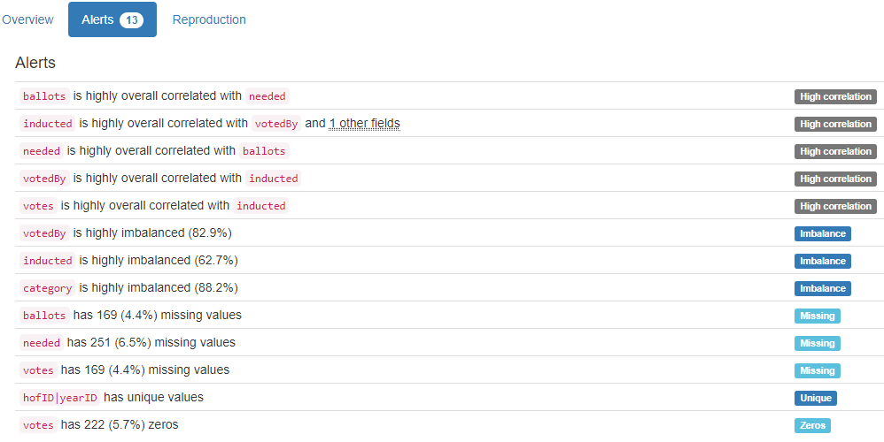

DB.table: lahman_2014.players – Sport – Type: Real
lahmanID (id):
Primary Key format: All 16407 ID values are unique and valid, and thus suitable for use as a Primary Key.
Numeric range of values: (1 : 17610)

playerID (id):
ID column format: Error(s) found:
DQI #9 (Duplicates - Uniqueness):
2 Duplicate value(s) at index(es): [[456, 'baezda01'], [457, 'baezda01']]

DQI #19 (Uniqueness Violation - Uniqueness):
1 Uniqueness violation(s) at index(es): [(457, 'baezda01')]

Alphanumeric range of values: (aardsda01 : zwilldu01)

managerID (id):
ID column format: Error(s) found:
DQI #1 (Missing Data - Completeness):
15850 Blank/Empty/Null/Missing value(s) at index(es): [(0, 'NULL'), (1, 'NULL'), (2, 'NULL'), (3, 'NULL'), (4, 'NULL'), (5, 'NULL'), (6, 'NULL'), (7, 'NULL'), (8, 'NULL'), (9, 'NULL'), ('...', '...'), (16397, 'NULL'), (16398, 'NULL'), (16399, 'NULL'), (16400, 'NULL'), (16401, 'NULL'), (16402, 'NULL'), (16403, 'NULL'), (16404, 'NULL'), (16405, 'NULL'), (16406, 'NULL')] (displaying only the first and last 10 items)

Alphanumeric range of values: (adcocjo01m : zimmedo01m)

hofID (id):
Foreign Key format: Error(s) found:
DQI #1 (Missing Data - Completeness):
15287 Blank/Empty/Null/Missing value(s) at index(es): [(1, 'NULL'), (2, 'NULL'), (3, 'NULL'), (4, 'NULL'), (5, 'NULL'), (6, 'NULL'), (7, 'NULL'), (8, 'NULL'), (9, 'NULL'), (10, 'NULL'), ('...', '...'), (16397, 'NULL'), (16398, 'NULL'), (16399, 'NULL'), (16400, 'NULL'), (16401, 'NULL'), (16402, 'NULL'), (16403, 'NULL'), (16404, 'NULL'), (16405, 'NULL'), (16406, 'NULL')] (displaying only the first and last 10 items)

Note: This is a Foreign Key, so duplicate values are allowed.
Alphanumeric range of values: (aaronha01h : ziskri01h)
References: halloffame.hofID

birthYear (year):
Year format: Error(s) found:
DQI #1 (Missing Data - Completeness):
230 Blank/Empty/Null/Missing value(s) at index(es): [(56, 'NULL'), (95, 'NULL'), (179, 'NULL'), (556, 'NULL'), (617, 'NULL'), (653, 'NULL'), (654, 'NULL'), (972, 'NULL'), (1018, 'NULL'), (1203, 'NULL'), ('...', '...'), (14931, 'NULL'), (15024, 'NULL'), (15119, 'NULL'), (15141, 'NULL'), (15313, 'NULL'), (15383, 'NULL'), (15476, 'NULL'), (15550, 'NULL'), (15567, 'NULL'), (16200, 'NULL')] (displaying only the first and last 10 items)

Actual range of values: (1831.0 : 1986.0)

birthMonth (month):
Month format: Error(s) found:
DQI #1 (Missing Data - Completeness):
445 Blank/Empty/Null/Missing value(s) at index(es): [(56, 'NULL'), (59, 'NULL'), (95, 'NULL'), (113, 'NULL'), (177, 'NULL'), (179, 'NULL'), (345, 'NULL'), (392, 'NULL'), (465, 'NULL'), (507, 'NULL'), ('...', '...'), (15401, 'NULL'), (15476, 'NULL'), (15514, 'NULL'), (15550, 'NULL'), (15564, 'NULL'), (15567, 'NULL'), (15801, 'NULL'), (15988, 'NULL'), (16198, 'NULL'), (16200, 'NULL')] (displaying only the first and last 10 items)

Frequency Distribution:
Month Frequency
August 1552
October 1508
November 1399
January 1391
September 1374
December 1335
March 1315
July 1295
May 1218
April 1209
February 1204
June 1162

birthDay (integer):
Numerical format: Error(s) found:
DQI #1 (Missing Data - Completeness):
585 Blank/Empty/Null/Missing value(s) at index(es): [(56, 'NULL'), (59, 'NULL'), (76, 'NULL'), (95, 'NULL'), (113, 'NULL'), (177, 'NULL'), (179, 'NULL'), (345, 'NULL'), (367, 'NULL'), (392, 'NULL'), ('...', '...'), (15476, 'NULL'), (15514, 'NULL'), (15550, 'NULL'), (15564, 'NULL'), (15567, 'NULL'), (15801, 'NULL'), (15805, 'NULL'), (15988, 'NULL'), (16198, 'NULL'), (16200, 'NULL')] (displaying only the first and last 10 items)

Range of values: (1.0:31.0).

birthCountry (country):
Country format: Error(s) found:
DQI #1 (Missing Data - Completeness):
278 Blank/Empty/Null/Missing value(s) at index(es): [(56, 'NULL'), (95, 'NULL'), (556, 'NULL'), (617, 'NULL'), (653, 'NULL'), (654, 'NULL'), (731, 'NULL'), (972, 'NULL'), (1018, 'NULL'), (1203, 'NULL'), ('...', '...'), (14931, 'NULL'), (15024, 'NULL'), (15119, 'NULL'), (15141, 'NULL'), (15313, 'NULL'), (15383, 'NULL'), (15476, 'NULL'), (15550, 'NULL'), (15567, 'NULL'), (16200, 'NULL')] (displaying only the first and last 10 items)

DQI #15 (Domain Violation - Accuracy):
1 Capitalization/Format issue(s) at index(es): [(11255, 'A Ship on Atlantic Ocean')]

Frequency Distribution (showing top and bottom 10 of 54 countries):
Country Frequency
USA 14524
D.R. 411
NULL 278
P.R. 215
CAN 205
Venezuela 181
Cuba 150
Mexico 98
Panama 45
Ireland 40
... ...
China 1
Denmark 1
Finland 1
Greece 1
Honduras 1
Okinawa 1
Philippines 1
Singapore 1
South Vietnam 1
Switzerland 1

birthState (state):
State format: Error(s) found:
DQI #1 (Missing Data - Completeness):
1578 Blank/Empty/Null/Missing value(s) at index(es): [(30, 'NULL'), (33, 'NULL'), (39, 'NULL'), (40, 'NULL'), (41, 'NULL'), (56, 'NULL'), (91, 'NULL'), (92, 'NULL'), (95, 'NULL'), (99, 'NULL'), ('...', '...'), (16396, 'NULL'), (16397, 'NULL'), (16398, 'NULL'), (16399, 'NULL'), (16400, 'NULL'), (16401, 'NULL'), (16402, 'NULL'), (16403, 'NULL'), (16404, 'NULL'), (16406, 'NULL')] (displaying only the first and last 10 items)

DQI #5 (Extraneous Data - Consistency, Uniqueness):
98 Extraneous data value(s) at index(es): [(34, '6'), (38, '25'), (186, '26'), (216, '26'), (222, '26'), (229, '30'), (424, '30'), (644, '30'), (652, '30'), (667, '26'), ('...', '...'), (15632, '25'), (15633, '26'), (15907, '25'), (15908, '19'), (15909, '26'), (15910, '19'), (15911, '19'), (16158, '19'), (16359, '2'), (16361, '2')] (displaying only the first and last 10 items)

Frequency Distribution (showing top and bottom 10 of 80 states/provinces):
State Frequency
CA 1793
NULL 1578
PA 1320
NY 1105
IL 976
OH 952
TX 702
MA 635
MO 549
MI 403
... ...
14 2
15 2
20 2
28 2
7 2
PE 2
16 1
21 1
NF 1
PH 1

birthCity (city):
City format: Error(s) found:
DQI #1 (Missing Data - Completeness):
392 Blank/Empty/Null/Missing value(s) at index(es): [(56, 'NULL'), (95, 'NULL'), (99, 'NULL'), (478, 'NULL'), (544, 'NULL'), (556, 'NULL'), (613, 'NULL'), (617, 'NULL'), (653, 'NULL'), (654, 'NULL'), ('...', '...'), (15313, 'NULL'), (15345, 'NULL'), (15383, 'NULL'), (15476, 'NULL'), (15550, 'NULL'), (15567, 'NULL'), (15805, 'NULL'), (15988, 'NULL'), (16198, 'NULL'), (16200, 'NULL')] (displaying only the first and last 10 items)

DQI #15 (Domain Violation - Accuracy):
119 Capitalization/Format issue(s) at index(es): [(158, 'DeLand'), (187, 'ElPaso'), (311, 'ElTigre'), (356, 'ElPaso'), (813, 'ElDorado'), (842, 'ElDorado'), (961, 'LaSalle'), (1147, 'DeSoto'), (1287, 'LaMesa'), (1289, 'ElCajon'), ('...', '...'), (15081, 'LaCrosse'), (15301, 'Cincinnatiwilliam wolfe'), (15602, 'San Jose de las Lajas'), (15799, 'Puerto la Cruz'), (15908, 'Nuevo San Nicolas de los Garza'), (15910, 'San Nicolas de los Garza'), (15956, 'Hua-lien'), (15984, 'Neu-ulm'), (16395, 'San Juan de la Maguana'), (16401, 'Sabana de la Mar')] (displaying only the first and last 10 items)

Frequency Distribution (showing top and bottom 10 of 4421 cities):
City Frequency
NULL 392
Chicago 361
Philadelphia 310
St. Louis 267
New York 236
Brooklyn 215
Los Angeles 214
Cincinnati 182
San Francisco 168
Baltimore 140
... ...
Yulee 1
Yuma 1
Zachary 1
Zaragoza 1
Zborov 1
Zealandia 1
Zebulon 1
Zeigler 1
Zeist 1
Zerbe 1

deathYear (year):
Year format: Error(s) found:
DQI #1 (Missing Data - Completeness):
8065 Blank/Empty/Null/Missing value(s) at index(es): [(0, 'NULL'), (2, 'NULL'), (3, 'NULL'), (10, 'NULL'), (11, 'NULL'), (12, 'NULL'), (13, 'NULL'), (14, 'NULL'), (16, 'NULL'), (20, 'NULL'), ('...', '...'), (16397, 'NULL'), (16398, 'NULL'), (16399, 'NULL'), (16400, 'NULL'), (16401, 'NULL'), (16402, 'NULL'), (16403, 'NULL'), (16404, 'NULL'), (16405, 'NULL'), (16406, 'NULL')] (displaying only the first and last 10 items)

Actual range of values: (1872.0 : 2008.0)

deathMonth (month):
Month format: Error(s) found:
DQI #1 (Missing Data - Completeness):
8071 Blank/Empty/Null/Missing value(s) at index(es): [(0, 'NULL'), (2, 'NULL'), (3, 'NULL'), (10, 'NULL'), (11, 'NULL'), (12, 'NULL'), (13, 'NULL'), (14, 'NULL'), (16, 'NULL'), (20, 'NULL'), ('...', '...'), (16397, 'NULL'), (16398, 'NULL'), (16399, 'NULL'), (16400, 'NULL'), (16401, 'NULL'), (16402, 'NULL'), (16403, 'NULL'), (16404, 'NULL'), (16405, 'NULL'), (16406, 'NULL')] (displaying only the first and last 10 items)
Frequency Distribution:
Month Frequency
January 755
December 742
April 731
October 723
March 719
November 712
May 699
September 674
February 663
August 651
July 635
June 632

deathDay (integer):
Numerical format: Error(s) found:
DQI #1 (Missing Data - Completeness):
8071 Blank/Empty/Null/Missing value(s) at index(es): [(0, 'NULL'), (2, 'NULL'), (3, 'NULL'), (10, 'NULL'), (11, 'NULL'), (12, 'NULL'), (13, 'NULL'), (14, 'NULL'), (16, 'NULL'), (20, 'NULL'), ('...', '...'), (16397, 'NULL'), (16398, 'NULL'), (16399, 'NULL'), (16400, 'NULL'), (16401, 'NULL'), (16402, 'NULL'), (16403, 'NULL'), (16404, 'NULL'), (16405, 'NULL'), (16406, 'NULL')] (displaying only the first and last 10 items)

Range of values: (1.0:31.0).

deathCountry (country):
Country format: Error(s) found:
DQI #1 (Missing Data - Completeness):
8105 Blank/Empty/Null/Missing value(s) at index(es): [(0, 'NULL'), (2, 'NULL'), (3, 'NULL'), (10, 'NULL'), (11, 'NULL'), (12, 'NULL'), (13, 'NULL'), (14, 'NULL'), (16, 'NULL'), (20, 'NULL'), ('...', '...'), (16397, 'NULL'), (16398, 'NULL'), (16399, 'NULL'), (16400, 'NULL'), (16401, 'NULL'), (16402, 'NULL'), (16403, 'NULL'), (16404, 'NULL'), (16405, 'NULL'), (16406, 'NULL')] (displaying only the first and last 10 items)

DQI #15 (Domain Violation - Accuracy):
4 Capitalization/Format issue(s) at index(es): [(2526, 'in a plane crash at sea'), (6743, 'Atlantic Ocean from N.Y. to Boston'), (8888, 'uSA'), (9771, 'Atlantic Ocean from N.Y. to P.R.')]

Frequency Distribution (showing top and bottom 10 of 27 countries):
Country Frequency
USA 8142
NULL 8105
CAN 58
Cuba 21
Mexico 16
Venezuela 15
D.R. 12
P.R. 10
Bahamas 4
France 4
... ...
England 1
Japan 1
Marianas Islands 1
North Korea (MIA) 1
Panama 1
Panama Canal Zone 1
Taiwan 1
V.I. 1
in a plane crash at sea 1
uSA 1

deathState (state):
State format: Error(s) found:
DQI #1 (Missing Data - Completeness):
8190 Blank/Empty/Null/Missing value(s) at index(es): [(0, 'NULL'), (2, 'NULL'), (3, 'NULL'), (10, 'NULL'), (11, 'NULL'), (12, 'NULL'), (13, 'NULL'), (14, 'NULL'), (16, 'NULL'), (20, 'NULL'), ('...', '...'), (16397, 'NULL'), (16398, 'NULL'), (16399, 'NULL'), (16400, 'NULL'), (16401, 'NULL'), (16402, 'NULL'), (16403, 'NULL'), (16404, 'NULL'), (16405, 'NULL'), (16406, 'NULL')] (displaying only the first and last 10 items)

DQI #5 (Extraneous Data - Consistency, Uniqueness):
16 Extraneous data value(s) at index(es): [(186, '26'), (424, '30'), (667, '26'), (1081, '28'), (1096, '28'), (1722, '30'), (3410, '26'), (3651, '30'), (4680, '2'), (5185, '28'), (5199, '4'), (8332, '24'), (9748, '7'), (11991, '23'), (12312, '11'), (13221, '19')]

Frequency Distribution (showing top and bottom 10 of 67 states/provinces):
State Frequency
NULL 8190
CA 947
PA 736
NY 632
OH 536
FL 464
IL 429
MA 426
TX 423
MO 311
... ...
11 1
19 1
2 1
23 1
24 1
4 1
7 1
AK 1
BC 1
NB 1

deathCity (city):
City format: Error(s) found:
DQI #1 (Missing Data - Completeness):
8109 Blank/Empty/Null/Missing value(s) at index(es): [(0, 'NULL'), (2, 'NULL'), (3, 'NULL'), (10, 'NULL'), (11, 'NULL'), (12, 'NULL'), (13, 'NULL'), (14, 'NULL'), (16, 'NULL'), (20, 'NULL'), ('...', '...'), (16397, 'NULL'), (16398, 'NULL'), (16399, 'NULL'), (16400, 'NULL'), (16401, 'NULL'), (16402, 'NULL'), (16403, 'NULL'), (16404, 'NULL'), (16405, 'NULL'), (16406, 'NULL')] (displaying only the first and last 10 items)

DQI #15 (Domain Violation - Accuracy):
49 Capitalization/Format issue(s) at index(es): [(103, 'LaCrosse'), (451, 'LeRoy'), (1538, 'ElToro'), (2087, 'ElPaso'), (2590, 'ElPaso'), (2592, 'ElPaso'), (2700, 'LaMesa'), (2705, 'DeSoto'), (3202, 'LaGrange'), (3235, 'ElDorado'), ('...', '...'), (12574, 'ElMonte'), (12630, 'ElPaso'), (12851, 'DeSoto'), (13173, 'DuBois'), (13402, 'LaJolla'), (14033, 'LaJolla'), (14378, 'ElPaso'), (15075, 'LaJolla'), (15129, 'ElReno'), (15596, 'LaCrescenta')] (displaying only the first and last 10 items)

Frequency Distribution (showing top and bottom 10 of 2344 cities):
City Frequency
NULL 8109
Philadelphia 224
Chicago 167
St.Louis 144
Los Angeles 122
New York 112
Cincinnati 104
Baltimore 102
Boston 88
Brooklyn 88
... ...
Yeadon 1
York Township 1
Yorktown 1
Yosemite 1
Yountville 1
Yuba City 1
Yucca Valley 1
Zachary 1
Zaleski 1
Zimmerman 1

nameFirst (name):
Name format: Error(s) found:
DQI #1 (Missing Data - Completeness):
48 Blank/Empty/Null/Missing value(s) at index(es):
NULL values (48): [(653, 'NULL'), (1018, 'NULL'), (1239, 'NULL'), (1296, 'NULL'), (1616, 'NULL'), (1758, 'NULL'), (2639, 'NULL'), (3964, 'NULL'), (4004, 'NULL'), (4155, 'NULL'), ('...', '...'), (12713, 'NULL'), (12806, 'NULL'), (13030, 'NULL'), (13277, 'NULL'), (13530, 'NULL'), (13660, 'NULL'), (13924, 'NULL'), (15024, 'NULL'), (15141, 'NULL'), (15313, 'NULL')]

DQI #15 (Domain Violation - Accuracy):
2 Capitalization/Format issue(s) at index(es): [(5936, 'LaTroy'), (15956, 'Chin-hui')]

Frequency Distribution:
nameFirst Frequency
Bill 544
John 451
Jim 431
Mike 397
Joe 381
Bob 337
George 299
Ed 280
Tom 276
Frank 267
... ...
Youngy 1
Yovanny 1
Yuniesky 1
Zachary 1
Zak 1
Zane 1
Zaza 1
Ziggy 1
Zinn 1
Zoilo 1

Range of Values: (A.J. to Zoilo)

nameLast (name):
Name format: Error(s) found:
DQI #15 (Domain Violation - Accuracy):
98 Capitalization/Format issue(s) at index(es): [(3341, 'de la Cruz'), (3342, 'de la Hoz'), (3343, 'de la Maza'), (3344, 'de la Rosa'), (3345, 'de la Rosa'), (3346, 'de la Rosa'), (3347, 'de los Santos'), (3348, 'de los Santos'), (3349, 'de los Santos'), (3365, 'DeArmond'), ('...', '...'), (15604, 'de los Santos'), (15770, 'DuBose'), (15851, 'DePaula'), (15925, 'DeJesus'), (15945, 'DePastino'), (15949, 'LaForest'), (16024, 'LaRoche'), (16032, 'DiNardo'), (16056, 'DeVore'), (16158, 'de la Rosa')] (displaying only the first and last 10 items)

Frequency Distribution:
nameLast Frequency
Smith 139
Johnson 100
Jones 90
Miller 80
Brown 76
Williams 73
Wilson 66
Davis 60
Moore 47
Taylor 45
... ...
Zuleta 1
Zupcic 1
Zupo 1
Zuvella 1
Zuverink 1
Zwilling 1
de la Cruz 1
de la Hoz 1
de la Maza 1
del Toro 1

Range of Values: (Aardsma to del Toro)

nameNote (name):
Name format: Error(s) found:
DQI #1 (Missing Data - Completeness):
15959 Blank/Empty/Null/Missing value(s) at index(es): [(0, 'NULL'), (1, 'NULL'), (2, 'NULL'), (3, 'NULL'), (4, 'NULL'), (5, 'NULL'), (6, 'NULL'), (7, 'NULL'), (8, 'NULL'), (10, 'NULL'), ('...', '...'), (16397, 'NULL'), (16398, 'NULL'), (16399, 'NULL'), (16400, 'NULL'), (16401, 'NULL'), (16402, 'NULL'), (16403, 'NULL'), (16404, 'NULL'), (16405, 'NULL'), (16406, 'NULL')] (displaying only the first and last 10 items)

DQI #5 (Extraneous Data - Consistency, Uniqueness):
23 Extraneous data value(s) at index(es): [(315, 'born Peter William Jablonowski and legally changed name in 1933'), (703, 'Also Played One Game In 1918 Under Name Of Johnson'), (771, 'a.k.a. W.Thomas In 1871-1873'), (1305, 'a.k.a. Joseph Emley Josephs In 1875'), (1922, 'a.k.a. Frederick King In 1901'), (2560, 'a.k.a. Jack Mc Allister In 1902'), (4500, 'Also Played Under Name Of Wm. G. Morris 1 Game In 1915'), (6575, 'a.k.a. Al West For 1 Game In 1883'), (7306, 'Also Played Under Real Name Of Robert John Taggert In 1918'), (7634, 'a.k.a. Fred Brady In 1913'), ('...', '...'), (9889, 'a.k.a. Joseph Harley Bennett In 1918'), (10170, 'Played One Game In 1912 Under Name Of Costello'), (10478, 'a.k.a. Michael Joyce In 1901'), (11337, 'a.k.a. George Pepper Wilson In 1901'), (12243, 'Previously thought to be John Ryan (ryanjo02)'), (12667, 'Born with last name Sellman, Also Played Under Name Of Frank C. Williams 1871-75'), (13043, 'a.k.a. Robert M. Brown In 1914'), (14326, 'In 1984, played under real name of Jose Altagracia Gonzalez (Uribe)'), (15528, 'a.k.a. Zach Walton In 1918'), (16396, 'Played under the name Leo Nunez through 2011 season')] (displaying only the first and last 10 items)

DQI #15 (Domain Violation - Accuracy):
410 Capitalization/Format issue(s) at index(es): [(9, 'born Harry Frederick Winbigler'), (18, 'Formerly thought to be Dave Abercrombie'), (21, 'also called Ted'), (99, 'born Edward Anshmedt'), (118, 'born Santo Anibal (Alcala)'), (135, 'born Manuel De Jesus (Alexander)'), (147, 'born Alvah Charles Elliott'), (151, 'Also played as Richie Allen'), (197, 'born Felipe Rojas (Alou)'), (198, 'born Jesus Maria Rojas (Alou)'), ('...', '...'), (15456, 'also Yellowhorse'), (15515, 'played as Ross Young'), (15526, 'born Albert Myron Zarski'), (15556, 'also Zeiser'), (15804, 'Record previously combined with Denny Driscoll'), (15805, 'Previously combined with Bill Morgan'), (15989, 'Formerly thought to be Mike Lehane'), (16183, 'also Jairo Garcia'), (16198, 'record previously given to other George Winkelman'), (16199, 'previously credited to Joe Yingling')] (displaying only the first and last 10 items)

Frequency Distribution:
nameNote Frequency
NULL 15959
also known as Joe 2
Also Emil Geis and Bill Geis 1
Also Known As Arthur Lee Whitehorn 1
Also Played One Game In 1918 Under Name Of Johnson 1
Also Played Under Name Of Albert May In 1872 1
Also Played Under Name Of Edward P. Bevens 1
Also Played Under Name Of Harry Zieber 1
Also Played Under Name Of Joseph Henry Greene 1
Also Played Under Name Of Ossee Schreck, born Schrecongost 1
... ...
previously spelled Claire 1
previously thought to be Edward L. 1
previously thought to be Kip Dowd 1
real last name Furrer 1
real last name Schultz 1
real name James Thomas Walsh 1
real name Pedro 1
real name is Eleutero Encarnacion 1
record previously given to other George Winkelman 1
went by Wayman 1

Range of Values: (Also Emil Geis and Bill Geis to went by Wayman)

nameGiven (name):
Name format: Error(s) found:
DQI #1 (Missing Data - Completeness):
741 Blank/Empty/Null/Missing value(s) at index(es): [(3, 'NULL'), (20, 'NULL'), (33, 'NULL'), (100, 'NULL'), (119, 'NULL'), (126, 'NULL'), (150, 'NULL'), (152, 'NULL'), (191, 'NULL'), (192, 'NULL'), ('...', '...'), (15474, 'NULL'), (15487, 'NULL'), (15511, 'NULL'), (15539, 'NULL'), (15559, 'NULL'), (15573, 'NULL'), (15575, 'NULL'), (15591, 'NULL'), (15804, 'NULL'), (16200, 'NULL')] (displaying only the first and last 10 items)

DQI #15 (Domain Violation - Accuracy):
14 Capitalization/Format issue(s) at index(es): [(2665, 'Jesus (De la Cruz)'), (5936, 'LaTroy'), (7987, 'DeWitt Wiley'), (8766, 'Albert DeGroot'), (8810, 'Manuel (DeJesus)'), (15607, 'Miguel (DePaula)'), (15614, 'Alexis DeJesus'), (15615, 'Francis LeBron'), (15678, 'Delvin DeWayne'), (15742, 'Desmond DeChone'), (15767, 'Eric DeBari'), (15895, 'Stephen LeCharles'), (15956, 'Chin-hui'), (15960, 'Rontrez DeMon')]

Frequency Distribution:
nameGiven Frequency
NULL 741
John Joseph 69
John 59
William Henry 50
William Joseph 41
William 38
James Edward 36
Michael Joseph 34
John Francis 32
John William 31
... ...
Zachary Quinn 1
Zachary Taylor 1
Zachary Thomas 1
Zakary Sebastien 1
Zane William 1
Zebulon Alexander 1
Zebulon Vance 1
Zerah Zequiel 1
Zinn Bertram 1
Zoilo Casanova (Rodriguez) 1

Range of Values: (A. Harry to Zoilo Casanova (Rodriguez))

nameNick (name):
Name format: Error(s) found:
DQI #1 (Missing Data - Completeness):
13632 Blank/Empty/Null/Missing value(s) at index(es): [(1, 'NULL'), (2, 'NULL'), (3, 'NULL'), (4, 'NULL'), (6, 'NULL'), (7, 'NULL'), (9, 'NULL'), (10, 'NULL'), (11, 'NULL'), (12, 'NULL'), ('...', '...'), (16396, 'NULL'), (16397, 'NULL'), (16398, 'NULL'), (16399, 'NULL'), (16400, 'NULL'), (16401, 'NULL'), (16402, 'NULL'), (16404, 'NULL'), (16405, 'NULL'), (16406, 'NULL')] (displaying only the first and last 10 items)

DQI #5 (Extraneous Data - Consistency, Uniqueness):
3 Extraneous data value(s) at index(es): [(3327, '3-Dog'), (11991, 'Oh Henry!'), (15382, 'A-1')]

DQI #15 (Domain Violation - Accuracy):
10 Capitalization/Format issue(s) at index(es): [(462, 'BagPipes'), (4294, 'Death to Flying Things'), (5339, 'Baby-faced Assassin'), (6946, 'HoJo'), (7939, 'Long arm of the Law'), (8973, "Shake n' Bake"), (9661, 'Moonie; Moon-man'), (9788, 'Crossfire,Big Ebbie,Steam Engine in Boots'), (13242, "Slammin' Sammy, Say it Ain't Sosa"), (15058, "Sweet Swingin' Billy from Whistler")]

Frequency Distribution:
nameNick Frequency
NULL 13632
Lefty 125
Red 48
Dutch 32
Doc 26
Buck 17
Big Bill 15
Moose 15
Whitey 14
Big Ed 12
... ...
Zamboni 1
Zip 1
Zorro 1
the Animal 1
the Blade 1
the Bull 1
the Cat 1
the Chief 1
the Hacker 1
the Polish Prince 1

Range of Values: (3-Dog to the Polish Prince)

weight:
Numerical >=0 format: Error(s) found:
DQI #1 (Missing Data - Completeness):
786 Blank/Empty/Null/Missing value(s) at index(es): [(18, 'NULL'), (59, 'NULL'), (83, 'NULL'), (95, 'NULL'), (155, 'NULL'), (179, 'NULL'), (248, 'NULL'), (255, 'NULL'), (285, 'NULL'), (352, 'NULL'), ('...', '...'), (15550, 'NULL'), (15563, 'NULL'), (15567, 'NULL'), (15801, 'NULL'), (15803, 'NULL'), (15805, 'NULL'), (15988, 'NULL'), (15989, 'NULL'), (16198, 'NULL'), (16200, 'NULL')] (displaying only the first and last 10 items)

Range of values: (65.0:320.0).

height:
Numerical >=0 format: Error(s) found:
DQI #1 (Missing Data - Completeness):
737 Blank/Empty/Null/Missing value(s) at index(es): [(18, 'NULL'), (59, 'NULL'), (83, 'NULL'), (95, 'NULL'), (159, 'NULL'), (179, 'NULL'), (248, 'NULL'), (255, 'NULL'), (285, 'NULL'), (328, 'NULL'), ('...', '...'), (15550, 'NULL'), (15563, 'NULL'), (15567, 'NULL'), (15801, 'NULL'), (15803, 'NULL'), (15805, 'NULL'), (15988, 'NULL'), (15989, 'NULL'), (16198, 'NULL'), (16200, 'NULL')] (displaying only the first and last 10 items)

Range of values: (43.0:83.0).

bats (varchar):
String format: Error(s) found:
DQI #1 (Missing Data - Completeness):
1193 Blank/Empty/Null/Missing value(s) at index(es):
NULL values (1193): [(18, 'NULL'), (59, 'NULL'), (83, 'NULL'), (95, 'NULL'), (155, 'NULL'), (157, 'NULL'), (177, 'NULL'), (178, 'NULL'), (179, 'NULL'), (225, 'NULL'), ('...', '...'), (15578, 'NULL'), (15801, 'NULL'), (15803, 'NULL'), (15804, 'NULL'), (15805, 'NULL'), (15988, 'NULL'), (15989, 'NULL'), (16198, 'NULL'), (16199, 'NULL'), (16200, 'NULL')]

String range (lexicographical): (B : R)
Frequency Distribution:
bats Frequency
R 10039
L 4177
NULL 1193
B 998

throws (varchar):
String format: Error(s) found:
DQI #1 (Missing Data - Completeness):
956 Blank/Empty/Null/Missing value(s) at index(es):
NULL values (956): [(7, 'NULL'), (18, 'NULL'), (83, 'NULL'), (95, 'NULL'), (155, 'NULL'), (157, 'NULL'), (177, 'NULL'), (178, 'NULL'), (179, 'NULL'), (225, 'NULL'), ('...', '...'), (15578, 'NULL'), (15801, 'NULL'), (15803, 'NULL'), (15804, 'NULL'), (15805, 'NULL'), (15988, 'NULL'), (15989, 'NULL'), (16198, 'NULL'), (16199, 'NULL'), (16200, 'NULL')]

String range (lexicographical): (L : R)
Frequency Distribution:
throws Frequency
R 12377
L 3074
NULL 956

debut:
String format: Error(s) found:
DQI #1 (Missing Data - Completeness):
2 Blank/Empty/Null/Missing value(s) at index(es):
NULL values (2): [(9095, 'NULL'), (16200, 'NULL')]

String range (lexicographical): (10/1/1874 : 9/9/2005)
Frequency Distribution:
debut Frequency
5/1/1884 36
5/1/1879 26
5/2/1882 26
4/17/1884 25
4/13/1954 24
4/19/1890 22
4/26/1995 21
4/15/1958 20
4/14/1942 19
4/17/1945 19
... ...
9/9/1954 1
9/9/1955 1
9/9/1956 1
9/9/1964 1
9/9/1970 1
9/9/1985 1
9/9/1991 1
9/9/1992 1
9/9/1997 1
9/9/2005 1

finalGame (final):
String format: Error(s) found:
DQI #1 (Missing Data - Completeness):
788 Blank/Empty/Null/Missing value(s) at index(es):
NULL values (788): [(30, 'NULL'), (56, 'NULL'), (76, 'NULL'), (126, 'NULL'), (159, 'NULL'), (178, 'NULL'), (253, 'NULL'), (264, 'NULL'), (301, 'NULL'), (363, 'NULL'), ('...', '...'), (16389, 'NULL'), (16390, 'NULL'), (16393, 'NULL'), (16396, 'NULL'), (16398, 'NULL'), (16399, 'NULL'), (16403, 'NULL'), (16404, 'NULL'), (16405, 'NULL'), (16406, 'NULL')]

String range (lexicographical): (10/1/1874 : 9/9/2006)
Frequency Distribution:
finalGame Frequency
NULL 788
9/28/2003 48
10/1/2000 47
10/3/1999 45
10/7/2001 43
10/5/1980 42
10/3/1993 41
9/29/1996 40
10/3/1915 39
10/6/1985 39
... ...
9/9/1978 1
9/9/1979 1
9/9/1980 1
9/9/1985 1
9/9/1986 1
9/9/1988 1
9/9/1989 1
9/9/1993 1
9/9/2000 1
9/9/2006 1

college:
Categorical format: Error(s) found:
DQI #1 (Missing Data - Completeness):
13350 Blank/Empty/Null/Missing value(s) at index(es):
NULL values (13085): [(0, 'NULL'), (1, 'NULL'), (4, 'NULL'), (5, 'NULL'), (6, 'NULL'), (7, 'NULL'), (8, 'NULL'), (9, 'NULL'), (13, 'NULL'), (15, 'NULL'), ('...', '...'), (16396, 'NULL'), (16397, 'NULL'), (16398, 'NULL'), (16399, 'NULL'), (16400, 'NULL'), (16401, 'NULL'), (16402, 'NULL'), (16403, 'NULL'), (16404, 'NULL'), (16406, 'NULL')]
Non-NULL values (265): [(15597, 'None'), (15602, 'None'), (15603, 'None'), (15604, 'None'), (15605, 'None'), (15606, 'None'), (15607, 'None'), (15608, 'None'), (15609, 'None'), (15610, 'None'), ('...', '...'), (16186, 'None'), (16187, 'None'), (16188, 'None'), (16189, 'None'), (16190, 'None'), (16191, 'None'), (16192, 'None'), (16193, 'None'), (16194, 'None'), (16195, 'None')]

DQI #10 (Structural Conflicts - Consistency, Uniqueness):
Data seems not categorical or has too many categories (> 100).
Categorical format with 882 unique value(s):
Category Frequency
NULL 13085
None 265
Arizona State 59
Stanford 46
Texas 45
UCLA 44
USC 41
Arizona 39
Florida State 39
Cal St. Fullerton 36
... ...
Wisconsin-Stevens Point 1
Wisconsin-Whitewater 1
YSU 1
Yakima Valley 1
Yale University 1
York 1
Youngstown State; Florida St. 1
ohio state 1
oklahoma 1
texas 1

lahman40ID (id):
ID column format: Error(s) found:
DQI #1 (Missing Data - Completeness):
810 Blank/Empty/Null/Missing value(s) at index(es): [(15597, 'NULL'), (15598, 'NULL'), (15599, 'NULL'), (15600, 'NULL'), (15601, 'NULL'), (15602, 'NULL'), (15603, 'NULL'), (15604, 'NULL'), (15605, 'NULL'), (15606, 'NULL'), ('...', '...'), (16397, 'NULL'), (16398, 'NULL'), (16399, 'NULL'), (16400, 'NULL'), (16401, 'NULL'), (16402, 'NULL'), (16403, 'NULL'), (16404, 'NULL'), (16405, 'NULL'), (16406, 'NULL')] (displaying only the first and last 10 items)

Alphanumeric range of values: (aaronha01 : zwilldu01)

lahman45ID (id):
ID column format: Error(s) found:
810 Blank/Empty/Null/Missing value(s) at index(es):
NULL values (810): [(15597, 'NULL'), (15598, 'NULL'), (15599, 'NULL'), (15600, 'NULL'), (15601, 'NULL'), (15602, 'NULL'), (15603, 'NULL'), (15604, 'NULL'), (15605, 'NULL'), (15606, 'NULL'), ('...', '...'), (16397, 'NULL'), (16398, 'NULL'), (16399, 'NULL'), (16400, 'NULL'), (16401, 'NULL'), (16402, 'NULL'), (16403, 'NULL'), (16404, 'NULL'), (16405, 'NULL'), (16406, 'NULL')]

Alphanumeric range of values: (aaronha01 : zwilldu01)

retroID (id):
ID column format: Error(s) found:
DQI #1 (Missing Data - Completeness):
1 Blank/Empty/Null/Missing value(s) at index(es):
NULL values (1): [(16200, 'NULL')]
Alphanumeric range of values: (aardd001 : zwild101)

holtzID (id):
ID column format: Error(s) found:
DQI #1 (Missing Data - Completeness):
802 Blank/Empty/Null/Missing value(s) at index(es):
NULL values (802): 15597, 'NULL'), (15598, 'NULL'), (15599, 'NULL'), (15600, 'NULL'), (15601, 'NULL'), (15602, 'NULL'), (15603, 'NULL'), (15604, 'NULL'), (15605, 'NULL'), (15606, 'NULL'), ('...', '...'), (16397, 'NULL'), (16398, 'NULL'), (16399, 'NULL'), (16400, 'NULL'), (16401, 'NULL'), (16402, 'NULL'), (16403, 'NULL'), (16404, 'NULL'), (16405, 'NULL'), (16406, 'NULL')] (displaying only the first and last 10 items)

Alphanumeric range of values: (aaronha01 : zwilldu01)

bbrefID (id):
ID column format: All 16407 ID values are unique and valid, and thus suitable for use as a Primary Key.
Alphanumeric range of values: (aardsda01 : zwilldu01)

YDATA Profiling results: It found correctly 25 of the 29 Missing values columns because they contain ALL NULLs. However, it did not find all the Missing values for column 'college'. It just found correctly 13085 NULL cases of 13350 that were found by our system, because there are 265 values 'None'. Besides that, it did not find the Missing values on columns nameFirst (48), debut (2) and retroID (1). It also found that the PK column 'lahmanid' has unique values:
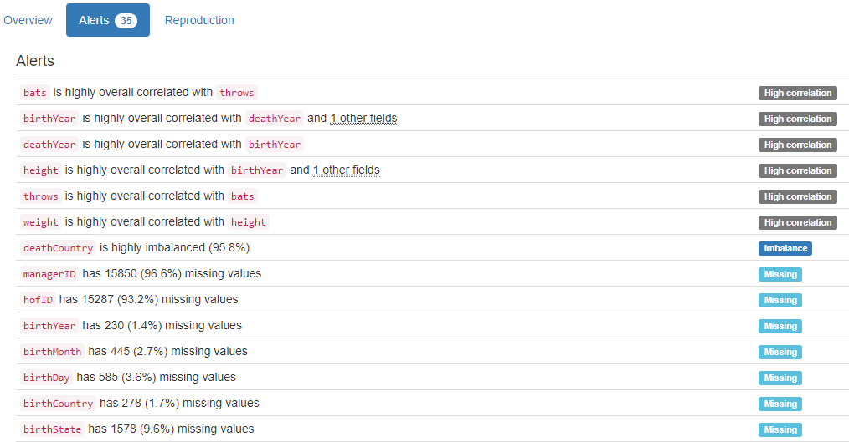
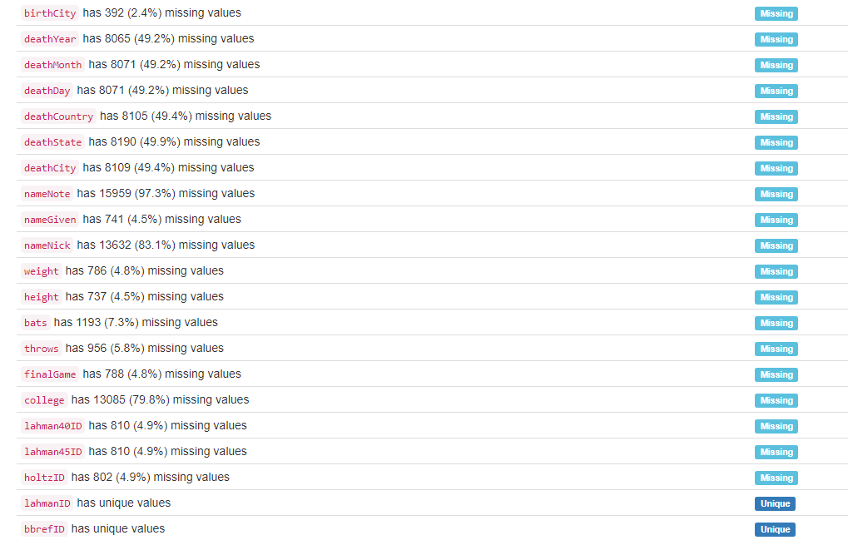

DB.table: lahman_2014.salaries – Sport – Type: Real

yearID|teamID|lgID|playerID (Composite Primary Key):
Composite Primary Key format: All 23111 ID values are unique and valid, and thus suitable for use as a Primary Key.
Alphanumeric range of values: (1985|ATL|NL|barkele01 : 2012|WAS|NL|zimmery01)

salary:
Numerical >=0 format: All 23111 values are numerical and greater or equal to 0 in the range (0:33000000).
YDATA Profiling results: It just found out that the Composite PK with 4 columns, yearID|teamID|lgid|playerid has unique values:
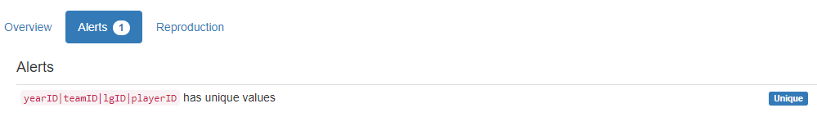

DB.table: lahman_2014.teams – Sport – Type: Real
yearID|lgID|teamID (Composite Primary Key):
Composite Primary Key format: All 2715 ID values are unique and valid, and thus suitable for use as a Primary Key.
Alphanumeric range of values: (1871|NA|BS1 : 2012|NL|WAS)

franchID (id):
ID column format: Error(s) found:
DQI #9 (Duplicates - Uniqueness):
2668 Duplicate value(s) at index(es): [[0, 'BNA'], [1, 'CNA'], [2, 'CFC'], [4, 'NNA'], [5, 'PNA'], [7, 'TRO'], [8, 'OLY'], [9, 'BLC'], [11, 'BRA'], [12, 'BNA'], ('...', '...'), [2705, 'LAD'], [2706, 'FLA'], [2707, 'MIL'], [2708, 'NYM'], [2709, 'PHI'], [2710, 'PIT'], [2711, 'SDP'], [2712, 'SFG'], [2713, 'STL'], [2714, 'WSN']] (displaying only the first and last 10 items)

DQI #19 (Uniqueness Violation - Uniqueness):
2595 Uniqueness violation(s) at index(es): [(12, 'BNA'), (13, 'CFC'), (15, 'NNA'), (16, 'PNA'), (17, 'TRO'), (18, 'OLY'), (20, 'BLC'), (22, 'BRA'), (23, 'BNA'), (25, 'NNA'), ('...', '...'), (2705, 'LAD'), (2706, 'FLA'), (2707, 'MIL'), (2708, 'NYM'), (2709, 'PHI'), (2710, 'PIT'), (2711, 'SDP'), (2712, 'SFG'), (2713, 'STL'), (2714, 'WSN')] (displaying only the first and last 10 items)

Alphanumeric range of values: (ALT : WST)

divID (id):
ID column format: Error(s) found:
DQI #1 (Missing Data - Completeness):
1517 Blank/Empty/Null/Missing value(s) at index(es): [(0, 'NULL'), (1, 'NULL'), (2, 'NULL'), (3, 'NULL'), (4, 'NULL'), (5, 'NULL'), (6, 'NULL'), (7, 'NULL'), (8, 'NULL'), (9, 'NULL'), ('...', '...'), (1507, 'NULL'), (1508, 'NULL'), (1509, 'NULL'), (1510, 'NULL'), (1511, 'NULL'), (1512, 'NULL'), (1513, 'NULL'), (1514, 'NULL'), (1515, 'NULL'), (1516, 'NULL')] (displaying only the first and last 10 items)

DQI #9 (Duplicates - Uniqueness):
1198 Duplicate value(s) at index(es): [[1517, 'E'], [1518, 'E'], [1519, 'W'], [1520, 'W'], [1521, 'E'], [1522, 'E'], [1523, 'W'], [1524, 'W'], [1525, 'E'], [1526, 'W'], ('...', '...'), [2705, 'W'], [2706, 'E'], [2707, 'C'], [2708, 'E'], [2709, 'E'], [2710, 'C'], [2711, 'W'], [2712, 'W'], [2713, 'C'], [2714, 'E']] (displaying only the first and last 10 items)

DQI #19 (Uniqueness Violation - Uniqueness):
1195 Uniqueness violation(s) at index(es): [(1518, 'E'), (1520, 'W'), (1521, 'E'), (1522, 'E'), (1523, 'W'), (1524, 'W'), (1525, 'E'), (1526, 'W'), (1527, 'W'), (1528, 'E'), ('...', '...'), (2705, 'W'), (2706, 'E'), (2707, 'C'), (2708, 'E'), (2709, 'E'), (2710, 'C'), (2711, 'W'), (2712, 'W'), (2713, 'C'), (2714, 'E')] (displaying only the first and last 10 items)

Alphanumeric range of values: (C : W)

Rank:
Numerical >=0 format: All 2715 values are numerical and greater or equal to 0 in the range (1:13).

G (integer):
Numerical format: All 2715 values are numerical in the range (6:165).

Ghome (integer):
Numerical format: Error(s) found:
DQI #1 (Missing Data - Completeness):
549 Blank/Empty/Null/Missing value(s) at index(es): [(0, 'NULL'), (1, 'NULL'), (2, 'NULL'), (3, 'NULL'), (4, 'NULL'), (5, 'NULL'), (6, 'NULL'), (7, 'NULL'), (8, 'NULL'), (9, 'NULL'), ('...', '...'), (2675, 'NULL'), (2676, 'NULL'), (2677, 'NULL'), (2678, 'NULL'), (2679, 'NULL'), (2680, 'NULL'), (2681, 'NULL'), (2682, 'NULL'), (2683, 'NULL'), (2684, 'NULL')] (displaying only the first and last 10 items)

Range of values: (44.0:84.0).

W (integer):
Numerical format: All 2715 values are numerical in the range (0:116).

L (integer):
Numerical format: All 2715 values are numerical in the range (4:134).

DivWin (varchar):
String format: Error(s) found:
DQI #1 (Missing Data - Completeness):
1545 Blank/Empty/Null/Missing value(s) at index(es): [(0, 'NULL'), (1, 'NULL'), (2, 'NULL'), (3, 'NULL'), (4, 'NULL'), (5, 'NULL'), (6, 'NULL'), (7, 'NULL'), (8, 'NULL'), (9, 'NULL'), ('...', '...'), (2171, 'NULL'), (2172, 'NULL'), (2173, 'NULL'), (2174, 'NULL'), (2175, 'NULL'), (2176, 'NULL'), (2177, 'NULL'), (2178, 'NULL'), (2179, 'NULL'), (2180, 'NULL')] (displaying only the first and last 10 items)

String range (lexicographical): (N : Y)

WCWin (varchar):
String format: Error(s) found:
DQI #1 (Missing Data - Completeness):
2181 Blank/Empty/Null/Missing value(s) at index(es): [(0, 'NULL'), (1, 'NULL'), (2, 'NULL'), (3, 'NULL'), (4, 'NULL'), (5, 'NULL'), (6, 'NULL'), (7, 'NULL'), (8, 'NULL'), (9, 'NULL'), ('...', '...'), (2171, 'NULL'), (2172, 'NULL'), (2173, 'NULL'), (2174, 'NULL'), (2175, 'NULL'), (2176, 'NULL'), (2177, 'NULL'), (2178, 'NULL'), (2179, 'NULL'), (2180, 'NULL')] (displaying only the first and last 10 items)

String range (lexicographical): (N : Y)

LgWin (varchar):
String format: Error(s) found:
DQI #1 (Missing Data - Completeness):
28 Blank/Empty/Null/Missing value(s) at index(es): [(2153, 'NULL'), (2154, 'NULL'), (2155, 'NULL'), (2156, 'NULL'), (2157, 'NULL'), (2158, 'NULL'), (2159, 'NULL'), (2160, 'NULL'), (2161, 'NULL'), (2162, 'NULL'), ('...', '...'), (2171, 'NULL'), (2172, 'NULL'), (2173, 'NULL'), (2174, 'NULL'), (2175, 'NULL'), (2176, 'NULL'), (2177, 'NULL'), (2178, 'NULL'), (2179, 'NULL'), (2180, 'NULL')] (displaying only the first and last 10 items)

String range (lexicographical): (N : Y)

WSWin (varchar):
String format: Error(s) found:
DQI #1 (Missing Data - Completeness):
357 Blank/Empty/Null/Missing value(s) at index(es): [(0, 'NULL'), (1, 'NULL'), (2, 'NULL'), (3, 'NULL'), (4, 'NULL'), (5, 'NULL'), (6, 'NULL'), (7, 'NULL'), (8, 'NULL'), (9, 'NULL'), ('...', '...'), (2171, 'NULL'), (2172, 'NULL'), (2173, 'NULL'), (2174, 'NULL'), (2175, 'NULL'), (2176, 'NULL'), (2177, 'NULL'), (2178, 'NULL'), (2179, 'NULL'), (2180, 'NULL')] (displaying only the first and last 10 items)

String range (lexicographical): (N : Y)

R (integer):
Numerical format: All 2715 values are numerical in the range (24:1220).

AB (integer):
Numerical format: All 2715 values are numerical in the range (211:5781).

H (integer):
Numerical format: All 2715 values are numerical in the range (33:1783).

2B (integer):
Numerical format: All 2715 values are numerical in the range (3:376).

3B (integer):
Numerical format: All 2715 values are numerical in the range (0:150).

HR (integer):
Numerical format: All 2715 values are numerical in the range (0:264).

BB (integer):
Numerical format: All 2715 values are numerical in the range (0:835).

SO (integer):
Numerical format: Error(s) found:
DQI #1 (Missing Data - Completeness):
120 Blank/Empty/Null/Missing value(s) at index(es): [(423, 'NULL'), (424, 'NULL'), (425, 'NULL'), (426, 'NULL'), (427, 'NULL'), (428, 'NULL'), (429, 'NULL'), (430, 'NULL'), (439, 'NULL'), (440, 'NULL'), ('...', '...'), (549, 'NULL'), (550, 'NULL'), (559, 'NULL'), (560, 'NULL'), (561, 'NULL'), (562, 'NULL'), (563, 'NULL'), (564, 'NULL'), (565, 'NULL'), (566, 'NULL')] (displaying only the first and last 10 items)

Range of values: (0.0:1529.0).

SB (integer):
Numerical format: Error(s) found:
DQI #1 (Missing Data - Completeness):
144 Blank/Empty/Null/Missing value(s) at index(es): [(29, 'NULL'), (30, 'NULL'), (31, 'NULL'), (32, 'NULL'), (33, 'NULL'), (34, 'NULL'), (35, 'NULL'), (36, 'NULL'), (37, 'NULL'), (38, 'NULL'), ('...', '...'), (163, 'NULL'), (164, 'NULL'), (165, 'NULL'), (166, 'NULL'), (167, 'NULL'), (168, 'NULL'), (169, 'NULL'), (170, 'NULL'), (171, 'NULL'), (172, 'NULL')] (displaying only the first and last 10 items)

Range of values: (0.0:581.0).

CS (integer):
Numerical format: Error(s) found:
DQI #1 (Missing Data - Completeness):
859 Blank/Empty/Null/Missing value(s) at index(es): [(0, 'NULL'), (1, 'NULL'), (2, 'NULL'), (3, 'NULL'), (4, 'NULL'), (5, 'NULL'), (6, 'NULL'), (7, 'NULL'), (8, 'NULL'), (29, 'NULL'), ('...', '...'), (1181, 'NULL'), (1182, 'NULL'), (1191, 'NULL'), (1192, 'NULL'), (1193, 'NULL'), (1194, 'NULL'), (1195, 'NULL'), (1196, 'NULL'), (1197, 'NULL'), (1198, 'NULL')] (displaying only the first and last 10 items)

Range of values: (0.0:191.0).

HBP (integer):
Numerical format: Error(s) found:
DQI #1 (Missing Data - Completeness):
2325 Blank/Empty/Null/Missing value(s) at index(es): [(0, 'NULL'), (1, 'NULL'), (2, 'NULL'), (3, 'NULL'), (4, 'NULL'), (5, 'NULL'), (6, 'NULL'), (7, 'NULL'), (8, 'NULL'), (9, 'NULL'), ('...', '...'), (2315, 'NULL'), (2316, 'NULL'), (2317, 'NULL'), (2318, 'NULL'), (2319, 'NULL'), (2320, 'NULL'), (2321, 'NULL'), (2322, 'NULL'), (2323, 'NULL'), (2324, 'NULL')] (displaying only the first and last 10 items)

Range of values: (28.0:103.0).

SF (integer):
Numerical format: Error(s) found:
DQI #1 (Missing Data - Completeness):
2325 Blank/Empty/Null/Missing value(s) at index(es): [(0, 'NULL'), (1, 'NULL'), (2, 'NULL'), (3, 'NULL'), (4, 'NULL'), (5, 'NULL'), (6, 'NULL'), (7, 'NULL'), (8, 'NULL'), (9, 'NULL'), ('...', '...'), (2315, 'NULL'), (2316, 'NULL'), (2317, 'NULL'), (2318, 'NULL'), (2319, 'NULL'), (2320, 'NULL'), (2321, 'NULL'), (2322, 'NULL'), (2323, 'NULL'), (2324, 'NULL')] (displaying only the first and last 10 items)

Range of values: (24.0:75.0).

RA (integer):
Numerical format: All 2715 values are numerical in the range (34:1252).

ER (integer):
Numerical format: All 2715 values are numerical in the range (25:1023).

ERA (integer):
Numerical format: All 2715 values are numerical in the range (1:8).

CG (integer):
Numerical format: All 2715 values are numerical in the range (0:148).

SHO (integer):
Numerical format: All 2715 values are numerical in the range (0:32).

SV (integer):
Numerical format: All 2715 values are numerical in the range (0:68).

IPouts (integer):
Numerical format: All 2715 values are numerical in the range (162:4518).

HA (integer):
Numerical format: All 2715 values are numerical in the range (49:1993).

HRA (integer):
Numerical format: All 2715 values are numerical in the range (0:241).

BBA (integer):
Numerical format: All 2715 values are numerical in the range (0:827).

SOA (integer):
Numerical format: All 2715 values are numerical in the range (0:1404).

E (integer):
Numerical format: All 2715 values are numerical in the range (47:639).

DP (integer):
Numerical format: Error(s) found:
DQI #1 (Missing Data - Completeness):
317 Blank/Empty/Null/Missing value(s) at index(es): [(0, 'NULL'), (1, 'NULL'), (2, 'NULL'), (3, 'NULL'), (4, 'NULL'), (5, 'NULL'), (6, 'NULL'), (7, 'NULL'), (8, 'NULL'), (9, 'NULL'), ('...', '...'), (365, 'NULL'), (366, 'NULL'), (367, 'NULL'), (368, 'NULL'), (369, 'NULL'), (370, 'NULL'), (371, 'NULL'), (372, 'NULL'), (373, 'NULL'), (374, 'NULL')] (displaying only the first and last 10 items)

Range of values: (18.0:217.0).

FP (integer):
Numerical format: All 2715 values are numerical in the range (0:0).

name:
Name format: Error(s) found:
DQI #5 (Extraneous Data - Consistency, Uniqueness):
3 Extraneous data value(s) at index(es): [(1389, "Houston Colt .45's"), (1409, "Houston Colt .45's"), (1429, "Houston Colt .45's")]

Frequency Distribution:
name Frequency
Cincinnati Reds 122
Pittsburgh Pirates 122
Philadelphia Phillies 121
St. Louis Cardinals 113
Chicago White Sox 112
Detroit Tigers 112
Chicago Cubs 110
Boston Red Sox 105
New York Yankees 100
Cleveland Indians 98
... ...
Rockford Forest Citys 1
Seattle Pilots 1
St. Louis Perfectos 1
St. Louis Red Stockings 1
St. Paul White Caps 1
Toledo Blue Stockings 1
Toledo Maumees 1
Washington Blue Legs 1
Washington Statesmen 1
Wilmington Quicksteps 1

Range of Values: (Altoona Mountain City to Worcester Ruby Legs)

park:
Categorical format: Error(s) found:
DQI #1 (Missing Data - Completeness):
34 Blank/Empty/Null/Missing value(s) at index(es): [(145, 'NULL'), (146, 'NULL'), (147, 'NULL'), (148, 'NULL'), (149, 'NULL'), (150, 'NULL'), (151, 'NULL'), (152, 'NULL'), (153, 'NULL'), (154, 'NULL'), ('...', '...'), (604, 'NULL'), (605, 'NULL'), (606, 'NULL'), (623, 'NULL'), (624, 'NULL'), (625, 'NULL'), (627, 'NULL'), (628, 'NULL'), (629, 'NULL'), (630, 'NULL')]

DQI #10 (Structural Conflicts - Consistency, Uniqueness):
Data seems not categorical or has too many categories (> 100).
Categorical format with 213 unique value(s):
Category Frequency
Wrigley Field 99
Sportsman's Park IV 90
Comiskey Park 80
Fenway Park II 79
Forbes Field 60
Crosley Field 58
Polo Grounds IV 58
Shibe Park 58
Dodger Stadium 55
Yankee Stadium I 51
... ...
South Street Park 1
Speranza Park 1
Sportsman's Park IV/Busch Stadium II 1
Star Park II 1
Sun Life Stadium 1
Troy Ball Club Grounds 1
Union Base-Ball Grounds 1
Washington Park II 1
Waverly Fairgrounds 1
Wrigley Field (LA) 1

attendance:
Numerical >=0 format: Error(s) found:
DQI #1 (Missing Data - Completeness):
309 Blank/Empty/Null/Missing value(s) at index(es): [(0, 'NULL'), (1, 'NULL'), (2, 'NULL'), (3, 'NULL'), (4, 'NULL'), (5, 'NULL'), (6, 'NULL'), (7, 'NULL'), (8, 'NULL'), (9, 'NULL'), ('...', '...'), (2645, 'NULL'), (2646, 'NULL'), (2647, 'NULL'), (2648, 'NULL'), (2649, 'NULL'), (2650, 'NULL'), (2651, 'NULL'), (2652, 'NULL'), (2653, 'NULL'), (2654, 'NULL')] (displaying only the first and last 10 items)

Range of values: (6088.0:4483350.0).

BPF (integer):
Numerical format: All 2715 values are numerical in the range (60:129).

PPF (integer):
Numerical format: All 2715 values are numerical in the range (60:141).

teamIDBR (team):
Categorical format: Error(s) found:
DQI #10 (Structural Conflicts - Consistency, Uniqueness):
Data seems not categorical or has too many categories (> 100).
Categorical format with 101 unique value(s):
Category Frequency
CHC 137
CIN 136
STL 134
PHI 133
PIT 131
BOS 120
CLE 117
CHW 112
DET 112
NYY 110
... ...
PHQ 1
RES 1
RIC 1
ROC 1
ROK 1
SEP 1
SLR 1
STP 1
WES 1
WIL 1

teamIDlahman45 (team):
Categorical format: Error(s) found:
DQI #10 (Structural Conflicts - Consistency, Uniqueness):
Data seems not categorical or has too many categories (> 100).
Categorical format with 148 unique value(s):
Category Frequency
CHN 137
PHI 130
PIT 126
CIN 123
SLN 121
BOS 112
CHA 112
CLE 112
DET 112
NYA 110
... ...
SR2 1
TL1 1
TL2 1
WIL 1
WS4 1
WS5 1
WS6 1
WS7 1
WS9 1
WSU 1

teamIDretro (team):
Categorical format: Error(s) found:
DQI #10 (Structural Conflicts - Consistency, Uniqueness):
Data seems not categorical or has too many categories (> 100).
Categorical format with 149 unique value(s):
Category Frequency
CHN 137
PHI 130
PIT 126
CIN 123
SLN 121
BOS 112
CHA 112
CLE 112
DET 112
NYA 110
... ...
SR2 1
TL1 1
TL2 1
WIL 1
WS4 1
WS5 1
WS6 1
WS7 1
WS9 1
WSU 1

YDATA Profiling results: It found the same 14 Missing values columns because they contain ALL NULLs. It also found that the column FP has constant value "0", and the Composite PK columns yearID|lgID|teamID has unique values:
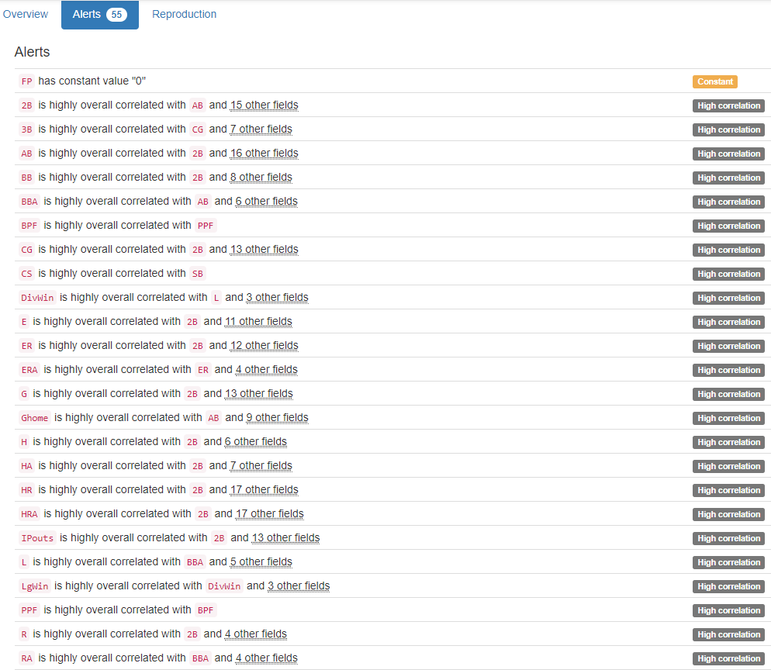
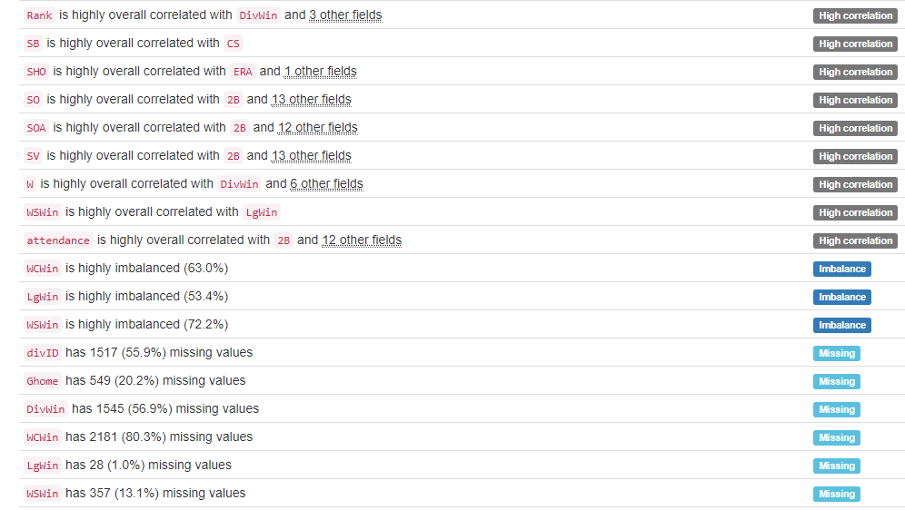
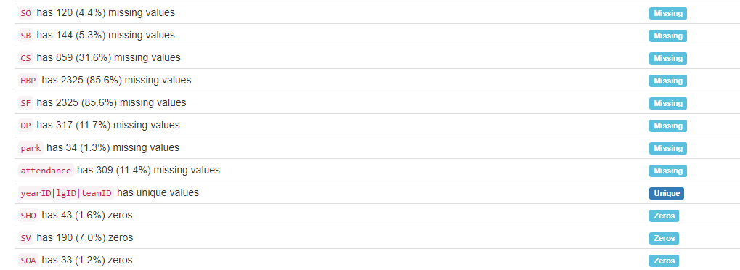

DB.table: legalActs.legalacts – Government – Type: Real
This database table’s content is in the Russian alphabet.

id:
Primary Key format: All 580049 ID values are unique and valid, and thus suitable for use as a Primary Key.
Numeric range of values: (4241 : 2332734)

hash:
ID column format: Error(s) found:
DQI #9 (Duplicates - Uniqueness):
2 Duplicate value(s) at index(es): [[4759, '5e14f1a3d7cbbe58091a1bebb307fb3d'], [5095, '5e14f1a3d7cbbe58091a1bebb307fb3d']]

DQI #19 (Uniqueness Violation - Uniqueness):
1 Uniqueness violation(s) at index(es): [(5095, '5e14f1a3d7cbbe58091a1bebb307fb3d')]

Alphanumeric range of values: (000001fad84142961932d0e8fce7c5ca : fffff80bdf4bf46f26740a4cab71fb22)

update (timestamp):
Datetime format: All 580049 datetime values are valid in the YYYYMMDD format in the range 2012/07/13 14:03 to 2012/08/04 15:06.

Court:
Categorical format: Error(s) found:
DQI #10 (Structural Conflicts - Consistency, Uniqueness):
Data seems not categorical or has too many categories (> 100).
Categorical format with 177 unique value(s):
Category Frequency
Софийски градски съд 37477
Районен съд - Варна 30529
Софийски районен съд 21745
Районен съд - Пловдив 20342
Окръжен съд - Варна 18409
Районен съд - Бургас 16742
Районен съд - Русе 13672
Районен съд - Ст.Загора 13600
Районен съд - Плевен 12895
Районен съд - Благоевград 11654
... ...
Окръжен съд - Монтана 204
Военен съд - Сливен 79
Военен съд - Варна 62
Специализиран наказателен съд 57
Районен съд - Пирдоп 43
Военен съд - Плевен 28
Апелативен съд - Велико Търново 5
Военен съд - София 3
Върховен административен съд 2
Районен съд - Сандански 1

CaseKind (kind):
Categorical format: All 580049 values are correctly categorical.

Categorical format with 25 unique value(s):
Category Frequency
Гражданско дело 187992
НОХД 90266
АНД 87020
Въззивно гражданско дело 57266
Административно дело 31254
Въззивно частно гражданско дело 20595
Търговско дело 18238
ВНОХД 17868
ЧНД 17748
КАНД 11918
... ...
Брачно дело 2559
ВНЧХД 1840
ВАНД 1269
Фирмено дело 1158
Частно административно дело 900
КЧАНД 572
Частно търговско дело 485
Касационно административно дело 234
Касационно частно административно дело 89
Търговско дело по несъстоятелност 81

CaseNumber (number):
Numerical format: All 580049 values are numerical in the range (1:32767).

ActYear (year):
Year format: All 580049 values are numerical and valid in the range [1800, 2100].
Actual range of values: (1933 : 2012)

Judge:
Name format: Error(s) found:
DQI #1 (Missing Data - Completeness):
474 Blank/Empty/Null/Missing value(s) at index(es): [(95673, 'NULL'), (96412, 'NULL'), (96416, 'NULL'), (96422, 'NULL'), (96427, 'NULL'), (96431, 'NULL'), (96434, 'NULL'), (96435, 'NULL'), (96439, 'NULL'), (96440, 'NULL'), ('...', '...'), (497608, 'NULL'), (497693, 'NULL'), (504927, 'NULL'), (509205, 'NULL'), (523352, 'NULL'), (560108, 'NULL'), (567412, 'NULL'), (567414, 'NULL'), (576372, 'NULL'), (577096, 'NULL')] (displaying only the first and last 10 items)

DQI #5 (Extraneous Data - Consistency, Uniqueness):
28516 Extraneous data value(s) at index(es): [(587, '1; Мариана Хитева, Румяна Цонева, Дочка Върбева'), (588, '4; Красимир Коларов, Емил Митев, Нестор Спасов'), (589, '9; Георги Чамбов, Красимир Коларов, Емил Митев'), (590, '3; Красимира Ангелова, Венета Махмудиева, Севдалин Божиков'), (591, '1; Мариана Хитева, Румяна Цонева, Дочка Върбева'), (592, '2; Евдокия Кемалова, Веселина Симеонова, Галя Геогиева'), (600, '3; Недялка Василева, Станко Кидиков, Христо Белев'), (601, '3; Недялка Василева, Станко Кидиков, Христо Белев'), (602, '3; Недялка Василева, Станко Кидиков, Христо Белев'), (603, '9; Георги Чамбов, Красимир Коларов, Емил Митев'), ('...', '...'), (578762, 'ГО 1-1 състав, АСЕН А. ВОДЕНИЧАРОВ'), (578763, 'ГО 1-1 състав, АСЕН А. ВОДЕНИЧАРОВ'), (578764, 'ГО 1-1 състав, АСЕН А. ВОДЕНИЧАРОВ'), (578766, 'НО 5 състав, ГЕОРГИ В. УШЕВ, ДАЯНА К. ЦВЕТАНОВА'), (578767, 'ГО 1-14 състав, КРАСИМИР Н. МАЗГАЛОВ'), (578768, 'ТО VI-3 състав, ЛИЛИЯ Ж. ИЛИЕВА'), (578771, 'ТО VI-13 състав, ДАНИЕЛА А. МАРЧЕВА'), (578772, 'ТО VI-8 състав, ИВАЙЛО С. МЛАДЕНОВ'), (578773, 'ТО VI-2 състав, АНЖЕЛИНА Д. ХРИСТОВА'), (578780, 'ГО 1-14 състав, КРАСИМИР Н. МАЗГАЛОВ')] (displaying only the first and last 10 items)

DQI #15 (Domain Violation - Accuracy):
330681 Capitalization/Format issue(s) at index(es): [(0, 'V състав, ГЕОРГИ Д. ВАСИЛЕВ'), (1, 'III състав, ГАЛИНА И. ВЪЛЧАНОВА'), (2, 'II състав, НИКОЛАЙ Е. ИВАНОВ'), (3, 'II състав, НИКОЛАЙ Е. ИВАНОВ'), (4, 'VI състав, НЕВЕНА И. НЕСТОРОВА'), (5, 'VI състав, ВАЛЕНТИНА ПЕТРОВА'), (6, 'V състав, КРАСИМИРА Т. ДОНЕВА'), (7, 'III състав, ГАЛИНА И. ВЪЛЧАНОВА'), (8, 'VI състав, ВАЛЕНТИНА ПЕТРОВА'), (9, 'I състав, СВЕТЛА Р. ДИМИТРОВА'), ('...', '...'), (580026, 'III състав, ПЕТЯ ТОПАЛОВА'), (580027, 'II състав, КРАСИМИР СЕМОВ'), (580028, 'II състав, КАЛИН К. БАТАЛСКИ'), (580029, 'I състав, ИВЕТА П. ТАКОВА'), (580030, 'I състав, ИВЕТА П. ТАКОВА'), (580044, 'I състав, ТАТЯНА Г. БЕТОВА, МАРИАНА К. ТОДОРОВА, СТЕФАН А. ДАНЧЕВ'), (580045, 'I състав, РЕНИ М. СПАРТАНСКА, ЖАНЕТА Д. ГЕОРГИЕВА, ВЕСЕЛА Л. САХАТЧИЕВА'), (580046, 'I състав, РУМЕН П. ЛАЗАРОВ'), (580047, 'I състав, КАЛОЯН В. ГЕРГОВ, ГЕОРГИ К. ГРЪНЧАРОВ, СИЛВИЯ Ц. КРЪСТЕВА'), (580048, 'I състав, ЖАНЕТА Д. ГЕОРГИЕВА, МЕТОДИ Н. ЗДРАВКОВ, ЕКАТЕРИНА Т. ГЕОРГИЕВА')] (displaying only the first and last 10 items)

Frequency Distribution:
Judge Frequency
Мария Тодорова 2371
Серафимка Мадолева 2244
Росен Василев 1832
Василка Шаламанова 1721
Владимир Ковачев 1638
Иван Петков 1511
Саша Алексова 1265
V състав, ЗЛАТКА Т. ИЛИЕВА 1179
VII състав, ТОДОР Г. МИНОВ 1176
VI състав, ЗЛАТКО Д. МАЗНИКОВ 1171
... ...
смесен; Цветана Михова, Красимир Коларов, Нестор Спасов 1
смесен; Цветана Михова, Красимир Коларов, Симеон Захариев 1
смесен; Цветана Михова, Красимир Коларов, Стела Дандарова 1
смесен; Цветана Михова, Красимира Ангелова, Красимир Коларов 1
смесен; Цветана Михова, Мариана Хитева, Красимир Коларов 1
смесен; Цветана Михова, Недялка Василева, Мариана Хитева 1
смесен; Цветана Михова, Нестор Спасов, Симеон Захариев 1
смесен; Цветана Михова, Севдалин Божиков, Галина Арнаудова 1
смесен; Цветана Михова, Севдалин Божиков, Нестор Спасов 1
станчо димов 1

Range of Values: ( НАДЯ УЗУНОВА to цвета желязкова)

ActKind (kind):
Categorical format: All 580049 values are correctly categorical.

Categorical format with 7 unique value(s):
Category Frequency
Решение 365298
Определение 115400
Споразумение 42512
Присъда 39136
Заповед 6271
Протокол 6042
Разпореждане 5390

ActNumber (number):
Numerical format: Error(s) found:
DQI #1 (Missing Data - Completeness):
187900 Blank/Empty/Null/Missing value(s) at index(es): [(0, 'NULL'), (1, 'NULL'), (2, 'NULL'), (3, 'NULL'), (4, 'NULL'), (5, 'NULL'), (6, 'NULL'), (7, 'NULL'), (8, 'NULL'), (9, 'NULL'), ('...', '...'), (580034, 'NULL'), (580035, 'NULL'), (580036, 'NULL'), (580037, 'NULL'), (580038, 'NULL'), (580039, 'NULL'), (580040, 'NULL'), (580041, 'NULL'), (580042, 'NULL'), (580043, 'NULL')] (displaying only the first and last 10 items)

Range of values: (1.0:32767.0).

StartDate (date):
Date format: All 580049 date values are valid in the YYYYMMDD format in the range 1999-07-09 to 2012-07-27.

LegalDate (date):
Date format: Error(s) found:
DQI #1 (Missing Data - Completeness):
293636 Blank/Empty/Null/Missing value(s) at index(es): [(12, 'NULL'), (13, 'NULL'), (15, 'NULL'), (18, 'NULL'), (19, 'NULL'), (20, 'NULL'), (21, 'NULL'), (26, 'NULL'), (27, 'NULL'), (29, 'NULL'), ('...', '...'), (580030, 'NULL'), (580031, 'NULL'), (580032, 'NULL'), (580035, 'NULL'), (580037, 'NULL'), (580044, 'NULL'), (580045, 'NULL'), (580046, 'NULL'), (580047, 'NULL'), (580048, 'NULL')] (displaying only the first and last 10 items)

Date range: 2006-07-03 to 2012-12-02

Status:
Categorical format: All 580049 values are correctly categorical.

Categorical format with 5 unique value(s):
Category Frequency
Влязъл в сила 275395
Не е влязъл в сила 266867
Потвърден 16389
Отменен 13579
Изменен 7819

ActLink (tinyint):
Numerical format: All 580049 values are numerical in the range (0:1).

MotiveDate (date):
Date format: Error(s) found:
DQI #1 (Missing Data - Completeness):
530677 Blank/Empty/Null/Missing value(s) at index(es): [(0, 'NULL'), (1, 'NULL'), (2, 'NULL'), (3, 'NULL'), (4, 'NULL'), (5, 'NULL'), (6, 'NULL'), (7, 'NULL'), (8, 'NULL'), (9, 'NULL'), ('...', '...'), (580037, 'NULL'), (580038, 'NULL'), (580039, 'NULL'), (580041, 'NULL'), (580042, 'NULL'), (580043, 'NULL'), (580044, 'NULL'), (580045, 'NULL'), (580047, 'NULL'), (580048, 'NULL')] (displaying only the first and last 10 items)

Date range: 1999-07-21 to 2012-07-27

MotiveLink (tinyint):
Numerical format: All 580049 values are numerical in the range (0:1).

HighCourt (court):
Categorical format: Error(s) found:
DQI #1 (Missing Data - Completeness):
465545 Blank/Empty/Null/Missing value(s) at index(es): [(0, 'NULL'), (1, 'NULL'), (2, 'NULL'), (3, 'NULL'), (4, 'NULL'), (5, 'NULL'), (6, 'NULL'), (7, 'NULL'), (8, 'NULL'), (9, 'NULL'), ('...', '...'), (580031, 'NULL'), (580033, 'NULL'), (580034, 'NULL'), (580035, 'NULL'), (580036, 'NULL'), (580038, 'NULL'), (580039, 'NULL'), (580043, 'NULL'), (580047, 'NULL'), (580048, 'NULL')]
Categorical format with 60 unique value(s):
Category Frequency
NULL 465545
Върховен касационен съд 19023
Върховен административен съд 11057
Окръжен съд - Варна 7701
Апелативен съд - София 5789
Окръжен съд - Пловдив 4449
Административен съд - Варна 3984
Окръжен съд - Бургас 3408
Административен съд - Бургас 3039
Апелативен съд - Варна 2803
... ...
Окръжен съд - Търговище 540
Административен съд - Видин 504
Административен съд - Кърджали 474
Административен съд - Разград 472
Административен съд - Габрово 467
Административен съд - Търговище 465
Софийски окръжен съд 172
Административен съд - София-област 98
Военно-апелативен съд 56
Апелативен специализиран наказателен съд 11

OutNumber (number):
Numerical format: Error(s) found:
DQI #1 (Missing Data - Completeness):
465545 Blank/Empty/Null/Missing value(s) at index(es): [(0, 'NULL'), (1, 'NULL'), (2, 'NULL'), (3, 'NULL'), (4, 'NULL'), (5, 'NULL'), (6, 'NULL'), (7, 'NULL'), (8, 'NULL'), (9, 'NULL'), ('...', '...'), (580031, 'NULL'), (580033, 'NULL'), (580034, 'NULL'), (580035, 'NULL'), (580036, 'NULL'), (580038, 'NULL'), (580039, 'NULL'), (580043, 'NULL'), (580047, 'NULL'), (580048, 'NULL')] (displaying only the first and last 10 items)
Range of values: (1.0:32767.0).

YearHigherCourt (year):
Year format: Error(s) found:
DQI #1 (Missing Data - Completeness):
465545 Blank/Empty/Null/Missing value(s) at index(es): [(0, 'NULL'), (1, 'NULL'), (2, 'NULL'), (3, 'NULL'), (4, 'NULL'), (5, 'NULL'), (6, 'NULL'), (7, 'NULL'), (8, 'NULL'), (9, 'NULL'), ('...', '...'), (580031, 'NULL'), (580033, 'NULL'), (580034, 'NULL'), (580035, 'NULL'), (580036, 'NULL'), (580038, 'NULL'), (580039, 'NULL'), (580043, 'NULL'), (580047, 'NULL'), (580048, 'NULL')] (displaying only the first and last 10 items)
Actual range of values: (2005.0 : 2012.0)

TypeOfDocument (type):
Categorical format: Error(s) found:
DQI #1 (Missing Data - Completeness):
465545 Blank/Empty/Null/Missing value(s) at index(es): [(0, 'NULL'), (1, 'NULL'), (2, 'NULL'), (3, 'NULL'), (4, 'NULL'), (5, 'NULL'), (6, 'NULL'), (7, 'NULL'), (8, 'NULL'), (9, 'NULL'), ('...', '...'), (580031, 'NULL'), (580033, 'NULL'), (580034, 'NULL'), (580035, 'NULL'), (580036, 'NULL'), (580038, 'NULL'), (580039, 'NULL'), (580043, 'NULL'), (580047, 'NULL'), (580048, 'NULL')]
Categorical format with 4 unique value(s):
Category Frequency
NULL 465545
Писмо 114404
Писмо - предложение за възобновяване 72
Писмо - молба за опр. срок при бавност 28

SendDate (date):
Date format: Error(s) found:
DQI #1 (Missing Data - Completeness):
465545 Blank/Empty/Null/Missing value(s) at index(es): [(0, 'NULL'), (1, 'NULL'), (2, 'NULL'), (3, 'NULL'), (4, 'NULL'), (5, 'NULL'), (6, 'NULL'), (7, 'NULL'), (8, 'NULL'), (9, 'NULL'), ('...', '...'), (580031, 'NULL'), (580033, 'NULL'), (580034, 'NULL'), (580035, 'NULL'), (580036, 'NULL'), (580038, 'NULL'), (580039, 'NULL'), (580043, 'NULL'), (580047, 'NULL'), (580048, 'NULL')] (displaying only the first and last 10 items)

Date range: 2005-06-29 to 2012-07-27

ResultOfAppeal (result):
String format: Error(s) found:
DQI #1 (Missing Data - Completeness):
504994 Blank/Empty/Null/Missing value(s) at index(es): [(0, 'NULL'), (1, 'NULL'), (2, 'NULL'), (3, 'NULL'), (4, 'NULL'), (5, 'NULL'), (6, 'NULL'), (7, 'NULL'), (8, 'NULL'), (9, 'NULL'), ('...', '...'), (580035, 'NULL'), (580036, 'NULL'), (580037, 'NULL'), (580038, 'NULL'), (580039, 'NULL'), (580043, 'NULL'), (580044, 'NULL'), (580046, 'NULL'), (580047, 'NULL'), (580048, 'NULL')] (displaying only the first and last 10 items)

String range (lexicographical): (Изменен : Частично отменено и обезсилено, поради наличие на касационните основания по чл.209, т.3 АПК)
YDATA Profiling results: It found correctly 9 of the 10 Missing values columns because they contain ALL NULLs. It did not find all the 474 Missing values for column 'judge' even though they are also NULLs. It also found that the PK column 'id' is Unique.

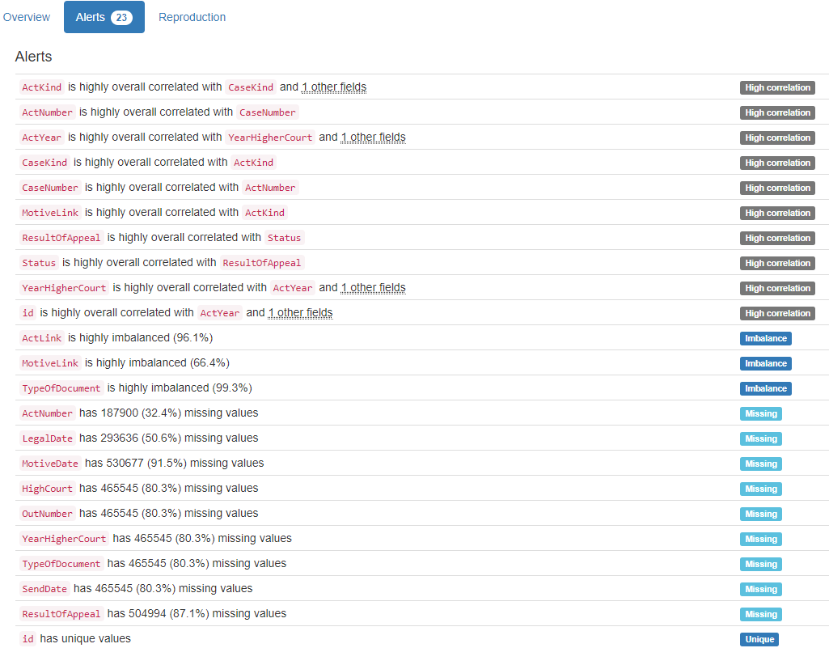

DB.table: Mondial.city – Geography – Type: Real
Name|Province (Composite Primary Key):
Composite Primary Key format: All 3111 ID values are unique and valid, and thus suitable for use as a Primary Key.
Alphanumeric range of values: (Aachen|Nordrhein Westfalen : s Hertogenbosch|Noord Brabant)

Country (id):
Foreign Key format: All 3111 ID values are valid for use as a Foreign Key, and duplicate values are allowed.
Alphanumeric range of values: (A : ZW)
References: country.Code

Population:
Numerical >=0 format: Error(s) found:
DQI #1 (Missing Data - Completeness):
465 Blank/Empty/Null/Missing value(s) at index(es): [(2, 'NULL'), (8, 'NULL'), (11, 'NULL'), (12, 'NULL'), (21, 'NULL'), (22, 'NULL'), (30, 'NULL'), (32, 'NULL'), (33, 'NULL'), (35, 'NULL'), ('...', '...'), (3048, 'NULL'), (3054, 'NULL'), (3063, 'NULL'), (3065, 'NULL'), (3066, 'NULL'), (3069, 'NULL'), (3080, 'NULL'), (3088, 'NULL'), (3106, 'NULL'), (3110, 'NULL')] (displaying only the first and last 10 items)

Range of values: (0.0:10229262.0).

Longitude:
Longitude format: Error(s) found:
DQI #1 (Missing Data - Completeness):
2310 Blank/Empty/Null/Missing value(s) at index(es): [(0, 'NULL'), (2, 'NULL'), (4, 'NULL'), (5, 'NULL'), (6, 'NULL'), (7, 'NULL'), (8, 'NULL'), (9, 'NULL'), (10, 'NULL'), (11, 'NULL'), ('...', '...'), (3101, 'NULL'), (3102, 'NULL'), (3103, 'NULL'), (3104, 'NULL'), (3105, 'NULL'), (3106, 'NULL'), (3107, 'NULL'), (3108, 'NULL'), (3109, 'NULL'), (3110, 'NULL')] (displaying only the first and last 10 items)

Actual range of values: (-175.2 : 178.0)

Latitude:
Latitude format: Error(s) found:
DQI #1 (Missing Data - Completeness):
2310 Blank/Empty/Null/Missing value(s) at index(es): [(0, 'NULL'), (2, 'NULL'), (4, 'NULL'), (5, 'NULL'), (6, 'NULL'), (7, 'NULL'), (8, 'NULL'), (9, 'NULL'), (10, 'NULL'), (11, 'NULL'), ('...', '...'), (3101, 'NULL'), (3102, 'NULL'), (3103, 'NULL'), (3104, 'NULL'), (3105, 'NULL'), (3106, 'NULL'), (3107, 'NULL'), (3108, 'NULL'), (3109, 'NULL'), (3110, 'NULL')] (displaying only the first and last 10 items)

Actual range of values: (-54.5 : 78.13)

YDATA Profiling results: It found the same 3 Missing values columns because they contain ALL NULLs. It also found that the Composite PK Name|Province is Unique.
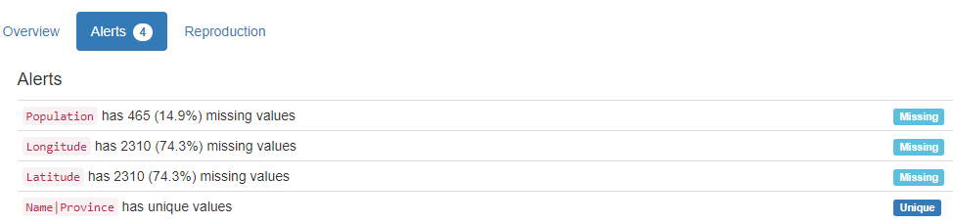

DB.table: Mondial.country – Geography – Type: Real
Name (country_name):
Country format: Error(s) found:
DQI #15 (Domain Violation - Accuracy):
1 Capitalization/Format issue(s) at index(es): [(35, 'Cote dIvoire')]

Frequency Distribution (showing top and bottom 10 of 238 countries):
Country Frequency
Afghanistan 1
Albania 1
Algeria 1
American Samoa 1
Andorra 1
Angola 1
Anguilla 1
Antigua and Barbuda 1
Argentina 1
Armenia 1
... ...
Venezuela 1
Vietnam 1
Virgin Islands 1
Wallis and Futuna 1
West Bank 1
Western Sahara 1
Yemen 1
Zaire 1
Zambia 1
Zimbabwe 1

Code (id):
Primary Key format: All 238 ID values are unique and valid, and thus suitable for use as a Primary Key.
Alphanumeric range of values: (A : ZW)

Capital:
City format: Error(s) found:
DQI #1 (Missing Data - Completeness):
2 Blank/Empty/Null/Missing value(s) at index(es): [(69, 'NULL'), (226, 'NULL')]

DQI #15 (Domain Violation - Accuracy):
6 Capitalization/Format issue(s) at index(es): [(5, 'Andorra la Vella'), (52, 'Dar es Salaam'), (118, 'Fort-de-France'), (167, 'Port-au-Prince'), (202, 'NDjamena'), (210, 'Port-of-Spain')]

Frequency Distribution (showing top and bottom 10 of 236 cities):
City Frequency
Kingston 2
NULL 2
Abu Dhabi 1
Abuja 1
Accra 1
Adamstown 1
Addis Ababa 1
Agana 1
Algier 1
Almaty 1
... ...
Washington 1
Wellington 1
West Island 1
Willemstad 1
Windhoek 1
Yamoussoukro 1
Yaounde 1
Yaren 1
Yerevan 1
Zagreb 1

Province:
State format: Error(s) found:
DQI #1 (Missing Data - Completeness):
2 Blank/Empty/Null/Missing value(s) at index(es): [(69, 'NULL'), (226, 'NULL')]

DQI #15 (Domain Violation - Accuracy):
17 Capitalization/Format issue(s) at index(es): [(2, 'Antigua and Barbuda'), (21, 'Bosnia and Herzegovina'), (30, 'Ciudad de la Habana'), (35, 'Cote dIvoire'), (85, 'Budapest (munic.)'), (101, 'Almaty (munic.)'), (104, 'Saint Kitts and Nevis'), (128, 'Maputo (munic.)'), (194, 'Saint Pierre and Miquelon'), (196, 'Sao Tome and Principe'), (197, 'al Khartum'), (201, 'Dushanbe (munic.)'), (204, 'Beijing (munic.)'), (210, 'Trinidad and Tobago'), (211, 'Turks and Caicos Islands'), (221, 'Wallis and Futuna'), (231, 'Saint Vincent and the Grenadines')]

Frequency Distribution (showing top and bottom 10 of 234 states/provinces):
State Frequency
Distrito Federal 4
NULL 2
Abu Dhabi 1
Afghanistan 1
Ahal 1
Albania 1
Algeria 1
Almaty (munic.) 1
American Samoa 1
Andorra 1
... ...
Vienna 1
Vietnam 1
Virgin Islands 1
Wallis and Futuna 1
Warszwaskie 1
Western Sahara 1
Yangon 1
Yemen 1
Zimbabwe 1
al Khartum 1

Area:
Numerical >=0 format: All 238 values are numerical and greater or equal to 0 in the range (0.44:17075200.0).

Population:
Numerical >=0 format: All 238 values are numerical and greater or equal to 0 in the range (48:1210004956).

YDATA Profiling results: It just found out that the PK column 'code' has unique values but did not find the Missing values on columns Capital (2), and province (2).

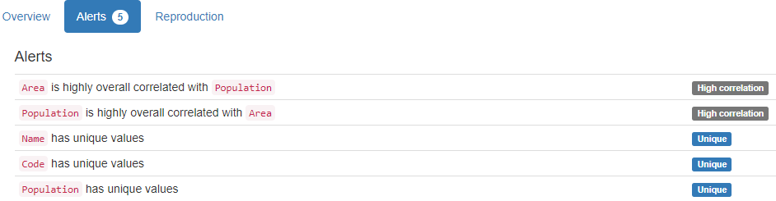

DB.table: Mondial.politics – Geography – Type: Real
Country (id):
Primary Key format: All 238 ID values are valid for use as a Foreign Key, and duplicate values are allowed.
Alphanumeric range of values: (A : ZW)

Independence (end):
Date format: Error(s) found:
DQI #1 (Missing Data - Completeness):
55 Blank/Empty/Null/Missing value(s) at index(es): [(4, 'NULL'), (5, 'NULL'), (8, 'NULL'), (10, 'NULL'), (16, 'NULL'), (27, 'NULL'), (32, 'NULL'), (34, 'NULL'), (38, 'NULL'), (40, 'NULL'), ('...', '...'), (190, 'NULL'), (194, 'NULL'), (198, 'NULL'), (204, 'NULL'), (211, 'NULL'), (218, 'NULL'), (221, 'NULL'), (226, 'NULL'), (230, 'NULL'), (232, 'NULL')] (displaying only the first and last 10 items)

DQI #6 (Outdated Temporal Data - Timeliness):
11 Date value(s) not in [1800-2100] period at index(es): [(50, '1492-01-01'), (65, '1719-01-23'), (85, '1001-01-01'), (120, '1419-01-01'), (138, '1768-01-01'), (141, '1579-01-01'), (146, '1650-01-01'), (147, '1140-01-01'), (179, '0301-01-01'), (203, '1238-01-01'), (215, '1776-07-04')]

Date range: 0301-01-01 to 2008-02-17

Dependent (id):
Foreign Key format: Error(s) found:
DQI #1 (Missing Data - Completeness):
200 Blank/Empty/Null/Missing value(s) at index(es): [(0, 'NULL'), (1, 'NULL'), (2, 'NULL'), (3, 'NULL'), (5, 'NULL'), (6, 'NULL'), (7, 'NULL'), (9, 'NULL'), (11, 'NULL'), (12, 'NULL'), ('...', '...'), (227, 'NULL'), (228, 'NULL'), (229, 'NULL'), (230, 'NULL'), (231, 'NULL'), (233, 'NULL'), (234, 'NULL'), (235, 'NULL'), (236, 'NULL'), (237, 'NULL')] (displaying only the first and last 10 items)

Note: This is a Foreign Key, so duplicate values are allowed.
Alphanumeric range of values: (AUS : USA)
References: country.Code

Government:
Categorical format: Error(s) found:
DQI #1 (Missing Data - Completeness):
3 Blank/Empty/Null/Missing value(s) at index(es): [(69, 'NULL'), (193, 'none'), (226, 'NULL')]
Categorical format with 74 unique value(s):
Category Frequency
republic 86
parliamentary democracy 20
constitutional monarchy 15
British Overseas Territories 9
federal republic 7
Communist state 5
emerging democracy 5
monarchy 4
overseas department of France 4
British crown dependency 3
... ...
republic within Commonwealth 1
republican parliamentary democracy 1
self governing parliamentary government in free association with New Zealand 1
self governing territory in free association with New Zealand 1
territory of Norway administered by the Ministry of Industry 1
theocratic republic 1
transitional government nominally a multiparty democracy with a strong presidential system 1
transitional previously ruling military junta 1
unincorporated and unorganized territory of the US 1
unitary republic 1

YDATA Profiling results: It found 2 of the 3 Missing values columns because they contain ALL NULLs. However, it did not find all Missing values for column 'Government' (2 NULL and 1 'None'). It also found that the PK column 'Country' is Unique.

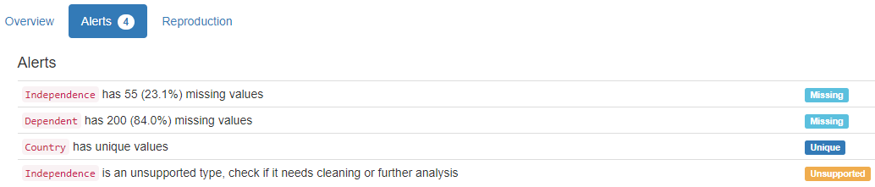

DB.table: Mondial.population – Geography – Type: Real
Country (id):
Primary Key format: All 238 ID values are valid for use as a Foreign Key, and duplicate values are allowed.
Alphanumeric range of values: (A : ZW)

Population_Growth (growth):
Numerical format: Error(s) found:
DQI #1 (Missing Data - Completeness):
9 Blank/Empty/Null/Missing value(s) at index(es): [(38, 'NULL'), (61, 'NULL'), (105, 'NULL'), (140, 'NULL'), (144, 'NULL'), (151, 'NULL'), (190, 'NULL'), (217, 'NULL'), (232, 'NULL')]

Range of values: (-3.3:16.49).

Infant_Mortality (float):
Numerical format: Error(s) found:
DQI #1 (Missing Data - Completeness):
11 Blank/Empty/Null/Missing value(s) at index(es): [(38, 'NULL'), (61, 'NULL'), (105, 'NULL'), (125, 'NULL'), (140, 'NULL'), (144, 'NULL'), (151, 'NULL'), (190, 'NULL'), (198, 'NULL'), (217, 'NULL'), (232, 'NULL')]

Range of values: (2.2:149.7).

YDATA Profiling results: It found the same 2 Missing values columns because they contain ALL NULLs. It also found that the PK column 'Country ' is Unique.

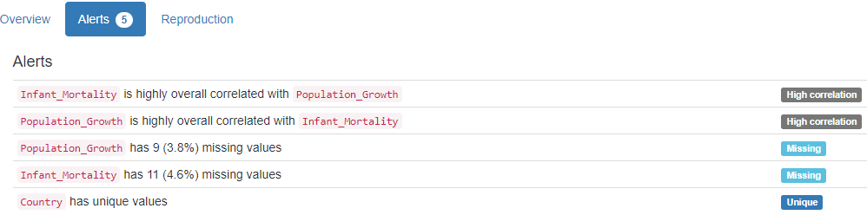

DB.table: Mondial.province – Geography – Type: Real
Name|Country (Composite Primary Key):
Composite Primary Key format: All 1450 ID values are unique and valid, and thus suitable for use as a Primary Key.
Alphanumeric range of values: (AG|CH : ash Sharqiyah|SUD)

Population:
Numerical >=0 format: All 1450 values are numerical and greater or equal to 0 in the range (0:206611600).

Area:
Numerical >=0 format: Error(s) found:
DQI #1 (Missing Data - Completeness):
210 Blank/Empty/Null/Missing value(s) at index(es): [(9, 'NULL'), (18, 'NULL'), (31, 'NULL'), (34, 'NULL'), (37, 'NULL'), (49, 'NULL'), (58, 'NULL'), (60, 'NULL'), (65, 'NULL'), (87, 'NULL'), ('...', '...'), (1350, 'NULL'), (1363, 'NULL'), (1364, 'NULL'), (1370, 'NULL'), (1375, 'NULL'), (1390, 'NULL'), (1395, 'NULL'), (1406, 'NULL'), (1421, 'NULL'), (1446, 'NULL')] (displaying only the first and last 10 items)

Range of values: (0.0:3379680.0).

Capital:
City format: Error(s) found:
DQI #1 (Missing Data - Completeness):
9 Blank/Empty/Null/Missing value(s) at index(es): [(3, 'NULL'), (17, 'NULL'), (23, 'NULL'), (94, 'NULL'), (373, 'NULL'), (457, 'NULL'), (1062, 'NULL'), (1333, 'NULL'), (1395, 'NULL')]

DQI #15 (Domain Violation - Accuracy):
22 Capitalization/Format issue(s) at index(es): [(2, 'LAquila'), (58, 'Andorra la Vella'), (93, 'ad Damir'), (264, 'NDjamena'), (266, 'Chalons en Champagne'), (339, 'Dar es Salaam'), (340, 'al Fasher'), (394, 'Shibin el Kom'), (516, 'Port-au-Prince'), (610, 'Kafr el Sheikh'), ('...', '...'), (711, 'Victoria de las Tunas'), (798, 'Fort-de-France'), (915, 's Hertogenbosch'), (941, 'Newcastle upon Tyne'), (1045, 'Dar es Salaam'), (1096, 'Rostov no Donu'), (1160, 'Usti nad Labem'), (1310, 'Port-of-Spain'), (1324, 'Newcastle upon Tyne'), (1448, 's Gravenhage')] (displaying only the first and last 10 items)

Frequency Distribution (showing top and bottom 10 of 1406 cities):
City Frequency
NULL 9
Chandigarh 3
Kingston 3
La Paz 3
Merida 3
San Juan 3
Trujillo 3
Alexandria 2
Almaty 2
Barcelona 2
... ...
Ziguinchor 1
Zonguldak 1
Zug 1
Zurich 1
Zwolle 1
ad Damir 1
al Fasher 1
al Ubayyid 1
s Gravenhage 1
s Hertogenbosch 1

CapProv (varchar):
String format: Error(s) found:
DQI #1 (Missing Data - Completeness):
9 Blank/Empty/Null/Missing value(s) at index(es): [(3, 'NULL'), (17, 'NULL'), (23, 'NULL'), (94, 'NULL'), (373, 'NULL'), (457, 'NULL'), (1062, 'NULL'), (1333, 'NULL'), (1395, 'NULL')]

String range (lexicographical): (AG : ash Sharqiyah)

YDATA Profiling results: It found only 1 of the 3 Missing values columns that contain ALL NULLs. It did not find any Missing values for columns 'Capital' and CapProv (9 NULLs each). It also found that the Composite PK column 'Name|Country' is Unique.

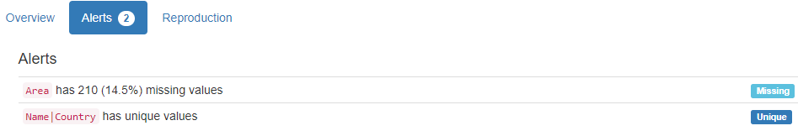

DB.table: northwind.Invoices – Retail – Type: Synth
ShipName (name):
Name format: Error(s) found:
DQI #15 (Domain Violation - Accuracy):
837 Capitalization/Format issue(s) at index(es): [(4, 'Romero y tomillo'), (5, 'Romero y tomillo'), (6, 'Romero y tomillo'), (7, 'Du monde entier'), (8, 'Du monde entier'), (16, 'Bon app-'), (17, 'Bon app-'), (18, 'Bon app-'), (19, 'LILA-Supermercado'), (20, 'LILA-Supermercado'), ('...', '...'), (2137, 'Blondel pre et fils'), (2138, 'Blondel pre et fils'), (2139, 'Blondel pre et fils'), (2141, 'QUICK-Stop'), (2142, 'QUICK-Stop'), (2143, 'QUICK-Stop'), (2144, 'QUICK-Stop'), (2148, 'Rancho grande'), (2149, 'Rancho grande'), (2154, 'Blido Comidas preparadas')] (displaying only the first and last 10 items)

Frequency Distribution:
ShipName Frequency
Save-a-lot Markets 116
Ernst Handel 102
QUICK-Stop 86
Rattlesnake Canyon Grocery 71
Hungry Owl All-Night Grocers 55
Berglunds snabbkp 52
Frankenversand 48
Folk och f HB 45
HILARION-Abastos 45
Bon app- 44
... ...
Consolidated Holdings 7
The Big Cheese 7
Blido Comidas preparadas 6
France restauration 6
North/South 6
Spcialits du monde 6
GROSELLA-Restaurante 4
Alfreds Futterkiste 3
Centro comercial Moctezuma 2
Lazy K Kountry Store 2

Range of Values: (Alfred-s Futterkiste to Wolski Zajazd)

ShipAddress (address):
Street format: Error(s) found:
DQI #15 (Domain Violation - Accuracy):
339 Capitalization/Format issue(s) at index(es): [(19, 'Carrera 52 con Ave. Bolvar #65-98 Llano Largo'), (20, 'Carrera 52 con Ave. Bolvar #65-98 Llano Largo'), (21, 'Carrera 52 con Ave. Bolvar #65-98 Llano Largo'), (22, 'ul. Filtrowa 68'), (23, 'ul. Filtrowa 68'), (39, 'Carrera 52 con Ave. Bolvar #65-98 Llano Largo'), (40, 'Carrera 52 con Ave. Bolvar #65-98 Llano Largo'), (41, 'Carrera 52 con Ave. Bolvar #65-98 Llano Largo'), (57, 'Jardim das rosas n. 32'), (58, 'Jardim das rosas n. 32'), ('...', '...'), (2047, 'Carrera 52 con Ave. Bolvar #65-98 Llano Largo'), (2079, 'Jardim das rosas n. 32'), (2087, '722 DaVinci Blvd.'), (2088, '722 DaVinci Blvd.'), (2089, '722 DaVinci Blvd.'), (2095, 'Carrera 22 con Ave. Carlos Soublette #8-35'), (2096, 'Carrera 22 con Ave. Carlos Soublette #8-35'), (2137, '24, place Klber'), (2138, '24, place Klber'), (2139, '24, place Klber')] (displaying only the first and last 10 items)

ShipCity (city):
City format: Error(s) found:
DQI #15 (Domain Violation - Accuracy):
70 Capitalization/Format issue(s) at index(es): [(42, 'rhus'), (43, 'rhus'), (44, 'rhus'), (45, 'rhus'), (46, 'rhus'), (206, 'rhus'), (207, 'rhus'), (208, 'rhus'), (283, 'rhus'), (284, 'rhus'), ('...', '...'), (1815, 'rhus'), (1863, 'Frankfurt a.M.'), (1902, 'Frankfurt a.M.'), (1903, 'Frankfurt a.M.'), (1904, 'Frankfurt a.M.'), (1911, 'rhus'), (1938, 'Frankfurt a.M.'), (1939, 'Frankfurt a.M.'), (2085, 'Frankfurt a.M.'), (2086, 'Frankfurt a.M.')] (displaying only the first and last 10 items)

Frequency Distribution (showing top and bottom 10 of 70 cities):
City Frequency
Boise 116
Graz 102
Cunewalde 86
Rio de Janeiro 83
London 82
Sao Paulo 82
Mxico D.F. 72
Albuquerque 71
Cork 55
Lule 52
... ...
San Francisco 10
Torino 10
Elgin 9
Kirkland 9
Barcelona 8
Butte 8
Vancouver 8
Paris 6
Caracas 4
Walla Walla 2

ShipRegion (region):
Categorical format: Error(s) found:
DQI #1 (Missing Data - Completeness):
1299 Blank/Empty/Null/Missing value(s) at index(es): [(0, 'NULL'), (1, 'NULL'), (2, 'NULL'), (3, 'NULL'), (4, 'NULL'), (5, 'NULL'), (6, 'NULL'), (7, 'NULL'), (8, 'NULL'), (11, 'NULL'), ('...', '...'), (2141, 'NULL'), (2142, 'NULL'), (2143, 'NULL'), (2144, 'NULL'), (2145, 'NULL'), (2146, 'NULL'), (2147, 'NULL'), (2148, 'NULL'), (2149, 'NULL'), (2154, 'NULL')]
Categorical format with 20 unique value(s):
Category Frequency
NULL 1299
SP 120
ID 116
RJ 83
NM 71
Co. Cork 55
OR 52
WA 51
Tchira 45
BC 43
Nueva Esparta 35
Lara 34
Qubec 32
Essex 30
AK 24
Isle of Wight 23
WY 20
CA 10
MT 8
DF 4

ShipPostalCode (postal code):
Postal Code format: Error(s) found:
DQI #1 (Missing Data - Completeness):
55 Blank/Empty/Null/Missing value(s) at index(es): [(277, 'NULL'), (278, 'NULL'), (279, 'NULL'), (355, 'NULL'), (356, 'NULL'), (357, 'NULL'), (461, 'NULL'), (462, 'NULL'), (563, 'NULL'), (564, 'NULL'), ('...', '...'), (1808, 'NULL'), (2064, 'NULL'), (2065, 'NULL'), (2066, 'NULL'), (2067, 'NULL'), (2092, 'NULL'), (2093, 'NULL'), (2094, 'NULL'), (2097, 'NULL'), (2098, 'NULL')] (displaying only the first and last 10 items)

ShipCountry (country):
Country format: All 2155 country values are valid.
Frequency Distribution (showing top and bottom 10 of 21 countries):
Country Frequency
USA 352
Germany 328
Brazil 203
France 184
UK 135
Austria 125
Venezuela 118
Sweden 97
Canada 75
Mexico 72
... ...
Ireland 55
Finland 54
Spain 54
Italy 53
Switzerland 52
Denmark 46
Argentina 34
Portugal 30
Norway 16
Poland 16

CustomerID (id):
ID column format: Error(s) found:
DQI #9 (Duplicates - Uniqueness):
2155 Duplicate value(s) at index(es): [[0, 'TORTU'], [1, 'TORTU'], [2, 'TORTU'], [3, 'TORTU'], [4, 'ROMEY'], [5, 'ROMEY'], [6, 'ROMEY'], [7, 'DUMON'], [8, 'DUMON'], [9, 'RATTC'], ('...', '...'), [2145, 'WARTH'], [2146, 'WARTH'], [2147, 'WARTH'], [2148, 'RANCH'], [2149, 'RANCH'], [2150, 'ISLAT'], [2151, 'ISLAT'], [2152, 'ISLAT'], [2153, 'ISLAT'], [2154, 'BOLID']] (displaying only the first and last 10 items)

DQI #19 (Uniqueness Violation - Uniqueness):
2066 Uniqueness violation(s) at index(es): [(1, 'TORTU'), (2, 'TORTU'), (3, 'TORTU'), (5, 'ROMEY'), (6, 'ROMEY'), (8, 'DUMON'), (10, 'RATTC'), (12, 'KOENE'), (13, 'KOENE'), (14, 'KOENE'), ('...', '...'), (2145, 'WARTH'), (2146, 'WARTH'), (2147, 'WARTH'), (2148, 'RANCH'), (2149, 'RANCH'), (2150, 'ISLAT'), (2151, 'ISLAT'), (2152, 'ISLAT'), (2153, 'ISLAT'), (2154, 'BOLID')] (displaying only the first and last 10 items)

Alphanumeric range of values: (ALFKI : WOLZA)

CustomerName (name):
Name format: Error(s) found:
DQI #15 (Domain Violation - Accuracy):
787 Capitalization/Format issue(s) at index(es): [(4, 'Romero y tomillo'), (5, 'Romero y tomillo'), (6, 'Romero y tomillo'), (7, 'Du monde entier'), (8, 'Du monde entier'), (16, "Bon app'"), (17, "Bon app'"), (18, "Bon app'"), (19, 'LILA-Supermercado'), (20, 'LILA-Supermercado'), ('...', '...'), (2137, 'Blondesddsl pre et fils'), (2138, 'Blondesddsl pre et fils'), (2139, 'Blondesddsl pre et fils'), (2141, 'QUICK-Stop'), (2142, 'QUICK-Stop'), (2143, 'QUICK-Stop'), (2144, 'QUICK-Stop'), (2148, 'Rancho grande'), (2149, 'Rancho grande'), (2154, 'Blido Comidas preparadas')] (displaying only the first and last 10 items)

Frequency Distribution:
CustomerName Frequency
Save-a-lot Markets 116
Ernst Handel 102
QUICK-Stop 86
Rattlesnake Canyon Grocery 71
Hungry Owl All-Night Grocers 55
Berglunds snabbkp 52
Frankenversand 48
Folk och f HB 45
HILARION-Abastos 45
Bon app' 44
... ...
The Cracker Box 8
Consolidated Holdings 7
The Big Cheese 7
Blido Comidas preparadas 6
France restauration 6
North/South 6
Spcialits du monde 6
GROSELLA-Restaurante 4
Centro comercial Moctezuma 2
Lazy K Kountry Store 2

Range of Values: (Alfreds Futterkiste to Wolski Zajazd)

Address:
Street format: Error(s) found:
DQI #15 (Domain Violation - Accuracy):
339 Capitalization/Format issue(s) at index(es): [(19, 'Carrera 52 con Ave. Bolvar #65-98 Llano Largo'), (20, 'Carrera 52 con Ave. Bolvar #65-98 Llano Largo'), (21, 'Carrera 52 con Ave. Bolvar #65-98 Llano Largo'), (22, 'ul. Filtrowa 68'), (23, 'ul. Filtrowa 68'), (39, 'Carrera 52 con Ave. Bolvar #65-98 Llano Largo'), (40, 'Carrera 52 con Ave. Bolvar #65-98 Llano Largo'), (41, 'Carrera 52 con Ave. Bolvar #65-98 Llano Largo'), (57, 'Jardim das rosas n. 32'), (58, 'Jardim das rosas n. 32'), ('...', '...'), (2047, 'Carrera 52 con Ave. Bolvar #65-98 Llano Largo'), (2079, 'Jardim das rosas n. 32'), (2087, '722 DaVinci Blvd.'), (2088, '722 DaVinci Blvd.'), (2089, '722 DaVinci Blvd.'), (2095, 'Carrera 22 con Ave. Carlos Soublette #8-35'), (2096, 'Carrera 22 con Ave. Carlos Soublette #8-35'), (2137, '24, place Klber'), (2138, '24, place Klber'), (2139, '24, place Klber')] (displaying only the first and last 10 items)

City:
City format: Error(s) found:
DQI #15 (Domain Violation - Accuracy):
70 Capitalization/Format issue(s) at index(es): [(42, 'rhus'), (43, 'rhus'), (44, 'rhus'), (45, 'rhus'), (46, 'rhus'), (206, 'rhus'), (207, 'rhus'), (208, 'rhus'), (283, 'rhus'), (284, 'rhus'), ('...', '...'), (1815, 'rhus'), (1863, 'Frankfurt a.M.'), (1902, 'Frankfurt a.M.'), (1903, 'Frankfurt a.M.'), (1904, 'Frankfurt a.M.'), (1911, 'rhus'), (1938, 'Frankfurt a.M.'), (1939, 'Frankfurt a.M.'), (2085, 'Frankfurt a.M.'), (2086, 'Frankfurt a.M.')] (displaying only the first and last 10 items)

Frequency Distribution (showing top and bottom 10 of 69 cities):
City Frequency
Boise 116
London 112
Graz 102
Cunewalde 86
Rio de Janeiro 83
Sao Paulo 82
Mxico D.F. 72
Albuquerque 71
Cork 55
Lule 52
... ...
San Francisco 10
Torino 10
Elgin 9
Kirkland 9
Barcelona 8
Butte 8
Vancouver 8
Paris 6
Caracas 4
Walla Walla 2

Region:
Categorical format: Error(s) found:
DQI #1 (Missing Data - Completeness):
1329 Blank/Empty/Null/Missing value(s) at index(es): [(0, 'NULL'), (1, 'NULL'), (2, 'NULL'), (3, 'NULL'), (4, 'NULL'), (5, 'NULL'), (6, 'NULL'), (7, 'NULL'), (8, 'NULL'), (11, 'NULL'), ('...', '...'), (2141, 'NULL'), (2142, 'NULL'), (2143, 'NULL'), (2144, 'NULL'), (2145, 'NULL'), (2146, 'NULL'), (2147, 'NULL'), (2148, 'NULL'), (2149, 'NULL'), (2154, 'NULL')]
Categorical format with 19 unique value(s):
Category Frequency
NULL 1329
SP 120
ID 116
RJ 83
NM 71
Co. Cork 55
OR 52
WA 51
Tchira 45
BC 43
Nueva Esparta 35
Lara 34
Qubec 32
AK 24
Isle of Wight 23
WY 20
CA 10
MT 8
DF 4

PostalCode (postal code):
Postal Code format: Error(s) found:
DQI #1 (Missing Data - Completeness):
55 Blank/Empty/Null/Missing value(s) at index(es): [(277, 'NULL'), (278, 'NULL'), (279, 'NULL'), (355, 'NULL'), (356, 'NULL'), (357, 'NULL'), (461, 'NULL'), (462, 'NULL'), (563, 'NULL'), (564, 'NULL'), ('...', '...'), (1808, 'NULL'), (2064, 'NULL'), (2065, 'NULL'), (2066, 'NULL'), (2067, 'NULL'), (2092, 'NULL'), (2093, 'NULL'), (2094, 'NULL'), (2097, 'NULL'), (2098, 'NULL')] (displaying only the first and last 10 items)

Country:
Country format: All 2155 country values are valid.
Frequency Distribution (showing top and bottom 10 of 21 countries):
Country Frequency
USA 352
Germany 328
Brazil 203
France 184
UK 135
Austria 125
Venezuela 118
Sweden 97
Canada 75
Mexico 72
... ...
Ireland 55
Finland 54
Spain 54
Italy 53
Switzerland 52
Denmark 46
Argentina 34
Portugal 30
Norway 16
Poland 16

Salesperson (double):
Numerical format: All 2155 values are numerical in the range (0.0:0.0).

OrderID (id):
ID column format: Error(s) found:
DQI #9 (Duplicates - Uniqueness):
2018 Duplicate value(s) at index(es): [[0, 10293], [1, 10293], [2, 10293], [3, 10293], [4, 10306], [5, 10306], [6, 10306], [7, 10311], [8, 10311], [9, 10316], ('...', '...'), [2144, 10745], [2145, 10750], [2146, 10750], [2147, 10750], [2148, 10828], [2149, 10828], [2150, 10829], [2151, 10829], [2152, 10829], [2153, 10829]] (displaying only the first and last 10 items)

DQI #19 (Uniqueness Violation - Uniqueness):
1325 Uniqueness violation(s) at index(es): [(1, 10293), (2, 10293), (3, 10293), (5, 10306), (6, 10306), (8, 10311), (10, 10316), (12, 10325), (13, 10325), (14, 10325), ('...', '...'), (2139, 10566), (2142, 10745), (2143, 10745), (2144, 10745), (2146, 10750), (2147, 10750), (2149, 10828), (2151, 10829), (2152, 10829), (2153, 10829)] (displaying only the first and last 10 items)

Numeric range of values: (10248 : 11077)

OrderDate (datetime):
Datetime format: All 2155 datetime values are valid in the YYYYMMDD format in the range 1996/07/04 00:00 to 1998/05/06 00:00.

RequiredDate (datetime):
Datetime format: All 2155 datetime values are valid in the YYYYMMDD format in the range 1996/07/24 00:00 to 1998/06/11 00:00.

ShippedDate (datetime):
Datetime format: Error(s) found:
DQI #1 (Missing Data - Completeness):
73 Blank/Empty/Null/Missing value(s) at index(es): [(217, 'NULL'), (218, 'NULL'), (219, 'NULL'), (220, 'NULL'), (223, 'NULL'), (224, 'NULL'), (225, 'NULL'), (226, 'NULL'), (227, 'NULL'), (228, 'NULL'), ('...', '...'), (1976, 'NULL'), (1977, 'NULL'), (1978, 'NULL'), (2044, 'NULL'), (2045, 'NULL'), (2046, 'NULL'), (2047, 'NULL'), (2080, 'NULL'), (2081, 'NULL'), (2082, 'NULL')] (displaying only the first and last 10 items)

ShipperName (name):
Name format: All 2155 ShipperName values are valid.

Frequency Distribution:
ShipperName Frequency
United Package 864
Speedy Express 646
Federal Shipping 645

Range of Values: (Federal Shipping to United Package)

ProductID (id):
ID column format: Error(s) found:
DQI #9 (Duplicates - Uniqueness):
2155 Duplicate value(s) at index(es): [[0, 18], [1, 24], [2, 63], [3, 75], [4, 30], [5, 53], [6, 54], [7, 42], [8, 69], [9, 41], ('...', '...'), [2145, 14], [2146, 45], [2147, 59], [2148, 20], [2149, 38], [2150, 2], [2151, 8], [2152, 13], [2153, 60], [2154, 52]] (displaying only the first and last 10 items)

DQI #19 (Uniqueness Violation - Uniqueness):
2078 Uniqueness violation(s) at index(es): [(16, 18), (17, 41), (22, 31), (27, 14), (29, 26), (30, 31), (31, 13), (32, 62), (35, 72), (40, 30), ('...', '...'), (2145, 14), (2146, 45), (2147, 59), (2148, 20), (2149, 38), (2150, 2), (2151, 8), (2152, 13), (2153, 60), (2154, 52)] (displaying only the first and last 10 items)

Numeric range of values: (1 : 77)

ProductName (name):
Name format: Error(s) found:
DQI #15 (Domain Violation - Accuracy):
377 Capitalization/Format issue(s) at index(es): [(2, 'Vegie-spread'), (10, 'Tarte au sucre'), (15, 'Mozzarella di Giovanni'), (25, 'Chartreuse verte'), (28, 'NuNuCa Nu-Nougat-Creme'), (32, 'Tarte au sucre'), (35, 'Mozzarella di Giovanni'), (41, 'Pt chinois'), (45, 'Rogede sild'), (46, 'Valkoinen suklaa'), ('...', '...'), (2067, 'Original Frankfurter grne Soe'), (2074, 'Zaanse koeken'), (2082, "Sirop d'rable"), (2083, 'NuNuCa Nu-Nougat-Creme'), (2085, 'Wimmers gute Semmelkndel'), (2087, 'Chartreuse verte'), (2089, 'Original Frankfurter grne Soe'), (2132, 'Vegie-spread'), (2144, 'Mozzarella di Giovanni'), (2146, 'Rogede sild')] (displaying only the first and last 10 items)

Frequency Distribution:
ProductName Frequency
Raclette Courdavault 54
Camembert Pierrot 51
Gorgonzola Telino 51
Guaran Fantstica 51
Gnocchi di nonna Alice 50
Tarte au sucre 48
Jack's New England Clam Chowder 47
Rhnbru Klosterbier 46
Chang 44
Pavlova 43
... ...
Grandma's Boysenberry Spread 12
Chef Anton's Gumbo Mix 10
Laughing Lumberjack Lager 10
Valkoinen suklaa 10
Schoggi Schokolade 9
Louisiana Hot Spiced Okra 8
Chocolade 6
Genen Shouyu 6
Gravad lax 6
Mishi Kobe Niku 5

Range of Values: (Alice Mutton to Zaanse koeken)

UnitPrice (price):
Numerical format: All 2155 values are numerical in the range (2.0:263.5).

Quantity:
Numerical format: All 2155 values are numerical in the range (1:130).

Discount (double):
Numerical format: All 2155 values are numerical in the range (0.0:0.0).

ExtendedPrice (price):
Numerical format: All 2155 values are numerical in the range (4.8:15810.0).

Freight (decimal):
Numerical format: All 2155 values are numerical in the range (0.02:1007.64).

YDATA Profiling results: It found the same 5 Missing values columns because they contain ALL NULLs. It also found that the columns 'Salesperson' and 'Discount' have constant value "0", and it did not find any Unique values because there is no PK in this table:

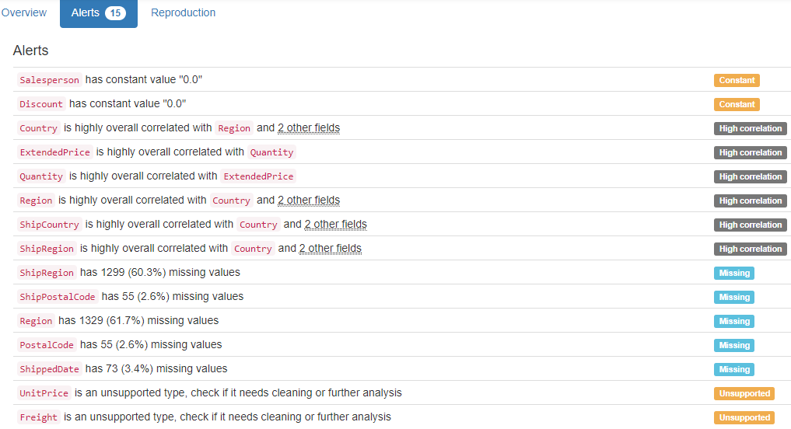

DB.table: northwind.Order Details Extended – Retail – Type: Synth – This is a Query, not a Table.
OrderID (id):
ID column format: Error(s) found:
DQI #9 (Duplicates - Uniqueness):
2018 Duplicate value(s) at index(es): [[0, 10265], [2, 10294], [3, 10302], [4, 10319], [5, 10338], [6, 10339], [7, 10346], [8, 10415], [9, 10430], [10, 10431], ('...', '...'), [2144, 10685], [2146, 10710], [2147, 10714], [2148, 10755], [2149, 10762], [2150, 10837], [2151, 10875], [2152, 10928], [2153, 10956], [2154, 10977]] (displaying only the first and last 10 items)

DQI #19 (Uniqueness Violation - Uniqueness):
1325 Uniqueness violation(s) at index(es): [(56, 10431), (69, 10607), (93, 10294), (116, 10658), (117, 10684), (119, 10728), (120, 10742), (126, 10895), (137, 11059), (140, 11077), ('...', '...'), (2144, 10685), (2146, 10710), (2147, 10714), (2148, 10755), (2149, 10762), (2150, 10837), (2151, 10875), (2152, 10928), (2153, 10956), (2154, 10977)] (displaying only the first and last 10 items)

Numeric range of values: (10248 : 11077)

ProductID (id):
ID column format: Error(s) found:
DQI #9 (Duplicates - Uniqueness):
2155 Duplicate value(s) at index(es): [[0, 17], [1, 17], [2, 17], [3, 17], [4, 17], [5, 17], [6, 17], [7, 17], [8, 17], [9, 17], ('...', '...'), [2145, 47], [2146, 47], [2147, 47], [2148, 47], [2149, 47], [2150, 47], [2151, 47], [2152, 47], [2153, 47], [2154, 47]] (displaying only the first and last 10 items)

DQI #19 (Uniqueness Violation - Uniqueness):
2078 Uniqueness violation(s) at index(es): [(1, 17), (2, 17), (3, 17), (4, 17), (5, 17), (6, 17), (7, 17), (8, 17), (9, 17), (10, 17), ('...', '...'), (2145, 47), (2146, 47), (2147, 47), (2148, 47), (2149, 47), (2150, 47), (2151, 47), (2152, 47), (2153, 47), (2154, 47)] (displaying only the first and last 10 items)

Numeric range of values: (1 : 77)

ProductName (name):
Name format: Error(s) found:
DQI #15 (Domain Violation - Accuracy):
377 Capitalization/Format issue(s) at index(es): [(250, 'Chartreuse verte'), (251, 'Chartreuse verte'), (252, 'Chartreuse verte'), (253, 'Chartreuse verte'), (254, 'Chartreuse verte'), (255, 'Chartreuse verte'), (256, 'Chartreuse verte'), (257, 'Chartreuse verte'), (258, 'Chartreuse verte'), (259, 'Chartreuse verte'), ('...', '...'), (2145, 'Zaanse koeken'), (2146, 'Zaanse koeken'), (2147, 'Zaanse koeken'), (2148, 'Zaanse koeken'), (2149, 'Zaanse koeken'), (2150, 'Zaanse koeken'), (2151, 'Zaanse koeken'), (2152, 'Zaanse koeken'), (2153, 'Zaanse koeken'), (2154, 'Zaanse koeken')] (displaying only the first and last 10 items)

Frequency Distribution:
ProductName Frequency
Raclette Courdavault 54
Camembert Pierrot 51
Gorgonzola Telino 51
Guaran Fantstica 51
Gnocchi di nonna Alice 50
Tarte au sucre 48
Jack's New England Clam Chowder 47
Rhnbru Klosterbier 46
Chang 44
Pavlova 43
... ...
Grandma's Boysenberry Spread 12
Chef Anton's Gumbo Mix 10
Laughing Lumberjack Lager 10
Valkoinen suklaa 10
Schoggi Schokolade 9
Louisiana Hot Spiced Okra 8
Chocolade 6
Genen Shouyu 6
Gravad lax 6
Mishi Kobe Niku 5

Range of Values: (Alice Mutton to Zaanse koeken)

UnitPrice (price):
Numerical format: All 2155 values are numerical in the range (2.0:263.5).

Quantity:
Numerical format: All 2155 values are numerical in the range (1:130).

Discount (double):
Numerical format: All 2155 values are numerical in the range (0.0:0.0).

ExtendedPrice (price):
Numerical format: All 2155 values are numerical in the range (4.8:15810.0).

YDATA Profiling results: It just found that the columns 'Discount' has constant value "0", and it did not find any Unique values because there is no PK in this view:

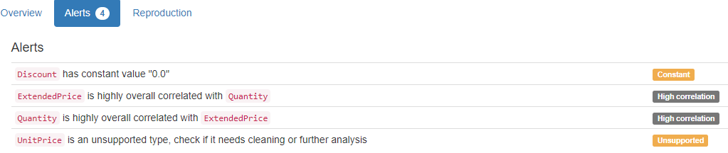

DB.table: northwind.Orders – Retail – Type: Synth
OrderID (id):
Primary Key format: All 830 ID values are unique and valid, and thus suitable for use as a Primary Key.
Numeric range of values: (10248 : 11077)

CustomerID (id):
Foreign Key format: All 830 ID values are valid for use as a Foreign Key, and duplicate values are allowed.
Alphanumeric range of values: (ALFKI : WOLZA)
References: Customers.CustomerID

EmployeeID (id):
Foreign Key format: All 830 ID values are valid for use as a Foreign Key, and duplicate values are allowed.
Numeric range of values: (1 : 9)
References: Employees.EmployeeID

OrderDate (datetime):
Datetime format: All 830 datetime values are valid in the YYYYMMDD format in the range 1996/07/04 00:00 to 1998/05/06 00:00.

RequiredDate (datetime):
Datetime format: All 830 datetime values are valid in the YYYYMMDD format in the range 1996/07/24 00:00 to 1998/06/11 00:00.

ShippedDate (datetime):
Datetime format: Error(s) found:
DQI #1 (Missing Data - Completeness):
21 Blank/Empty/Null/Missing value(s) at index(es): [(760, 'NULL'), (771, 'NULL'), (791, 'NULL'), (792, 'NULL'), (797, 'NULL'), (803, 'NULL'), (806, 'NULL'), (810, 'NULL'), (811, 'NULL'), (813, 'NULL'), ('...', '...'), (817, 'NULL'), (820, 'NULL'), (822, 'NULL'), (823, 'NULL'), (824, 'NULL'), (825, 'NULL'), (826, 'NULL'), (827, 'NULL'), (828, 'NULL'), (829, 'NULL')] (displaying only the first and last 10 items)

ShipVia (id):
Foreign Key format: All 830 ID values are valid for use as a Foreign Key, and duplicate values are allowed.
Numeric range of values: (1 : 3)
References: Shippers.ShipperID

Freight (decimal):
Numerical format: All 830 values are numerical in the range (0.02:1007.64).

ShipName (name):
Name format: Error(s) found:
DQI #15 (Domain Violation - Accuracy):
319 Capitalization/Format issue(s) at index(es): [(0, 'Vins et alcools Chevalier'), (3, 'Victuailles en stock'), (4, 'Suprmes dlices'), (6, 'Chop-suey Chinese'), (9, 'HILARION-Abastos'), (11, 'Centro comercial Moctezuma'), (16, 'Folk och f HB'), (17, 'Blondel pre et fils'), (20, 'GROSELLA-Restaurante'), (25, 'QUICK-Stop'), ('...', '...'), (805, 'Piccolo und mehr'), (806, 'Cactus Comidas para llevar'), (807, 'HILARION-Abastos'), (812, 'Franchi S.p.A.'), (816, 'Save-a-lot Markets'), (817, 'LILA-Supermercado'), (823, 'LILA-Supermercado'), (825, 'Pericles Comidas clsicas'), (826, 'Simons bistro'), (828, 'Bon app-')] (displaying only the first and last 10 items)

Frequency Distribution:
ShipName Frequency
Save-a-lot Markets 31
Ernst Handel 30
QUICK-Stop 28
Folk och f HB 19
Hungry Owl All-Night Grocers 19
Berglunds snabbkp 18
HILARION-Abastos 18
Rattlesnake Canyon Grocery 18
Bon app- 17
Frankenversand 15
... ...
Consolidated Holdings 3
France restauration 3
Laughing Bacchus Wine Cellars 3
North/South 3
The Cracker Box 3
Trail-s Head Gourmet Provisioners 3
GROSELLA-Restaurante 2
Lazy K Kountry Store 2
Alfreds Futterkiste 1
Centro comercial Moctezuma 1

Range of Values: (Alfred-s Futterkiste to Wolski Zajazd)

ShipAddress (address):
Street format: Error(s) found:
DQI #15 (Domain Violation - Accuracy):
137 Capitalization/Format issue(s) at index(es): [(0, '59 rue de l-Abbaye'), (9, 'Carrera 22 con Ave. Carlos Soublette #8-35'), (16, 'kergatan 24'), (17, '24, place Klber'), (26, '59 rue de l-Abbaye'), (27, 'Via Ludovico il Moro 22'), (35, 'Carrera 52 con Ave. Bolvar #65-98 Llano Largo'), (42, 'Av. dos Lusadas, 23'), (47, '59 rue de l-Abbaye'), (48, 'Carrera 52 con Ave. Bolvar #65-98 Llano Largo'), ('...', '...'), (753, 'kergatan 24'), (759, 'Estrada da sade n. 58'), (767, 'Erling Skakkes gate 78'), (794, 'Av. dos Lusadas, 23'), (796, 'ul. Filtrowa 68'), (802, 'kergatan 24'), (807, 'Carrera 22 con Ave. Carlos Soublette #8-35'), (817, 'Carrera 52 con Ave. Bolvar #65-98 Llano Largo'), (820, 'Alameda dos Canrios, 891'), (823, 'Carrera 52 con Ave. Bolvar #65-98 Llano Largo')] (displaying only the first and last 10 items)

ShipCity (city):
City format: Error(s) found:
DQI #15 (Domain Violation - Accuracy):
26 Capitalization/Format issue(s) at index(es): [(31, 'Frankfurt a.M.'), (36, 'Frankfurt a.M.'), (95, 'Frankfurt a.M.'), (119, 'rhus'), (151, 'rhus'), (217, 'rhus'), (249, 'Frankfurt a.M.'), (274, 'Frankfurt a.M.'), (286, 'Frankfurt a.M.'), (288, 'Frankfurt a.M.'), ('...', '...'), (496, 'rhus'), (521, 'rhus'), (524, 'Frankfurt a.M.'), (614, 'Frankfurt a.M.'), (643, 'Frankfurt a.M.'), (673, 'rhus'), (686, 'Frankfurt a.M.'), (698, 'rhus'), (746, 'rhus'), (822, 'Frankfurt a.M.')] (displaying only the first and last 10 items)

Frequency Distribution (showing top and bottom 10 of 70 cities):
City Frequency
Rio de Janeiro 34
London 33
Boise 31
Sao Paulo 31
Graz 30
Cunewalde 28
Mxico D.F. 28
Brcke 19
Cork 19
Albuquerque 18
... ...
Lille 5
Reims 5
Paris 4
San Francisco 4
Versailles 4
Butte 3
Kirkland 3
Vancouver 3
Caracas 2
Walla Walla 2

ShipRegion (region):
Categorical format: Error(s) found:
DQI #1 (Missing Data - Completeness):
507 Blank/Empty/Null/Missing value(s) at index(es): [(0, 'NULL'), (1, 'NULL'), (3, 'NULL'), (4, 'NULL'), (6, 'NULL'), (7, 'NULL'), (10, 'NULL'), (11, 'NULL'), (12, 'NULL'), (15, 'NULL'), ('...', '...'), (812, 'NULL'), (814, 'NULL'), (819, 'NULL'), (821, 'NULL'), (822, 'NULL'), (824, 'NULL'), (825, 'NULL'), (826, 'NULL'), (827, 'NULL'), (828, 'NULL')]
Categorical format with 20 unique value(s):
Category Frequency
NULL 507
SP 49
RJ 34
ID 31
OR 28
Co. Cork 19
WA 19
NM 18
Tchira 18
BC 17
Lara 14
Essex 13
Qubec 13
Nueva Esparta 12
AK 10
Isle of Wight 10
WY 9
CA 4
MT 3
DF 2

ShipPostalCode (postal code):
Postal Code format: Error(s) found:
DQI #1 (Missing Data - Completeness):
19 Blank/Empty/Null/Missing value(s) at index(es): [(50, 'NULL'), (61, 'NULL'), (87, 'NULL'), (125, 'NULL'), (132, 'NULL'), (181, 'NULL'), (255, 'NULL'), (268, 'NULL'), (319, 'NULL'), (398, 'NULL'), (413, 'NULL'), (439, 'NULL'), (453, 'NULL'), (464, 'NULL'), (488, 'NULL'), (649, 'NULL'), (664, 'NULL'), (737, 'NULL'), (815, 'NULL')]

ShipCountry (country):
Country format: All 830 country values are valid.
Frequency Distribution (showing top and bottom 10 of 21 countries):
Country Frequency
Germany 122
USA 122
Brazil 83
France 77
UK 56
Venezuela 46
Austria 40
Sweden 37
Canada 30
Italy 28
... ...
Spain 23
Finland 22
Belgium 19
Ireland 19
Denmark 18
Switzerland 18
Argentina 16
Portugal 13
Poland 7
Norway 6

YDATA Profiling results: It found the same 3 Missing values columns because they contain ALL NULLs. It also found that the PK column 'OrderID' is unique and uniformly distributed.

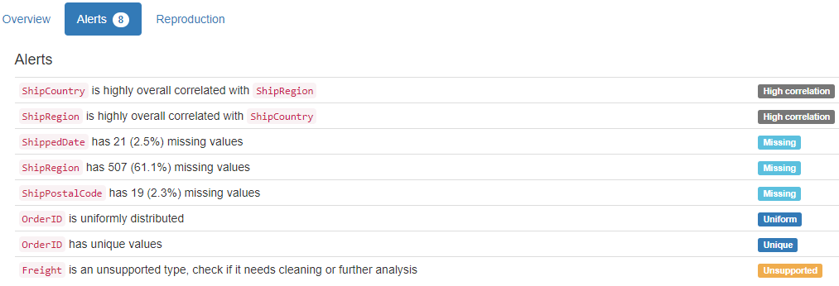

DB.table: northwind.Products – Retail – Type: Synth
ProductID (id):
Primary Key format: All 77 ID values are unique and valid, and thus suitable for use as a Primary Key.
Numeric range of values: (1 : 77)

ProductName (name):
Name format: Error(s) found:
DQI #15 (Domain Violation - Accuracy):
14 Capitalization/Format issue(s) at index(es): [(24, 'NuNuCa Nu-Nougat-Creme'), (36, 'Gravad lax'), (38, 'Chartreuse verte'), (44, 'Rogede sild'), (46, 'Zaanse koeken'), (49, 'Valkoinen suklaa'), (54, 'Pt chinois'), (55, 'Gnocchi di nonna Alice'), (60, "Sirop d'rable"), (61, 'Tarte au sucre'), (62, 'Vegie-spread'), (63, 'Wimmers gute Semmelkndel'), (71, 'Mozzarella di Giovanni'), (76, 'Original Frankfurter grne Soe')]

Frequency Distribution:
ProductName Frequency
Alice Mutton 1
Aniseed Syrup 1
Boston Crab Meat 1
Camembert Pierrot 1
Carnarvon Tigers 1
Chai 1
Chang 1
Chartreuse verte 1
Chef Anton's Cajun Seasoning 1
Chef Anton's Gumbo Mix 1
... ...
Teatime Chocolate Biscuits 1
Thringer Rostbratwurst 1
Tofu 1
Tourtire 1
Tunnbrd 1
Uncle Bob's Organic Dried Pears 1
Valkoinen suklaa 1
Vegie-spread 1
Wimmers gute Semmelkndel 1
Zaanse koeken 1

Range of Values: (Alice Mutton to Zaanse koeken)

SupplierID (id):
Foreign Key format: All 77 ID values are valid for use as a Foreign Key, and duplicate values are allowed.
Numeric range of values: (1 : 29)
References: Suppliers.SupplierID

CategoryID (id):
Foreign Key format: All 77 ID values are valid for use as a Foreign Key, and duplicate values are allowed.
Numeric range of values: (1 : 8)
References: Categories.CategoryID

QuantityPerUnit (quantity):
Numerical format: Error(s) found:
DQI #17 (Wrong Data Type - Consistency):
77 Non-numeric value(s) at index(es): [(0, '10 boxes x 20 bags'), (1, '24 - 12 oz bottles'), (2, '12 - 550 ml bottles'), (3, '48 - 6 oz jars'), (4, '36 boxes'), (5, '12 - 8 oz jars'), (6, '12 - 1 lb pkgs.'), (7, '12 - 12 oz jars'), (8, '18 - 500 g pkgs.'), (9, '12 - 200 ml jars'), ('...', '...'), (67, '10 boxes x 8 pieces'), (68, '10 kg pkg.'), (69, '24 - 355 ml bottles'), (70, '10 - 500 g pkgs.'), (71, '24 - 200 g pkgs.'), (72, '24 - 150 g jars'), (73, '5 kg pkg.'), (74, '24 - 0.5 l bottles'), (75, '500 ml'), (76, '12 boxes')] (displaying only the first and last 10 items)
No valid numeric values found.

UnitPrice (price):
Numerical format: All 77 values are numerical in the range (2.5:263.5).

UnitsInStock (stock):
Numerical format: All 77 values are numerical in the range (0:125).

UnitsOnOrder (units):
Numerical format: All 77 values are numerical in the range (0:100).

ReorderLevel (level):
Categorical format: All 77 values are correctly categorical.

Categorical format with 7 unique value(s):
Category Frequency
0 24
25 12
15 10
5 8
20 8
30 8
10 7

Discontinued (tinyint):
Numerical format: All 77 values are numerical in the range (0:1).

YDATA Profiling results: It just found out that the PK column ' ProductID' has unique values and is uniformly distributed:
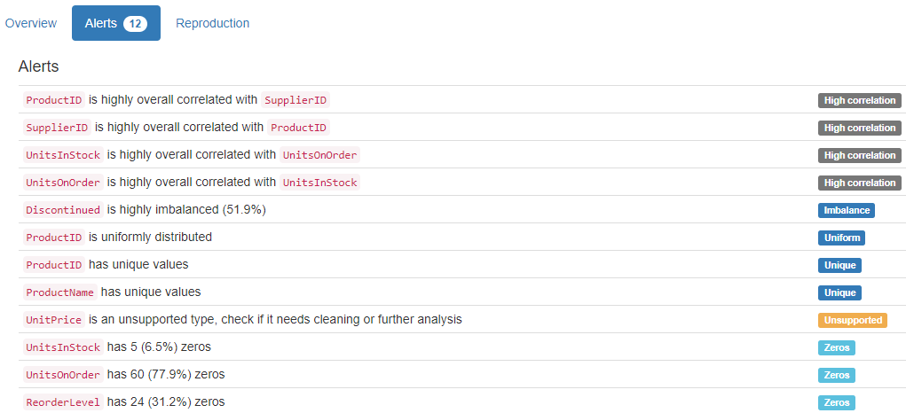

DB.table: northwind.Suppliers – Retail – Type: Synth
SupplierID (id):
Primary Key format: All 29 ID values are unique and valid, and thus suitable for use as a Primary Key.
Numeric range of values: (1 : 29)

CompanyName (name):
Name format: Error(s) found:
DQI #15 (Domain Violation - Accuracy):
8 Capitalization/Format issue(s) at index(es): [(10, 'Heli Swaren GmbH & Co. KG'), (12, 'Nord-Ost-Fisch Handelsgesellschaft mbH'), (13, 'Formaggi Fortini s.r.l.'), (17, 'Aux joyeux ecclsiastiques'), (23, "G'day, Mate"), (25, 'Pasta Buttini s.r.l.'), (27, 'Gai pturage'), (28, "Forts d'rables")]

Frequency Distribution:
CompanyName Frequency
Aux joyeux ecclsiastiques 1
Bigfoot Breweries 1
Cooperativa de Quesos 'Las Cabras' 1
Escargots Nouveaux 1
Exotic Liquids 1
Formaggi Fortini s.r.l. 1
Forts d'rables 1
G'day, Mate 1
Gai pturage 1
Grandma Kelly's Homestead 1
... ...
Norske Meierier 1
PB Knckebrd AB 1
Pasta Buttini s.r.l. 1
Pavlova, Ltd. 1
Plutzer Lebensmittelgromrkte AG 1
Refrescos Americanas LTDA 1
Specialty Biscuits, Ltd. 1
Svensk Sjfda AB 1
Tokyo Traders 1
Zaanse Snoepfabriek 1

Range of Values: (Aux joyeux ecclsiastiques to Zaanse Snoepfabriek)

ContactName (name):
Name format: All 29 ContactName values are valid.

Frequency Distribution:
ContactName Frequency
Anne Heikkonen 1
Antonio del Valle Saavedra 1
Beate Vileid 1
Carlos Diaz 1
Chandra Leka 1
Chantal Goulet 1
Charlotte Cooper 1
Cheryl Saylor 1
Dirk Luchte 1
Eliane Noz 1
... ...
Michael Bjrn 1
Niels Petersen 1
Peter Wilson 1
Petra Winkler 1
Regina Murphy 1
Robb Merchant 1
Shelley Burke 1
Sven Petersen 1
Wendy Mackenzie 1
Yoshi Nagase 1

Range of Values: (Anne Heikkonen to Yoshi Nagase)

ContactTitle (title):
Categorical format: All 29 values are correctly categorical.

Categorical format with 15 unique value(s):
Category Frequency
Sales Representative 6
Marketing Manager 5
Sales Manager 4
Accounting Manager 2
Order Administrator 2
Coordinator Foreign Markets 1
Export Administrator 1
International Marketing Mgr. 1
Marketing Representative 1
Owner 1
Product Manager 1
Purchasing Manager 1
Regional Account Rep. 1
Sales Agent 1
Wholesale Account Agent 1

Address:
Street format: Error(s) found:
DQI #5 (Extraneous Data - Consistency, Uniqueness):
9 Extraneous street data value(s) at index(es): [(3, '9-8 Sekimai\r\nMusashino-shi'), (5, '92 Setsuko\r\nChuo-ku'), (6, '74 Rose St.\r\nMoonie Ponds'), (15, '3400 - 8th Avenue\r\nSuite 210'), (18, 'Order Processing Dept.\r\n2100 Paul Revere Blvd.'), (20, 'Lyngbysild\r\nFiskebakken 10'), (21, 'Verkoop\r\nRijnweg 22'), (23, "170 Prince Edward Parade\r\nHunter's Hill"), (27, 'Bat. B\r\n3, rue des Alpes')]

DQI #15 (Domain Violation - Accuracy):
2 Capitalization/Format issue(s) at index(es): [(12, 'Frahmredder 112a'), (25, 'Via dei Gelsomini, 153')]

City:
City format: All 29 city values are valid.

Frequency Distribution (showing top and bottom 10 of 29 cities):
City Frequency
Ann Arbor 1
Annecy 1
Bend 1
Berlin 1
Boston 1
Cuxhaven 1
Frankfurt 1
Gteborg 1
Lappeenranta 1
London 1
... ...
Ravenna 1
Salerno 1
Sandvika 1
Singapore 1
So Paulo 1
Ste-Hyacinthe 1
Stockholm 1
Sydney 1
Tokyo 1
Zaandam 1

Region:
Categorical format: Error(s) found:
DQI #1 (Missing Data - Completeness):
20 Blank/Empty/Null/Missing value(s) at index(es): [(0, 'NULL'), (3, 'NULL'), (5, 'NULL'), (7, 'NULL'), (8, 'NULL'), (9, 'NULL'), (10, 'NULL'), (11, 'NULL'), (12, 'NULL'), (13, 'NULL'), (14, 'NULL'), (16, 'NULL'), (17, 'NULL'), (19, 'NULL'), (20, 'NULL'), (21, 'NULL'), (22, 'NULL'), (25, 'NULL'), (26, 'NULL'), (27, 'NULL')]
Categorical format with 9 unique value(s):
Category Frequency
NULL 20
Qubec 2
Asturias 1
LA 1
MA 1
MI 1
NSW 1
OR 1
Victoria 1

PostalCode (postal code):
Postal Code format: Error(s) found:
DQI #15 (Domain Violation - Accuracy):
2 Short length alphanumeric value(s) at index(es): [(3, '100'), (5, '545')]

Country:
Country format: All 29 country values are valid.
Frequency Distribution:
Country Frequency
USA 4
France 3
Germany 3
Australia 2
Canada 2
Italy 2
Japan 2
Sweden 2
UK 2
Brazil 1
Denmark 1
Finland 1
Netherlands 1
Norway 1
Singapore 1
Spain 1

Phone:
Phone format: Error(s) found:
DQI #15 (Domain Violation - Accuracy):
3 Incorrect telephone number format issue(s) at index(es): [(17, '(1) 03.83.00.68'), (26, '85.57.00.07'), (27, '38.76.98.06')]

Fax:
Phone format: Error(s) found:
DQI #1 (Missing Data - Completeness):
16 Blank/Empty/Null/Missing value(s) at index(es): [(0, 'NULL'), (1, 'NULL'), (3, 'NULL'), (4, 'NULL'), (5, 'NULL'), (7, 'NULL'), (9, 'NULL'), (10, 'NULL'), (11, 'NULL'), (14, 'NULL'), (15, 'NULL'), (16, 'NULL'), (19, 'NULL'), (22, 'NULL'), (24, 'NULL'), (26, 'NULL')]

DQI #15 (Domain Violation - Accuracy):
2 Incorrect telephone number format issue(s) at index(es): [(17, '(1) 03.83.00.62'), (27, '38.76.98.58')]

HomePage (home page):
URL format: Error(s) found:
DQI #1 (Missing Data - Completeness):
24 Blank/Empty/Null/Missing value(s) at index(es): [(0, 'NULL'), (2, 'NULL'), (3, 'NULL'), (4, 'NULL'), (6, 'NULL'), (7, 'NULL'), (8, 'NULL'), (9, 'NULL'), (10, 'NULL'), (12, 'NULL'), ('...', '...'), (18, 'NULL'), (19, 'NULL'), (20, 'NULL'), (21, 'NULL'), (22, 'NULL'), (24, 'NULL'), (25, 'NULL'), (26, 'NULL'), (27, 'NULL'), (28, 'NULL')] (displaying only the first and last 10 items)

DQI #15 (Domain Violation - Accuracy):
5 Invalid URL format issue(s) at index(es): [(1, '#CAJUN.HTM#'), (5, "Mayumi's (on the World Wide Web)#http://www.microsoft.com/accessdev/sampleapps/mayumi.htm#"), (11, 'Plutzer (on the World Wide Web)#http://www.microsoft.com/accessdev/sampleapps/plutzer.htm#'), (13, '#FORMAGGI.HTM#'), (23, "G'day Mate (on the World Wide Web)#http://www.microsoft.com/accessdev/sampleapps/gdaymate.htm#")]

YDATA Profiling results: It found the same 3 Missing values columns because they contain ALL NULLs. It also found that the PK column 'SupplierID' is unique and is uniformly distributed.

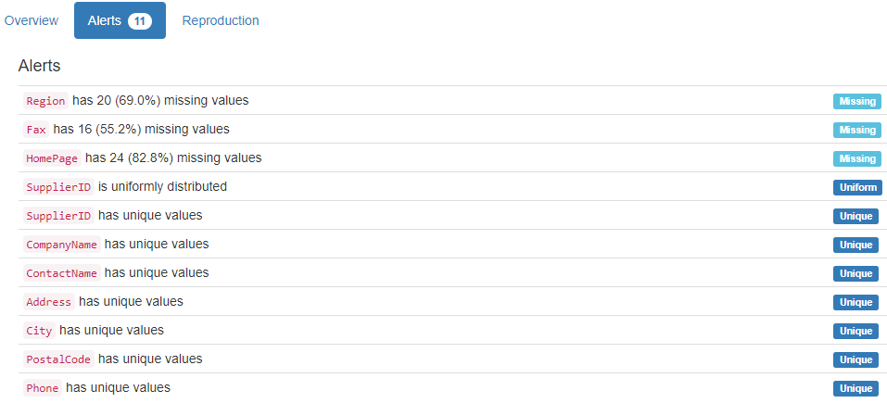

DB.table: PTE.pte_atm – Medicine – Type: Real
drug_id (id):
Foreign Key format: Error(s) found:
DQI #17 (Wrong Data Type - Consistency):
2593 Inconsistent length in alphanumeric value(s) at index(es): [(307, 'd10'), (308, 'd10'), (309, 'd10'), (310, 'd10'), (311, 'd10'), (312, 'd10'), (313, 'd10'), (314, 'd10'), (315, 'd10'), (316, 'd10'), ('...', '...'), (9179, 'd9'), (9180, 'd9'), (9181, 'd9'), (9182, 'd9'), (9183, 'd9'), (9184, 'd9'), (9185, 'd9'), (9186, 'd9'), (9187, 'd9'), (9188, 'd9')] (displaying only the first and last 10 items)

Note: This is a Foreign Key, so duplicate values are allowed.
Alphanumeric range of values: (d1 : d99)
References: pte_drug.drug_id

atom_id (id):
Primary Key format: All 9189 ID values are unique and valid, and thus suitable for use as a Primary Key.
Alphanumeric range of values: (d100_1 : d9_9)

atom_type (type):
Categorical format: All 9189 values are correctly categorical.

Categorical format with 24 unique value(s):
Category Frequency
h 4101
c 3471
o 734
n 394
cl 281
s 96
br 45
p 24
na 16
f 7
... ...
as 1
ba 1
ca 1
hg 1
k 1
mn 1
pb 1
se 1
te 1
zn 1

Arg3 (varchar):
String format: All 9189 string values are valid.
String range (lexicographical): (1 : 96)

Arg4 (decimal):
Numerical format: All 9189 values are numerical in the range (-0.812:2.007).

YDATA Profiling results: It just found out that the PK column 'atom_id' has unique values:

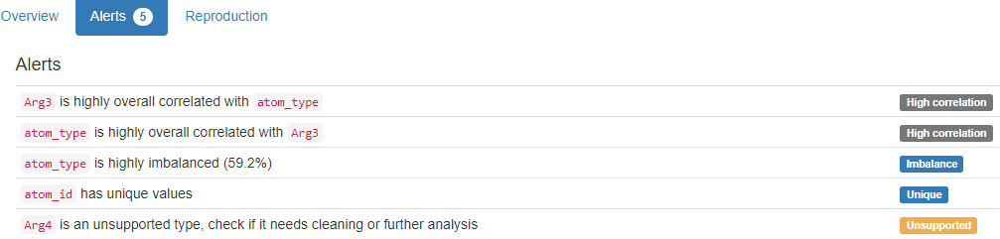

DB.table: PTE.pte_drug – Medicine – Type: Real
drug_id (id):
Primary Key format: All 340 ID values are unique and valid, and thus suitable for use as a Primary Key.
Alphanumeric range of values: (d1 : d99)
YDATA Profiling results: It just found out that the PK column 'drug_id' has unique values:
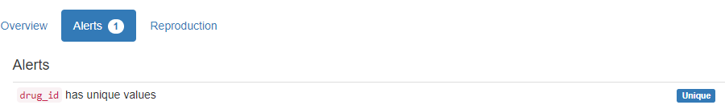

DB.table: sakila.address – Retail – Type: Synth
address_id (id):
Primary Key format: All 603 ID values are unique and valid, and thus suitable for use as a Primary Key.
Numeric range of values: (1 : 605)

address:
Street format: Error(s) found:
DQI #5 (Extraneous Data - Consistency, Uniqueness):
15 Extraneous street data value(s) at index(es): [(24, '262 A Corua (La Corua) Parkway'), (36, '127 Purnea (Purnia) Manor'), (39, '334 Munger (Monghyr) Lane'), (57, '1964 Allappuzha (Alleppey) Street'), (75, '89 Allappuzha (Alleppey) Manor'), (202, '1149 A Corua (La Corua) Boulevard'), (222, '1244 Allappuzha (Alleppey) Place'), (225, '810 Palghat (Palakkad) Boulevard'), (240, '647 A Corua (La Corua) Street'), (325, '1427 A Corua (La Corua) Place'), (473, '434 Ourense (Orense) Manor'), (518, '568 Dhule (Dhulia) Loop'), (521, '680 A Corua (La Corua) Manor'), (526, '600 Purnea (Purnia) Avenue'), (563, '1229 Varanasi (Benares) Manor')]

DQI #15 (Domain Violation - Accuracy):
14 Capitalization/Format issue(s) at index(es): [(0, '47 MySakila Drive'), (1, '28 MySQL Boulevard'), (185, '533 al-Ayn Boulevard'), (198, '1792 Valle de la Pascua Place'), (209, '1304 s-Hertogenbosch Way'), (283, '1006 Santa Brbara dOeste Manor'), (340, '124 al-Manama Way'), (364, '114 Jalib al-Shuyukh Manor'), (378, '1519 Santiago de los Caballeros Loop'), (423, '1866 al-Qatif Avenue'), (494, '775 ostka Drive'), (509, '1152 al-Qatif Lane'), (525, '1176 Southend-on-Sea Manor'), (552, '1764 Jalib al-Shuyukh Parkway')]

address2 (address):
Street format: Error(s) found:
DQI #1 (Missing Data - Completeness):
603 Blank/Empty/Null/Missing value(s) at index(es):
4 NULL values: [(0, 'NULL'), (1, 'NULL'), (2, 'NULL'), (3, 'NULL')]
599 Non-NULL values: [ 4, 'Empty'), (5, 'Empty'), (6, 'Empty'), (7, 'Empty'), (8, 'Empty'), (9, 'Empty'), ('...', '...'), (593, 'Empty'), (594, 'Empty'), (595, 'Empty'), (596, 'Empty'), (597, 'Empty'), (598, 'Empty'), (599, 'Empty'), (600, 'Empty'), (601, 'Empty'), (602, 'Empty')] (displaying only the first and last 10 items)
Frequency Distribution:
Street Frequency
Empty 599
NULL 4

Range of Values: ( to None)

district:
Categorical format: Error(s) found:
DQI #1 (Missing Data - Completeness):
3 Blank/Empty/Null/Missing value(s) at index(es):
3 Non-NULL values: [(29, 'Empty'), (384, 'Empty'), (516, 'Empty')]

DQI #10 (Structural Conflicts - Consistency, Uniqueness):
Data seems not categorical or has too many categories (> 100).
Categorical format with 378 unique value(s):
Category Frequency
Buenos Aires 10
California 9
Shandong 9
West Bengali 9
So Paulo 8
Uttar Pradesh 8
England 7
Maharashtra 7
Southern Tagalog 6
Gois 5
... ...
Wielkopolskie 1
Yerevan 1
Ynlin 1
Zanzibar West 1
Ziguinchor 1
Zufar 1
Zulia 1
al-Daqahliya 1
al-Manama 1
al-Qadarif 1

city_id (id):
Foreign Key format: All 603 ID values are valid for use as a Foreign Key, and duplicate values are allowed.
Numeric range of values: (1 : 600)
References: city.city_id

postal_code (postal code):
Postal Code format: Error(s) found:
DQI #1 (Missing Data - Completeness):
4 Blank/Empty/Null/Missing value(s) at index(es): [(0, 'Empty'), (1, 'Empty'), (2, 'Empty'), (3, 'Empty')]

DQI #15 (Domain Violation - Accuracy):
6 Short length alphanumeric value(s) at index(es): [(344, '504'), (397, '966'), (443, '3'), (520, '400'), (551, '841'), (574, '943')]

phone:
Phone format: Error(s) found:
DQI #1 (Missing Data - Completeness):
2 Blank/Empty/Null/Missing value(s) at index(es): [(0, 'Empty'), (1, 'Empty')]

last_update (timestamp):
Datetime format: All 603 datetime values are valid in the YYYYMMDD format in the range 2006/02/15 03:45 to 2006/02/15 03:45.

YDATA Profiling results: It just found out that the PK column 'address_id' has unique values and is uniformly distributed. It did not find that column 'address2' contains 599 Empty and 4 NULL values, nor found that column 'district' contains 3 Empty values, 'postal_code' has 3 Empty values and 'phone' has 2 Empty values :

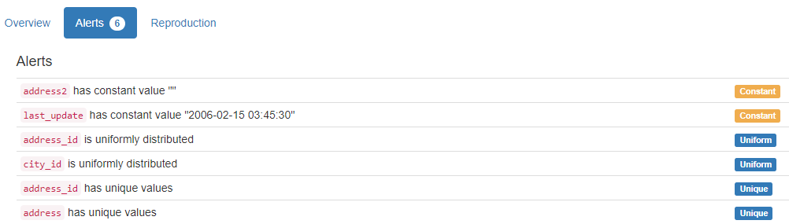

DB.table: sakila.city – Retail – Type: Synth
city_id (id):
Primary Key format: All 600 ID values are unique and valid, and thus suitable for use as a Primary Key.
Numeric range of values: (1 : 600)

city:
City format: Error(s) found:
DQI #15 (Domain Violation - Accuracy):
16 Capitalization/Format issue(s) at index(es): [(11, 'al-Ayn'), (12, 'al-Hawiya'), (13, 'al-Manama'), (14, 'al-Qadarif'), (15, 'al-Qatif'), (189, 'guas Lindas de Gois'), (232, 'Jalib al-Shuyukh'), (362, 'NDjamna'), (384, 'ostka'), (437, 's-Hertogenbosch'), (455, 'Santa Brbara dOeste'), (459, 'Santiago de los Caballeros'), (466, 'Shahr-e Kord'), (475, 'Shubra al-Khayma'), (494, 'Southend-on-Sea'), (561, 'Valle de la Pascua')]

Frequency Distribution (showing top and bottom 10 of 599 cities):
City Frequency
London 2
A Corua (La Corua) 1
Abha 1
Abu Dhabi 1
Acua 1
Adana 1
Addis Abeba 1
Aden 1
Adoni 1
Ahmadnagar 1
... ...
Zhoushan 1
Ziguinchor 1
al-Ayn 1
al-Hawiya 1
al-Manama 1
al-Qadarif 1
al-Qatif 1
guas Lindas de Gois 1
ostka 1
s-Hertogenbosch 1

country_id (id):
Foreign Key format: All 600 ID values are valid for use as a Foreign Key, and duplicate values are allowed.
Numeric range of values: (1 : 109)
References: country.country_id

last_update (timestamp):
Datetime format: All 600 datetime values are valid in the YYYYMMDD format in the range 2006/02/15 03:45 to 2006/02/15 03:45.

YDATA Profiling results: It just found out that the PK column 'city_id' has unique values and is uniformly distributed:

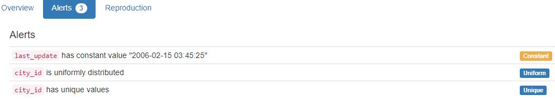

DB.table: sakila.country – Retail – Type: Synth
country_id (id):
Primary Key format: All 109 ID values are unique and valid, and thus suitable for use as a Primary Key.
Numeric range of values: (1 : 109)

country:
Country format: All 109 country values are valid.
Frequency Distribution (showing top and bottom 10 of 109 countries):
Country Frequency
Afghanistan 1
Algeria 1
American Samoa 1
Angola 1
Anguilla 1
Argentina 1
Armenia 1
Australia 1
Austria 1
Azerbaijan 1
... ...
Ukraine 1
United Arab Emirates 1
United Kingdom 1
United States 1
Venezuela 1
Vietnam 1
Virgin Islands, U.S. 1
Yemen 1
Yugoslavia 1
Zambia 1

last_update (timestamp):
Datetime format: All 109 datetime values are valid in the YYYYMMDD format in the range 2006/02/15 03:44 to 2006/02/15 03:44.
YDATA Profiling results: It just found out that the PK column 'country_id' has unique values and is uniformly distributed:

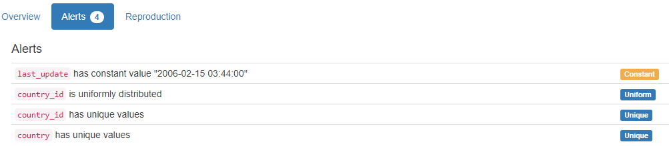

DB.table: sakila.customer – Retail – Type: Synth
customer_id (id):
Primary Key format: All 599 ID values are unique and valid, and thus suitable for use as a Primary Key.
Numeric range of values: (1 : 599)

store_id (id):
Foreign Key format: All 599 ID values are valid for use as a Foreign Key, and duplicate values are allowed.
Numeric range of values: (1 : 2)
References: store.store_id

first_name (name):
Name format: All 599 first_name values are valid.

Frequency Distribution:
first_name Frequency
JAMIE 2
JESSIE 2
KELLY 2
LESLIE 2
MARION 2
TERRY 2
TRACY 2
WILLIE 2
AARON 1
ADAM 1
... ...
WARREN 1
WAYNE 1
WENDY 1
WESLEY 1
WILLARD 1
WILLIAM 1
WILMA 1
YOLANDA 1
YVONNE 1
ZACHARY 1

Range of Values: (AARON to ZACHARY)

last_name (name):
Name format: All 599 last_name values are valid.

Frequency Distribution:
last_name Frequency
ABNEY 1
ADAM 1
ADAMS 1
ALEXANDER 1
ALLARD 1
ALLEN 1
ALVAREZ 1
ANDERSON 1
ANDREW 1
ANDREWS 1
... ...
WINDHAM 1
WOFFORD 1
WOOD 1
WOODS 1
WREN 1
WRIGHT 1
WYMAN 1
YANEZ 1
YEE 1
YOUNG 1

Range of Values: (ABNEY to YOUNG)

email:
Email format: All 599 email values are valid.

address_id (id):
Foreign Key format: All 599 ID values are valid for use as a Foreign Key, and duplicate values are allowed.
Numeric range of values: (5 : 605)
References: address.address_id

active (tinyint):
Numerical format: All 599 values are numerical in the range (0:1).

create_date (datetime):
Datetime format: All 599 datetime values are valid in the YYYYMMDD format in the range 2006/02/14 22:04 to 2006/02/14 22:04.

last_update (timestamp):
Datetime format: All 599 datetime values are valid in the YYYYMMDD format in the range 2006/02/15 03:57 to 2006/02/15 03:57.

YDATA Profiling results: It just found out that the PK column 'customer_id' has unique values and is uniformly distributed:

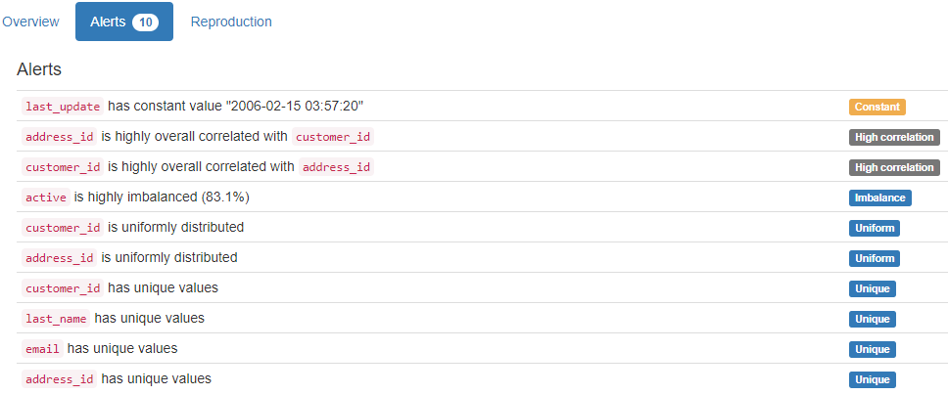

DB.table: sakila.film – Retail – Type: Synth
film_id (id):
Primary Key format: All 1000 ID values are unique and valid, and thus suitable for use as a Primary Key.
Numeric range of values: (1 : 1000)

title:
Categorical format: Error(s) found:
DQI #10 (Structural Conflicts - Consistency, Uniqueness):
Data seems not categorical or has too many categories (> 100).
Categorical format with 1000 unique value(s):
Category Frequency
ACADEMY DINOSAUR 1
ACE GOLDFINGER 1
ADAPTATION HOLES 1
AFFAIR PREJUDICE 1
AFRICAN EGG 1
AGENT TRUMAN 1
AIRPLANE SIERRA 1
AIRPORT POLLOCK 1
ALABAMA DEVIL 1
ALADDIN CALENDAR 1
... ...
WORST BANGER 1
WRATH MILE 1
WRONG BEHAVIOR 1
WYOMING STORM 1
YENTL IDAHO 1
YOUNG LANGUAGE 1
YOUTH KICK 1
ZHIVAGO CORE 1
ZOOLANDER FICTION 1
ZORRO ARK 1

description:
String format: All 1000 string values are valid.
String range (lexicographical): (A Action-Packed Character Study of a Astronaut And a Explorer who must Reach a Monkey in A MySQL Convention : A Unbelieveable Yarn of a Student And a Database Administrator who must Outgun a Husband in An Abandoned Mine Shaft)

release_year (year):
Year format: All 1000 values are numerical and valid in the range [1800, 2100].
Actual range of values: (2006 : 2006)

language_id (id):
Foreign Key format: All 1000 ID values are valid for use as a Foreign Key, and duplicate values are allowed.
Numeric range of values: (1 : 1)
References: language.language_id

original_language_id (id):
Foreign Key format: Error(s) found:
DQI #1 (Missing Data - Completeness):
1000 Blank/Empty/Null/Missing value(s) at index(es): [(0, 'NULL'), (1, 'NULL'), (2, 'NULL'), (3, 'NULL'), (4, 'NULL'), (5, 'NULL'), (6, 'NULL'), (7, 'NULL'), (8, 'NULL'), (9, 'NULL'), ('...', '...'), (990, 'NULL'), (991, 'NULL'), (992, 'NULL'), (993, 'NULL'), (994, 'NULL'), (995, 'NULL'), (996, 'NULL'), (997, 'NULL'), (998, 'NULL'), (999, 'NULL')] (displaying only the first and last 10 items)

Note: This is a Foreign Key, so duplicate values are allowed.
No valid values found.
References: language.language_id

rental_duration (duration):
Numerical >=0 format: All 1000 values are numerical and greater or equal to 0 in the range (3:7).

rental_rate (rate):
Numerical format: All 1000 values are numerical in the range (0.99:4.99).

length:
Numerical >=0 format: All 1000 values are numerical and greater or equal to 0 in the range (46:185).

replacement_cost (cost):
Numerical >=0 format: All 1000 values are numerical and greater or equal to 0 in the range (9.99:29.99).

rating:
Categorical format: All 1000 values are correctly categorical.

Categorical format with 5 unique value(s):
Category Frequency
PG-13 223
NC-17 210
R 195
PG 194
G 178

special_features (features):
Categorical format: All 1000 values are correctly categorical.

Categorical format with 15 unique value(s):
Category Frequency
Trailers,Commentaries,Behind the Scenes 79
Trailers 72
Trailers,Behind the Scenes 72
Trailers,Commentaries 72
Deleted Scenes,Behind the Scenes 71
Behind the Scenes 70
Commentaries,Behind the Scenes 70
Commentaries,Deleted Scenes,Behind the Scenes 66
Trailers,Deleted Scenes 66
Commentaries,Deleted Scenes 65
Trailers,Commentaries,Deleted Scenes 64
Commentaries 62
Deleted Scenes 61
Trailers,Commentaries,Deleted Scenes,Behind the Scenes 61
Trailers,Deleted Scenes,Behind the Scenes 49

last_update (timestamp):
Datetime format: All 1000 datetime values are valid in the YYYYMMDD format in the range 2006/02/15 04:03 to 2006/02/15 04:03.

YDATA Profiling results: It found the only Missing values column because it contains ALL NULLs. It also found that the PK column 'film_id' is unique and uniformly distributed.
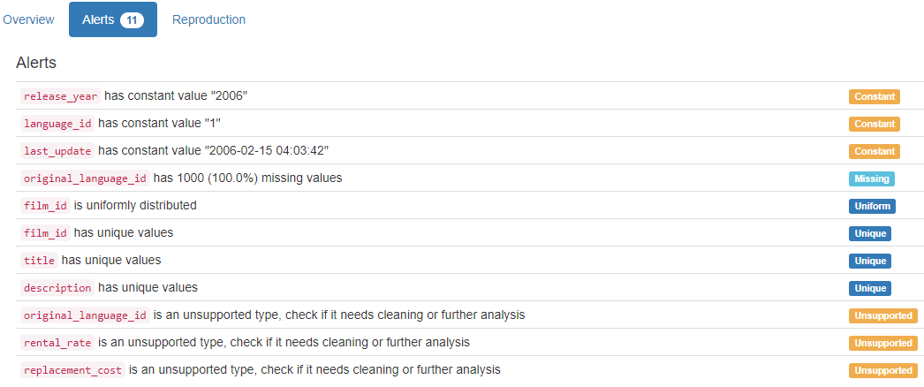

DB.table: sakila.inventory – Retail – Type: Synth
inventory_id (id):
Primary Key format: All 4581 ID values are unique and valid, and thus suitable for use as a Primary Key.
Numeric range of values: (1 : 4581)

film_id (id):
Foreign Key format: All 4581 ID values are valid for use as a Foreign Key, and duplicate values are allowed.
Numeric range of values: (1 : 1000)
References: film.film_id

store_id (id):
Foreign Key format: All 4581 ID values are valid for use as a Foreign Key, and duplicate values are allowed.
Numeric range of values: (1 : 2)
References: store.store_id

last_update (timestamp):
Datetime format: All 4581 datetime values are valid in the YYYYMMDD format in the range 2006/02/15 04:09 to 2006/02/15 04:09.

YDATA Profiling results: It just found out that the PK column 'inventory_id' has unique values and is uniformly distributed
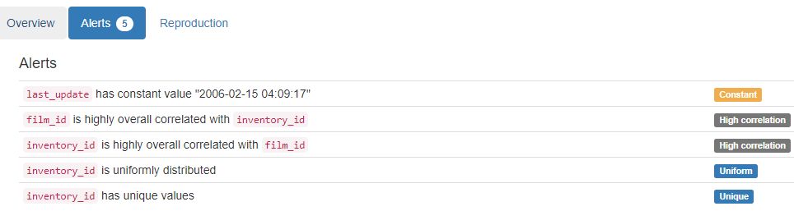

DB.table: sakila.language – Retail – Type: Synth
language_id (id):
Primary Key format: All 6 ID values are unique and valid, and thus suitable for use as a Primary Key.
Numeric range of values: (1 : 6)

name:
Name format: All 6 name values are valid.

Frequency Distribution:
name Frequency
English 1
French 1
German 1
Italian 1
Japanese 1
Mandarin 1

Range of Values: (English to Mandarin)

last_update (timestamp):
Datetime format: All 6 datetime values are valid in the YYYYMMDD format in the range 2006/02/15 04:02 to 2006/02/15 04:02.
YDATA Profiling results: It just found out that the PK column 'language_id' has unique values:

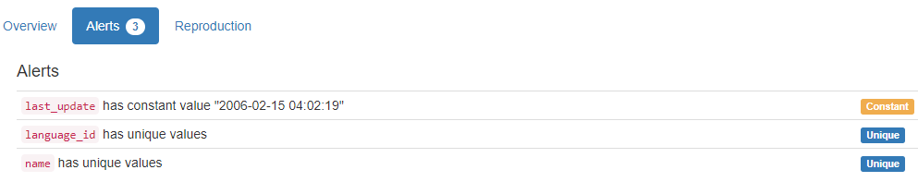

DB.table: sakila.rental – Retail – Type: Synth
rental_id (id):
Primary Key format: All 16044 ID values are unique and valid, and thus suitable for use as a Primary Key.
Numeric range of values: (1 : 16049)

rental_date (datetime):
Datetime format: All 16044 datetime values are valid in the YYYYMMDD format in the range 2005/05/24 22:53 to 2006/02/14 15:16.

inventory_id (id):
Foreign Key format: All 16044 ID values are valid for use as a Foreign Key, and duplicate values are allowed.
Numeric range of values: (1 : 4581)
References: inventory.inventory_id

customer_id (id):
Foreign Key format: All 16044 ID values are valid for use as a Foreign Key, and duplicate values are allowed.
Numeric range of values: (1 : 599)
References: customer.customer_id

return_date (datetime):
Datetime format: Error(s) found:
DQI #1 (Missing Data - Completeness):
183 Blank/Empty/Null/Missing value(s) at index(es): [(11491, 'NULL'), (11536, 'NULL'), (11558, 'NULL'), (11572, 'NULL'), (11588, 'NULL'), (11606, 'NULL'), (11641, 'NULL'), (11647, 'NULL'), (11652, 'NULL'), (11667, 'NULL'), ('...', '...'), (15739, 'NULL'), (15772, 'NULL'), (15774, 'NULL'), (15788, 'NULL'), (15807, 'NULL'), (15856, 'NULL'), (15861, 'NULL'), (15869, 'NULL'), (15888, 'NULL'), (15960, 'NULL')] (displaying only the first and last 10 items)

staff_id (id):
Foreign Key format: All 16044 ID values are valid for use as a Foreign Key, and duplicate values are allowed.
Numeric range of values: (1 : 2)
References: staff.staff_id

last_update (timestamp):
Datetime format: All 16044 datetime values are valid in the YYYYMMDD format in the range 2006/02/15 20:30 to 2006/02/23 03:12.

YDATA Profiling results: It found the only Missing values column because it contains NULLs. It also found that the PK column 'rental_id' is unique and uniformly distributed.

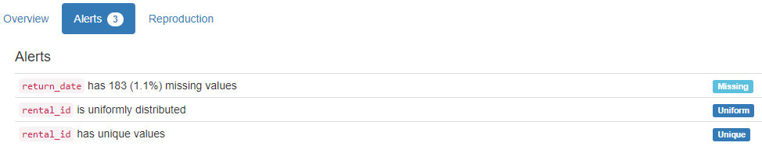

DB.table: sakila.staff – Retail – Type: Synth
staff_id (id):
Primary Key format: All 2 ID values are unique and valid, and thus suitable for use as a Primary Key.
Numeric range of values: (1 : 2)

first_name (name):
Name format: All 2 first_name values are valid.

Frequency Distribution:
first_name Frequency
Jon 1
Mike 1

Range of Values: (Jon to Mike)

last_name (name):
Name format: All 2 last_name values are valid.

Frequency Distribution:
last_name Frequency
Hillyer 1
Stephens 1

Range of Values: (Hillyer to Stephens)

address_id (id):
Foreign Key format: All 2 ID values are valid for use as a Foreign Key, and duplicate values are allowed.
Numeric range of values: (3 : 4)
References: address.address_id

picture:
String format: Error(s) found:
DQI #1 (Missing Data - Completeness):
1 Blank/Empty/Null/Missing value(s) at index(es): [(1, 'NULL')]

String range (lexicographical): (BLOB : BLOB)
Frequency Distribution:
picture Frequency
BLOB 1
NULL 1

email:
Email format: All 2 email values are valid.

store_id (id):
Foreign Key format: All 2 ID values are valid for use as a Foreign Key, and duplicate values are allowed.
Numeric range of values: (1 : 2)
References: store.store_id

active (tinyint):
Numerical format: All 2 values are numerical in the range (1:1).

username:
Name format: All 2 username values are valid.

Frequency Distribution:
username Frequency
Jon 1
Mike 1

Range of Values: (Jon to Mike)

password:
String format: All 2 string values are valid.
String range (lexicographical): (8cb2237d0679ca88db6464eac60da96345513964 : 8cb2237d0679ca88db6464eac60da96345513964)

Frequency Distribution:
password Frequency
8cb2237d0679ca88db6464eac60da96345513964 2

last_update (timestamp):
Datetime format: All 2 datetime values are valid in the YYYYMMDD format in the range 2006/02/15 03:57 to 2006/02/15 03:57.

YDATA Profiling results: It found the only Missing values column because it contains 1 NULL value. It also found that the PK column 'staff_id' is unique and uniformly distributed.

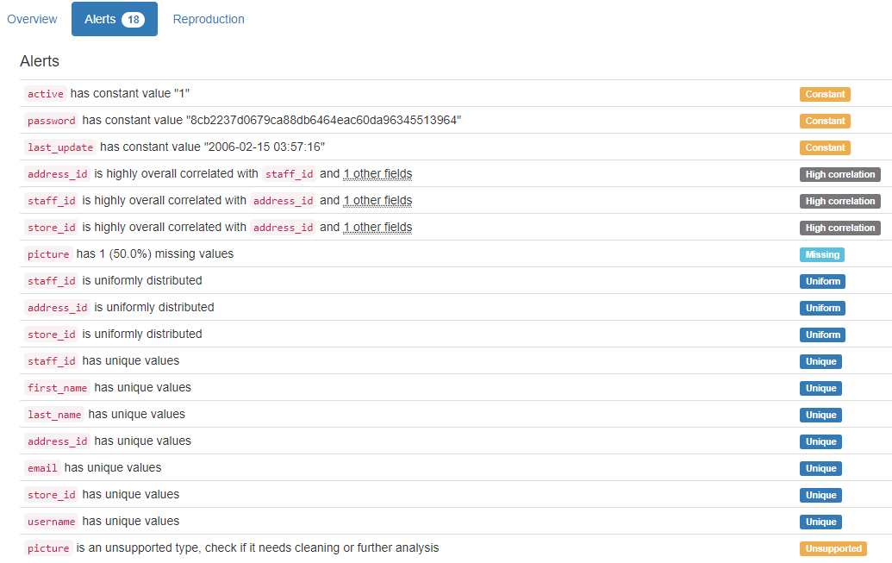

DB.table: sakila.store – Retail – Type: Synth
store_id (id):
Primary Key format: All 2 ID values are unique and valid, and thus suitable for use as a Primary Key.
Numeric range of values: (1 : 2)

manager_staff_id (id):
Foreign Key format: All 2 ID values are valid for use as a Foreign Key, and duplicate values are allowed.
Numeric range of values: (1 : 2)
References: staff.staff_id

address_id (id):
Foreign Key format: All 2 ID values are valid for use as a Foreign Key, and duplicate values are allowed.
Numeric range of values: (1 : 2)
References: address.address_id

last_update (timestamp):
Datetime format: All 2 datetime values are valid in the YYYYMMDD format in the range 2006/02/15 03:57 to 2006/02/15 03:57.

YDATA Profiling results: It just found out that the PK column 'store_id' has unique values and is uniformly distributed:

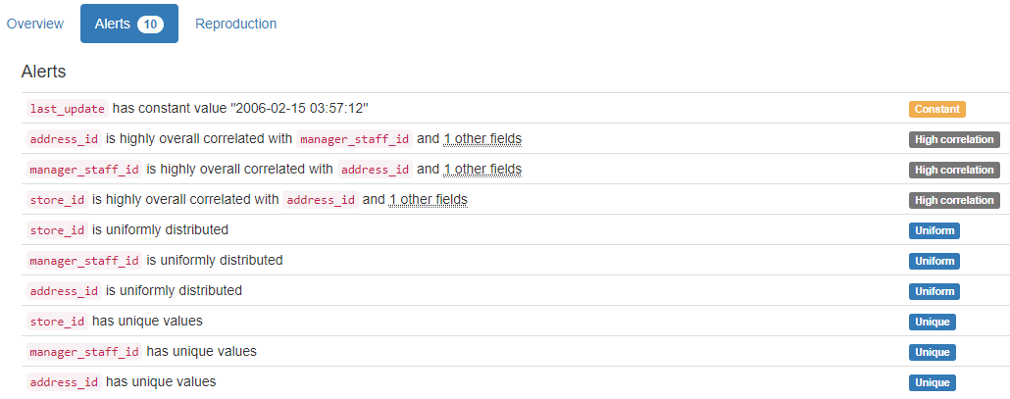

DB.table: SalesDB.Sales – Retail – Type: Synth
Here 6.7 million lines were analysed in less than 3 minutes.
SalesID (id):
Primary Key format: All 6715221 ID values are unique and valid, and thus suitable for use as a Primary Key.
Numeric range of values: (1 : 6737977)

SalesPersonID (id):
Foreign Key format: All 6715221 ID values are valid for use as a Foreign Key, and duplicate values are allowed.
Numeric range of values: (1 : 23)
References: Employees.EmployeeID

CustomerID (id):
Foreign Key format: All 6715221 ID values are valid for use as a Foreign Key, and duplicate values are allowed.
Numeric range of values: (1 : 19680)
References: Customers.CustomerID

ProductID (id):
Foreign Key format: All 6715221 ID values are valid for use as a Foreign Key, and duplicate values are allowed.
Numeric range of values: (1 : 504)
References: Products.ProductID

Quantity:
Numerical format: All 6715221 values are numerical in the range (1:1042).

YDATA Profiling results: It just found out that the PK column 'SalesID' has unique values:

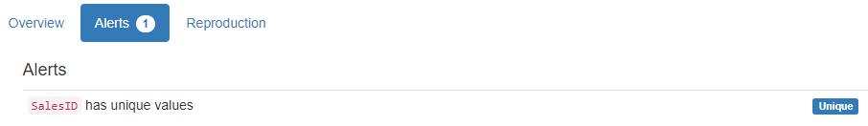

DB.table: stats.users – Education – Type: Real
Id:
Primary Key format: Error(s) found:
DQI #15 (Domain Violation - Accuracy):
1 Negative value(s) at index(es): [(0, -1)]

Numeric range of values: (-1 : 55747)

Reputation (integer):
Numerical format: All 40325 values are numerical in the range (1:87393).

CreationDate (datetime):
Datetime format: All 40325 datetime values are valid in the YYYYMMDD format in the range 2010/07/19 06:55 to 2014/09/14 01:01.

DisplayName (name):
Name format: Error(s) found:
DQI #1 (Missing Data - Completeness):
2 Blank/Empty/Null/Missing value(s) at index(es):
1 NULL values: [(24969, 'NULL')]
1 Non-NULL values: [(2018, 'None')]

DQI #5 (Extraneous Data - Consistency, Uniqueness):
7947 Extraneous data value(s) at index(es): [(28, 'adi92'), (68, 'c4il'), (104, 'd_2'), (120, 'nbv4'), (162, 'vrish88'), (173, 'user204'), (177, 'user211'), (196, 'm3rLinEz'), (233, 'user283'), (265, 'user333'), ('...', '...'), (40236, 'user21359'), (40237, 'user55659'), (40244, 'user2219907'), (40245, 'user2460415'), (40252, 'user2975986'), (40256, 'user55678'), (40260, 'user2329744'), (40262, 'georgiar18'), (40287, 'rmehta1987'), (40305, 'user56299')] (displaying only the first and last 10 items)

DQI #15 (Domain Violation - Accuracy):
12989 Capitalization/Format issue(s) at index(es): [(7, 'csgillespie'), (9, 'wahalulu'), (12, 'hannes.koller'), (13, 'slashnick'), (15, 'grokus'), (18, 'radek'), (23, 'balpha'), (25, 'gappy'), (31, 'EAMann'), (36, 'hadley'), ('...', '...'), (40303, 'SuPakarn Junfang'), (40304, 'biggvsdiccvs'), (40307, 'quants_mum'), (40311, 'jalen'), (40313, 'liszt'), (40314, 'oolusola'), (40315, 'guest'), (40316, 'kpivert'), (40320, 'AussieMeg'), (40322, 'tronbabylove')] (displaying only the first and last 10 items)

Frequency Distribution:
DisplayName Frequency
Chris 80
John 64
Alex 63
Tom 57
Michael 52
James 50
David 48
Dan 44
Matt 43
Andrew 40
... ...
ايمان محمد 1
يآسر الشيبآني 1
ダンボー 1
一二三 1
琼 朱 1
趙維雄 1
陈伟林 1
陳俊宇 1
黃宇陽 1
Ｊ. Ｍ. 1

Range of Values: ( Raid-Mahbouba to Ｊ. Ｍ.)

LastAccessDate (datetime):
Datetime format: All 40325 datetime values are valid in the YYYYMMDD format in the range 2010/07/19 06:55 to 2014/09/14 03:05.

WebsiteUrl (url):
URL format: Error(s) found:
DQI #1 (Missing Data - Completeness):
32204 Blank/Empty/Null/Missing value(s) at index(es): All NULL values:
[(13, 'NULL'), (14, 'NULL'), (17, 'NULL'), (18, 'NULL'), (20, 'NULL'), (22, 'NULL'), (26, 'NULL'), (30, 'NULL'), (37, 'NULL'), (39, 'NULL'), ('...', '...'), (40315, 'NULL'), (40316, 'NULL'), (40317, 'NULL'), (40318, 'NULL'), (40319, 'NULL'), (40320, 'NULL'), (40321, 'NULL'), (40322, 'NULL'), (40323, 'NULL'), (40324, 'NULL')]

DQI #15 (Domain Violation - Accuracy):
356 Invalid URL format issue(s) at index(es): [(51, 'http://None'), (150, 'http://@tzenes'), (160, 'http://none'), (216, 'http://none'), (300, 'http://twitter/simalam'), (343, 'http://twitter.com/#!/oluies'), (344, 'http://none'), (356, 'http://N/A'), (368, 'http://liveatthewitchtrials.blogspot.'), (441, 'http://somethingelsetodo'), ('...', '...'), (38403, 'http://-'), (38529, 'http://None'), (38996, 'http://none'), (39130, 'http://nope'), (39170, 'http://onedoubleapostrophe@gmail.com'), (39374, 'http://cananyoneexplaintomehowabjtransistorworksplease'), (39559, 'http://lovingher@gmail.com'), (39812, 'http://N/A'), (40111, 'http://none'), (40138, 'http://Missing')] (displaying only the first and last 10 items)

Location:
Categorical format: Error(s) found:
DQI #1 (Missing Data - Completeness):
28643 Blank/Empty/Null/Missing value(s) at index(es):
NULL values (28634): [(14, 'NULL'), (19, 'NULL'), (20, 'NULL'), (22, 'NULL'), (26, 'NULL'), (30, 'NULL'), (37, 'NULL'), (40, 'NULL'), (55, 'NULL'), (58, 'NULL'), ('...', '...'), (40312, 'NULL'), (40313, 'NULL'), (40314, 'NULL'), (40315, 'NULL'), (40316, 'NULL'), (40317, 'NULL'), (40319, 'NULL'), (40320, 'NULL'), (40321, 'NULL'), (40323, 'NULL')]
Non-NULL values (9): [(1111, 'Blank'), (6593, '-'), (8971, '.'), (13628, 'N/A'), (14203, '-'), (16245, 'None'), (17944, '!'), (21566, '-'), (33618, '-')]

DQI #10 (Structural Conflicts - Consistency, Uniqueness):
Data seems not categorical or has too many categories (> 100).
Categorical format with 2465 unique value(s):
Category Frequency
NULL 28634
United States 352
London, United Kingdom 281
Germany 221
United Kingdom 209
India 206
San Francisco, CA 154
New York, United States 148
Seattle, WA 131
Bangalore, India 130
... ...
Đà Nẵng, Việt Nam 1
İstanbul, Turkey 1
Široki Brijeg, Bosnia and Herzegovina 1
Žednik, Serbia 1
Зубин Поток 1
مزرعة يشوع, Lebanon 1
♁ 1
中国 1
仙台 1
北京 1

AboutMe:
Target word not found, and Format not determined

Views:
Numerical >=0 format: All 40325 values are numerical and greater or equal to 0 in the range (0:20932).

UpVotes (integer):
Numerical format: All 40325 values are numerical in the range (0:11442).

DownVotes (integer):
Numerical format: All 40325 values are numerical in the range (0:1920).

AccountId (id):
ID column format: Error(s) found:
DQI #15 (Domain Violation - Accuracy):
1 Negative value(s) at index(es): [(0, -1)]

Numeric range of values: (-1 : 5027354)

Age:
Age format: Error(s) found:
DQI #1 (Missing Data - Completeness):
32007 Blank/Empty/Null/Missing value(s) at index(es): [(0, 'NULL'), (14, 'NULL'), (18, 'NULL'), (20, 'NULL'), (22, 'NULL'), (25, 'NULL'), (26, 'NULL'), (27, 'NULL'), (30, 'NULL'), (35, 'NULL'), ('...', '...'), (40315, 'NULL'), (40316, 'NULL'), (40317, 'NULL'), (40318, 'NULL'), (40319, 'NULL'), (40320, 'NULL'), (40321, 'NULL'), (40322, 'NULL'), (40323, 'NULL'), (40324, 'NULL')] (displaying only the first and last 10 items)

Actual range of values: (13.0 : 94.0)

ProfileImageUrl (url):
URL format: Error(s) found:
DQI #1 (Missing Data - Completeness):
23846 Blank/Empty/Null/Missing value(s) at index(es): [(0, 'NULL'), (1, 'NULL'), (2, 'NULL'), (4, 'NULL'), (5, 'NULL'), (6, 'NULL'), (7, 'NULL'), (8, 'NULL'), (9, 'NULL'), (10, 'NULL'), ('...', '...'), (40296, 'NULL'), (40305, 'NULL'), (40306, 'NULL'), (40307, 'NULL'), (40308, 'NULL'), (40311, 'NULL'), (40314, 'NULL'), (40315, 'NULL'), (40319, 'NULL'), (40321, 'NULL')] (displaying only the first and last 10 items)

DQI #15 (Domain Violation - Accuracy):
14 Invalid URL format issue(s) at index(es): [(1249, 'http://www.gravatar.com/avatar/205ede43beb3ae5dd2695d88e7929612?s=128&amp;d=identicon&amp;r=PG'), (3278, 'http://www.gravatar.com/avatar/b2d2a783d6bb2ae8c8b4ca9d5237f405?s=128&amp;d=identicon&amp;r=PG'), (3916, 'http://www.gravatar.com/avatar/f5ef1b81e1aeb3b921a3034d460ce6af?s=128&amp;d=identicon&amp;r=PG'), (5712, 'http://www.gravatar.com/avatar/a5999e39a83c65b7921361fb82137cd3?s=128&amp;d=identicon&amp;r=PG'), (7888, 'http://www.gravatar.com/avatar/61c85d77bcaf5212b3a0aa2419c95f33?s=128&amp;d=identicon&amp;r=PG'), (9007, 'http://www.gravatar.com/avatar/61062bd44817f0d89414856b07a76ce4?s=128&amp;d=identicon&amp;r=PG'), (14975, 'http://www.gravatar.com/avatar/bd23c25c23fc0c52e8a914fb9d6124c8?s=128&amp;d=identicon&amp;r=PG'), (17136, 'http://www.gravatar.com/avatar/dd34caad3a10802fa65957709af629b1?s=128&amp;d=identicon&amp;r=PG'), (17751, 'http://www.gravatar.com/avatar/054dba7842330d7a9ae87d4773847d12?s=128&amp;d=identicon&amp;r=PG'), (19185, 'http://www.gravatar.com/avatar/6ee30aafb111ccb33f233eb153059bcb?s=128&amp;d=identicon&amp;r=PG'), (21383, 'http://www.gravatar.com/avatar/363da5c659a30b74d0a74f8eba92e346?s=128&amp;d=identicon&amp;r=PG'), (27754, 'http://www.gravatar.com/avatar/303b0a741a14439b53c23ce4c9e28a12?s=128&amp;d=identicon&amp;r=PG'), (37283, 'http://www.gravatar.com/avatar/21d92e60aa7179788093b60c029fe963?s=128&amp;d=identicon&amp;r=PG'), (38786, 'http://www.gravatar.com/avatar/3d15a12f51296073d9501892423b47ca?s=128&amp;d=identicon&amp;r=PG')]

YDATA Profiling results: It found correctly 4 of the 6 Missing values columns because they contain ALL NULLs. One of these was the only case where our system did not find, the 'AboutMe' column, which was not associated with any format in our Semantic Type Detection. It did not find all the Missing values for column 'Location'. It just found correctly 13085 cases of 13350 that were found by our system, because there are 265 values with these values: "N/A", "Blank", "!", "-", "." and "None". Besides that, it did not find the Missing values on column DisplayName (2: 1 NULL and 1 "None"). It also found that the PK column 'Id' has unique values:

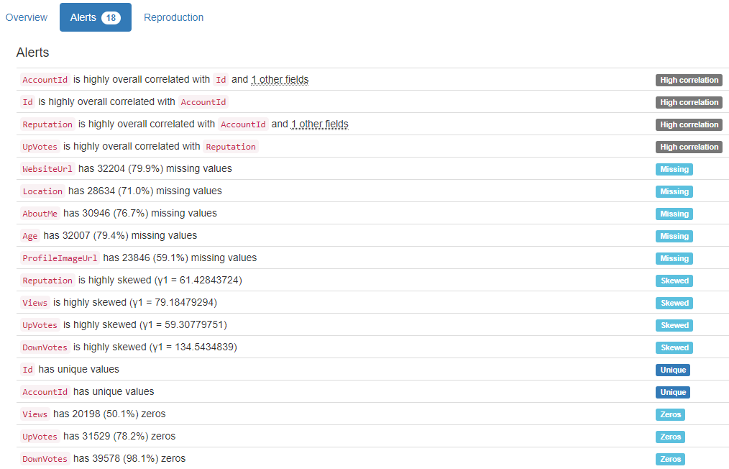

DB.table: tpcds.item – Retail – Type: Synth
i_item_sk (id):
Primary Key format: All 18000 ID values are unique and valid, and thus suitable for use as a Primary Key.
Numeric range of values: (1 : 18000)

i_item_id (id):
ID column format: Error(s) found:
DQI #9 (Duplicates - Uniqueness):
15000 Duplicate value(s) at index(es): [[1, 'AAAAAAAACAAAAAAA'], [2, 'AAAAAAAACAAAAAAA'], [3, 'AAAAAAAAEAAAAAAA'], [4, 'AAAAAAAAEAAAAAAA'], [5, 'AAAAAAAAEAAAAAAA'], [7, 'AAAAAAAAIAAAAAAA'], [8, 'AAAAAAAAIAAAAAAA'], [9, 'AAAAAAAAKAAAAAAA'], [10, 'AAAAAAAAKAAAAAAA'], [11, 'AAAAAAAAKAAAAAAA'], ('...', '...'), [17989, 'AAAAAAAAGEGEAAAA'], [17990, 'AAAAAAAAGEGEAAAA'], [17991, 'AAAAAAAAIEGEAAAA'], [17992, 'AAAAAAAAIEGEAAAA'], [17993, 'AAAAAAAAIEGEAAAA'], [17995, 'AAAAAAAAMEGEAAAA'], [17996, 'AAAAAAAAMEGEAAAA'], [17997, 'AAAAAAAAOEGEAAAA'], [17998, 'AAAAAAAAOEGEAAAA'], [17999, 'AAAAAAAAOEGEAAAA']] (displaying only the first and last 10 items)

DQI #19 (Uniqueness Violation - Uniqueness):
9000 Uniqueness violation(s) at index(es): [(2, 'AAAAAAAACAAAAAAA'), (4, 'AAAAAAAAEAAAAAAA'), (5, 'AAAAAAAAEAAAAAAA'), (8, 'AAAAAAAAIAAAAAAA'), (10, 'AAAAAAAAKAAAAAAA'), (11, 'AAAAAAAAKAAAAAAA'), (14, 'AAAAAAAAOAAAAAAA'), (16, 'AAAAAAAAABAAAAAA'), (17, 'AAAAAAAAABAAAAAA'), (20, 'AAAAAAAAEBAAAAAA'), ('...', '...'), (17981, 'AAAAAAAAMDGEAAAA'), (17984, 'AAAAAAAAAEGEAAAA'), (17986, 'AAAAAAAACEGEAAAA'), (17987, 'AAAAAAAACEGEAAAA'), (17990, 'AAAAAAAAGEGEAAAA'), (17992, 'AAAAAAAAIEGEAAAA'), (17993, 'AAAAAAAAIEGEAAAA'), (17996, 'AAAAAAAAMEGEAAAA'), (17998, 'AAAAAAAAOEGEAAAA'), (17999, 'AAAAAAAAOEGEAAAA')] (displaying only the first and last 10 items)

Alphanumeric range of values: (AAAAAAAAAAABAAAA : AAAAAAAAPPPBAAAA)

i_rec_start_date (date):
Date format: Error(s) found:
DQI #1 (Missing Data - Completeness):
46 Blank/Empty/Null/Missing value(s) at index(es): [(461, 'NULL'), (1047, 'NULL'), (1328, 'NULL'), (1914, 'NULL'), (2028, 'NULL'), (2722, 'NULL'), (2998, 'NULL'), (3211, 'NULL'), (3349, 'NULL'), (3974, 'NULL'), ('...', '...'), (13554, 'NULL'), (13688, 'NULL'), (13916, 'NULL'), (15190, 'NULL'), (15456, 'NULL'), (15544, 'NULL'), (16196, 'NULL'), (16251, 'NULL'), (17065, 'NULL'), (17391, 'NULL')] (displaying only the first and last 10 items)

Date range: 1997-10-27 to 2001-10-27

i_rec_end_date (date):
Date format: Error(s) found:
DQI #1 (Missing Data - Completeness):
9000 Blank/Empty/Null/Missing value(s) at index(es): [(0, 'NULL'), (2, 'NULL'), (5, 'NULL'), (6, 'NULL'), (8, 'NULL'), (11, 'NULL'), (12, 'NULL'), (14, 'NULL'), (17, 'NULL'), (18, 'NULL'), ('...', '...'), (17981, 'NULL'), (17982, 'NULL'), (17984, 'NULL'), (17987, 'NULL'), (17988, 'NULL'), (17990, 'NULL'), (17993, 'NULL'), (17994, 'NULL'), (17996, 'NULL'), (17999, 'NULL')] (displaying only the first and last 10 items)

Date range: 1999-10-27 to 2001-10-26

i_item_desc (item):
String format: Error(s) found:
DQI #1 (Missing Data - Completeness):
51 Blank/Empty/Null/Missing value(s) at index(es): [(180, 'NULL'), (461, 'NULL'), (779, 'NULL'), (940, 'NULL'), (1047, 'NULL'), (1145, 'NULL'), (1482, 'NULL'), (1693, 'NULL'), (1914, 'NULL'), (2243, 'NULL'), ('...', '...'), (15296, 'NULL'), (15456, 'NULL'), (15544, 'NULL'), (16251, 'NULL'), (16400, 'NULL'), (16646, 'NULL'), (16701, 'NULL'), (17065, 'NULL'), (17391, 'NULL'), (17953, 'NULL')] (displaying only the first and last 10 items)

String range (lexicographical): (A : Young, working horses see mentally)

i_current_price (price):
Numerical format: Error(s) found:
DQI #1 (Missing Data - Completeness):
45 Blank/Empty/Null/Missing value(s) at index(es): [(180, 'NULL'), (779, 'NULL'), (940, 'NULL'), (1145, 'NULL'), (1693, 'NULL'), (1914, 'NULL'), (2028, 'NULL'), (2243, 'NULL'), (2998, 'NULL'), (3015, 'NULL'), ('...', '...'), (13178, 'NULL'), (13554, 'NULL'), (14854, 'NULL'), (15253, 'NULL'), (15296, 'NULL'), (15456, 'NULL'), (16400, 'NULL'), (16701, 'NULL'), (17065, 'NULL'), (17391, 'NULL')] (displaying only the first and last 10 items)

Range of values: (0.09:99.99).

i_wholesale_cost (cost):
Numerical >=0 format: Error(s) found:
DQI #1 (Missing Data - Completeness):
46 Blank/Empty/Null/Missing value(s) at index(es): [(461, 'NULL'), (940, 'NULL'), (1328, 'NULL'), (1914, 'NULL'), (2028, 'NULL'), (2243, 'NULL'), (2722, 'NULL'), (2998, 'NULL'), (3211, 'NULL'), (3349, 'NULL'), ('...', '...'), (15061, 'NULL'), (15253, 'NULL'), (15296, 'NULL'), (15456, 'NULL'), (16196, 'NULL'), (16251, 'NULL'), (16400, 'NULL'), (16646, 'NULL'), (17391, 'NULL'), (17953, 'NULL')] (displaying only the first and last 10 items)

Range of values: (0.02:87.36).

i_brand_id (id):
ID column format: Error(s) found:
DQI #1 (Missing Data - Completeness):
44 Blank/Empty/Null/Missing value(s) at index(es): [(461, 'NULL'), (779, 'NULL'), (940, 'NULL'), (1047, 'NULL'), (1328, 'NULL'), (1482, 'NULL'), (1693, 'NULL'), (1914, 'NULL'), (2243, 'NULL'), (2998, 'NULL'), ('...', '...'), (12204, 'NULL'), (13688, 'NULL'), (15190, 'NULL'), (15296, 'NULL'), (15456, 'NULL'), (15544, 'NULL'), (16196, 'NULL'), (16400, 'NULL'), (16646, 'NULL'), (16701, 'NULL')] (displaying only the first and last 10 items)

DQI #9 (Duplicates - Uniqueness):
17945 Duplicate value(s) at index(es): [[0.0, 5003002.0], [1.0, 1001001.0], [2.0, 1001001.0], [3.0, 3002001.0], [4.0, 2002002.0], [5.0, 2002002.0], [6.0, 3001002.0], [7.0, 3003001.0], [8.0, 1004002.0], [9.0, 10008011.0], ('...', '...'), [17990.0, 6014007.0], [17991.0, 4002001.0], [17992.0, 4002001.0], [17993.0, 4002001.0], [17994.0, 6003004.0], [17995.0, 8004007.0], [17996.0, 8004007.0], [17997.0, 4004001.0], [17998.0, 4004001.0], [17999.0, 8001001.0]] (displaying only the first and last 10 items)

DQI #19 (Uniqueness Violation - Uniqueness):
17008 Uniqueness violation(s) at index(es): [(2, 1001001.0), (5, 2002002.0), (10, 10008011.0), (11, 10008011.0), (16, 1002001.0), (17, 1002001.0), (22, 10005006.0), (23, 10005006.0), (24, 1004002.0), (26, 2004001.0), ('...', '...'), (17990, 6014007.0), (17991, 4002001.0), (17992, 4002001.0), (17993, 4002001.0), (17994, 6003004.0), (17995, 8004007.0), (17996, 8004007.0), (17997, 4004001.0), (17998, 4004001.0), (17999, 8001001.0)] (displaying only the first and last 10 items)

Numeric range of values: (1001001.0 : 10016017.0)

i_brand (brand):
Categorical format: Error(s) found:
DQI #1 (Missing Data - Completeness):
40 Blank/Empty/Null/Missing value(s) at index(es): [(461, 'NULL'), (779, 'NULL'), (1145, 'NULL'), (1328, 'NULL'), (2028, 'NULL'), (2722, 'NULL'), (2998, 'NULL'), (3015, 'NULL'), (4098, 'NULL'), (5029, 'NULL'), ('...', '...'), (13178, 'NULL'), (13424, 'NULL'), (13688, 'NULL'), (13916, 'NULL'), (15190, 'NULL'), (15253, 'NULL'), (15456, 'NULL'), (16196, 'NULL'), (16400, 'NULL'), (17065, 'NULL')]

DQI #10 (Structural Conflicts - Consistency, Uniqueness):
Data seems not categorical or has too many categories (> 100).
Categorical format with 713 unique value(s):
Category Frequency
edu packscholar #1 253
importoscholar #2 253
importoimporto #2 251
exportischolar #1 245
edu packimporto #1 243
edu packscholar #2 243
importoedu pack #2 243
importoimporto #1 242
exportiexporti #1 241
importoedu pack #1 241
... ...
edu packamalgamalg #12 2
edu packamalgamalg #2 2
importoamalgamalg #6 2
namelessunivamalg #2 2
scholaramalgamalg #14 2
scholaramalgamalg #6 2
scholaramalgamalg #7 2
corpamalgamalg #11 1
scholaramalgamalg #5 1
univamalgamalg #12 1

i_class_id (id):
ID column format: Error(s) found:
DQI #1 (Missing Data - Completeness):
35 Blank/Empty/Null/Missing value(s) at index(es): [(180, 'NULL'), (461, 'NULL'), (779, 'NULL'), (1047, 'NULL'), (2998, 'NULL'), (3349, 'NULL'), (4641, 'NULL'), (4714, 'NULL'), (4990, 'NULL'), (5563, 'NULL'), ('...', '...'), (13554, 'NULL'), (13688, 'NULL'), (13916, 'NULL'), (15061, 'NULL'), (15296, 'NULL'), (15456, 'NULL'), (16196, 'NULL'), (16251, 'NULL'), (16400, 'NULL'), (16646, 'NULL')] (displaying only the first and last 10 items)

DQI #9 (Duplicates - Uniqueness):
17965 Duplicate value(s) at index(es): [[0.0, 3.0], [1.0, 1.0], [2.0, 7.0], [3.0, 2.0], [4.0, 2.0], [5.0, 3.0], [6.0, 1.0], [7.0, 3.0], [8.0, 3.0], [9.0, 8.0], ('...', '...'), [17990.0, 14.0], [17991.0, 2.0], [17992.0, 5.0], [17993.0, 5.0], [17994.0, 3.0], [17995.0, 4.0], [17996.0, 4.0], [17997.0, 4.0], [17998.0, 11.0], [17999.0, 11.0]] (displaying only the first and last 10 items)

DQI #19 (Uniqueness Violation - Uniqueness):
17949 Uniqueness violation(s) at index(es): [(4, 2.0), (5, 3.0), (6, 1.0), (7, 3.0), (8, 3.0), (11, 14.0), (13, 7.0), (14, 2.0), (15, 2.0), (16, 1.0), ('...', '...'), (17990, 14.0), (17991, 2.0), (17992, 5.0), (17993, 5.0), (17994, 3.0), (17995, 4.0), (17996, 4.0), (17997, 4.0), (17998, 11.0), (17999, 11.0)] (displaying only the first and last 10 items)

Numeric range of values: (1.0 : 16.0)

i_class (class):
Categorical format: Error(s) found:
DQI #1 (Missing Data - Completeness):
43 Blank/Empty/Null/Missing value(s) at index(es): [(180, 'NULL'), (1047, 'NULL'), (1328, 'NULL'), (1482, 'NULL'), (1693, 'NULL'), (2028, 'NULL'), (2722, 'NULL'), (3349, 'NULL'), (3974, 'NULL'), (4098, 'NULL'), ('...', '...'), (12901, 'NULL'), (13178, 'NULL'), (13688, 'NULL'), (13916, 'NULL'), (14854, 'NULL'), (15190, 'NULL'), (15296, 'NULL'), (16196, 'NULL'), (16646, 'NULL'), (17953, 'NULL')]
Categorical format with 100 unique value(s):
Category Frequency
kids 538
classical 495
shirts 492
mens 483
pop 483
fragrances 465
swimwear 460
toddlers 459
womens 459
athletic 451
... ...
birdal 96
earings 94
blinds/shades 93
business 93
loose stones 93
science 93
arts 90
mystery 90
football 87
NULL 43

i_category_id (id):
ID column format: Error(s) found:
DQI #1 (Missing Data - Completeness):
42 Blank/Empty/Null/Missing value(s) at index(es): [(180, 'NULL'), (461, 'NULL'), (779, 'NULL'), (1047, 'NULL'), (1145, 'NULL'), (1914, 'NULL'), (2998, 'NULL'), (3349, 'NULL'), (3408, 'NULL'), (4641, 'NULL'), ('...', '...'), (13554, 'NULL'), (14811, 'NULL'), (14854, 'NULL'), (15190, 'NULL'), (15296, 'NULL'), (15544, 'NULL'), (16646, 'NULL'), (17065, 'NULL'), (17391, 'NULL'), (17953, 'NULL')] (displaying only the first and last 10 items)

DQI #9 (Duplicates - Uniqueness):
17958 Duplicate value(s) at index(es): [[0.0, 5.0], [1.0, 1.0], [2.0, 7.0], [3.0, 3.0], [4.0, 2.0], [5.0, 2.0], [6.0, 3.0], [7.0, 3.0], [8.0, 1.0], [9.0, 10.0], ('...', '...'), [17990.0, 3.0], [17991.0, 4.0], [17992.0, 8.0], [17993.0, 4.0], [17994.0, 6.0], [17995.0, 8.0], [17996.0, 1.0], [17997.0, 4.0], [17998.0, 8.0], [17999.0, 8.0]] (displaying only the first and last 10 items)

DQI #19 (Uniqueness Violation - Uniqueness):
17948 Uniqueness violation(s) at index(es): [(5, 2.0), (6, 3.0), (7, 3.0), (8, 1.0), (11, 7.0), (12, 6.0), (14, 5.0), (15, 1.0), (16, 2.0), (17, 1.0), ('...', '...'), (17990, 3.0), (17991, 4.0), (17992, 8.0), (17993, 4.0), (17994, 6.0), (17995, 8.0), (17996, 1.0), (17997, 4.0), (17998, 8.0), (17999, 8.0)] (displaying only the first and last 10 items)

Numeric range of values: (1.0 : 10.0)

i_category (category):
Categorical format: Error(s) found:
DQI #1 (Missing Data - Completeness):
43 Blank/Empty/Null/Missing value(s) at index(es): [(180, 'NULL'), (1145, 'NULL'), (1328, 'NULL'), (1482, 'NULL'), (1914, 'NULL'), (2243, 'NULL'), (2998, 'NULL'), (3211, 'NULL'), (3408, 'NULL'), (4990, 'NULL'), ('...', '...'), (12204, 'NULL'), (12594, 'NULL'), (12901, 'NULL'), (13916, 'NULL'), (15544, 'NULL'), (16251, 'NULL'), (16400, 'NULL'), (16701, 'NULL'), (17391, 'NULL'), (17953, 'NULL')]
Categorical format with 11 unique value(s):
Category Frequency
Music 1860
Shoes 1835
Electronics 1812
Men 1811
Home 1807
Women 1790
Children 1786
Sports 1783
Jewelry 1740
Books 1733
NULL 43

i_manufact_id (id):
ID column format: Error(s) found:
DQI #1 (Missing Data - Completeness):
38 Blank/Empty/Null/Missing value(s) at index(es): [(461, 'NULL'), (779, 'NULL'), (940, 'NULL'), (1482, 'NULL'), (1693, 'NULL'), (2243, 'NULL'), (2722, 'NULL'), (2998, 'NULL'), (4714, 'NULL'), (4815, 'NULL'), ('...', '...'), (14811, 'NULL'), (14854, 'NULL'), (15253, 'NULL'), (15296, 'NULL'), (15544, 'NULL'), (16196, 'NULL'), (16400, 'NULL'), (16646, 'NULL'), (16701, 'NULL'), (17391, 'NULL')] (displaying only the first and last 10 items)

DQI #9 (Duplicates - Uniqueness):
17945 Duplicate value(s) at index(es): [[0.0, 52.0], [1.0, 294.0], [2.0, 294.0], [3.0, 479.0], [4.0, 220.0], [5.0, 212.0], [6.0, 214.0], [7.0, 630.0], [8.0, 630.0], [9.0, 350.0], ('...', '...'), [17990.0, 649.0], [17991.0, 356.0], [17992.0, 515.0], [17993.0, 515.0], [17994.0, 460.0], [17995.0, 225.0], [17996.0, 629.0], [17997.0, 172.0], [17998.0, 191.0], [17999.0, 191.0]] (displaying only the first and last 10 items)

DQI #19 (Uniqueness Violation - Uniqueness):
16968 Uniqueness violation(s) at index(es): [(2, 294.0), (8, 630.0), (16, 117.0), (17, 117.0), (20, 995.0), (23, 260.0), (30, 167.0), (34, 553.0), (35, 553.0), (50, 140.0), ('...', '...'), (17990, 649.0), (17991, 356.0), (17992, 515.0), (17993, 515.0), (17994, 460.0), (17995, 225.0), (17996, 629.0), (17997, 172.0), (17998, 191.0), (17999, 191.0)] (displaying only the first and last 10 items)

Numeric range of values: (1.0 : 1000.0)

i_manufact (char):
String format: Error(s) found:
DQI #1 (Missing Data - Completeness):
43 Blank/Empty/Null/Missing value(s) at index(es): [(461, 'NULL'), (1328, 'NULL'), (1482, 'NULL'), (1693, 'NULL'), (2243, 'NULL'), (2722, 'NULL'), (3015, 'NULL'), (3349, 'NULL'), (3408, 'NULL'), (3974, 'NULL'), ('...', '...'), (13424, 'NULL'), (13916, 'NULL'), (14811, 'NULL'), (15061, 'NULL'), (15190, 'NULL'), (15253, 'NULL'), (15296, 'NULL'), (15544, 'NULL'), (16196, 'NULL'), (16400, 'NULL')] (displaying only the first and last 10 items)

String range (lexicographical): (able : pripripri)
Frequency Distribution:
i_manufact Frequency
callyoughtought 58
ationeseought 56
eingantiought 55
prioughtpri 54
callypri 50
antin stable 49
ationbarable 48
eingese 48
baroughtought 47
oughtoughtpri 47
... ...
callyantin st 1
eingeingn st 1
eingoughtn st 1
esebareing 1
eseoughtn st 1
n stoughteing 1
oughtbarn st 1
oughtpriation 1
priableeing 1
priablen st 1

i_size (size):
Numerical >=0 format: Error(s) found:
DQI #1 (Missing Data - Completeness):
11020 Blank/Empty/Null/Missing value(s) at index(es): [(0, '"N/A"'), (2, '"N/A"'), (9, '"N/A"'), (10, '"N/A"'), (11, '"N/A"'), (12, '"N/A"'), (13, '"N/A"'), (14, '"N/A"'), (20, '"N/A"'), (21, '"N/A"'), ('...', '...'), (17984, '"N/A"'), (17985, '"N/A"'), (17986, '"N/A"'), (17988, '"N/A"'), (17989, '"N/A"'), (17992, '"N/A"'), (17994, '"N/A"'), (17995, '"N/A"'), (17998, '"N/A"'), (17999, '"N/A"')] (displaying only the first and last 10 items)

DQI #17 (Wrong Data Type - Consistency):
6980 Non-numeric value(s) at index(es): [(1, 'petite'), (3, 'extra large'), (4, 'petite'), (5, 'large'), (6, 'petite'), (7, 'extra large'), (8, 'medium'), (15, 'large'), (16, 'extra large'), (17, 'medium'), ('...', '...'), (17963, 'medium'), (17972, 'medium'), (17974, 'large'), (17977, 'medium'), (17987, 'medium'), (17990, 'petite'), (17991, 'medium'), (17993, 'extra large'), (17996, 'petite'), (17997, 'large')] (displaying only the first and last 10 items)

No valid numerical values found.

i_formulation (formulation):
String format: Error(s) found:
DQI #1 (Missing Data - Completeness):
43 Blank/Empty/Null/Missing value(s) at index(es): [(180, 'NULL'), (940, 'NULL'), (1328, 'NULL'), (1693, 'NULL'), (1914, 'NULL'), (2028, 'NULL'), (3974, 'NULL'), (4098, 'NULL'), (4641, 'NULL'), (5146, 'NULL'), ('...', '...'), (14854, 'NULL'), (15061, 'NULL'), (15190, 'NULL'), (15296, 'NULL'), (15456, 'NULL'), (15544, 'NULL'), (16251, 'NULL'), (16701, 'NULL'), (17391, 'NULL'), (17953, 'NULL')] (displaying only the first and last 10 items)

String range (lexicographical): (0001145946rose283864 : yellow97669389506333)
Frequency Distribution:
i_formulation Frequency
NULL 43
00588802055807peach8 3
0064sky6890999816999 3
007smoke758094520928 3
008217751thistle4373 3
00turquoise939138765 3
01066tan734187726993 3
014340058goldenrod58 3
01469987178440sky790 3
01537139789sky451400 3
... ...
yellow57856820939171 1
yellow58212992535573 1
yellow59211779642537 1
yellow71395936909612 1
yellow84066692212763 1
yellow89829491246347 1
yellow90447611874549 1
yellow91077138175627 1
yellow92939674830318 1
yellow97669389506333 1

i_color (color):
Categorical format: Error(s) found:
DQI #1 (Missing Data - Completeness):
45 Blank/Empty/Null/Missing value(s) at index(es): [(461, 'NULL'), (779, 'NULL'), (940, 'NULL'), (1047, 'NULL'), (1328, 'NULL'), (1482, 'NULL'), (1693, 'NULL'), (2243, 'NULL'), (2722, 'NULL'), (2998, 'NULL'), ('...', '...'), (13916, 'NULL'), (14811, 'NULL'), (14854, 'NULL'), (15061, 'NULL'), (15190, 'NULL'), (15253, 'NULL'), (16251, 'NULL'), (16646, 'NULL'), (16701, 'NULL'), (17953, 'NULL')]
Categorical format with 93 unique value(s):
Category Frequency
turquoise 449
slate 424
smoke 424
thistle 410
peach 409
spring 407
saddle 406
salmon 405
tan 405
papaya 402
... ...
burlywood 38
burnished 38
chocolate 38
cornflower 38
frosted 38
azure 35
dark 34
firebrick 34
coral 30
cream 30

i_units (units):
Numerical format: Error(s) found:
DQI #1 (Missing Data - Completeness):
925 Blank/Empty/Null/Missing value(s) at index(es): [(44, '"N/A"'), (91, '"N/A"'), (99, '"N/A"'), (101, '"N/A"'), (135, '"N/A"'), (143, '"N/A"'), (164, '"N/A"'), (180, 'NULL'), (185, '"N/A"'), (191, '"N/A"'), ('...', '...'), (17786, '"N/A"'), (17862, '"N/A"'), (17868, '"N/A"'), (17892, '"N/A"'), (17903, '"N/A"'), (17918, '"N/A"'), (17940, '"N/A"'), (17955, '"N/A"'), (17958, '"N/A"'), (17984, '"N/A"')] (displaying only the first and last 10 items)

DQI #17 (Wrong Data Type - Consistency):
17075 Non-numeric value(s) at index(es): [(0, 'Tsp'), (1, 'Bunch'), (2, 'Cup'), (3, 'Tbl'), (4, 'Cup'), (5, 'Bundle'), (6, 'Tsp'), (7, 'Carton'), (8, 'Tbl'), (9, 'Tsp'), ('...', '...'), (17990, 'Bundle'), (17991, 'Ounce'), (17992, 'Cup'), (17993, 'Box'), (17994, 'Dozen'), (17995, 'Dozen'), (17996, 'Bunch'), (17997, 'Ounce'), (17998, 'Ton'), (17999, 'Ton')] (displaying only the first and last 10 items)
No valid numeric values found.

i_container (container):
String format: Error(s) found:
DQI #1 (Missing Data - Completeness):
39 Blank/Empty/Null/Missing value(s) at index(es): [(940, 'NULL'), (1047, 'NULL'), (1145, 'NULL'), (1328, 'NULL'), (1482, 'NULL'), (1693, 'NULL'), (2243, 'NULL'), (3349, 'NULL'), (3408, 'NULL'), (3974, 'NULL'), ('...', '...'), (11629, 'NULL'), (11891, 'NULL'), (12594, 'NULL'), (12901, 'NULL'), (13178, 'NULL'), (14854, 'NULL'), (15061, 'NULL'), (16646, 'NULL'), (17065, 'NULL'), (17953, 'NULL')] (displaying only the first and last 10 items)

String range (lexicographical): (Unknown : Unknown)
Frequency Distribution:
i_container Frequency
Unknown 17961
NULL 39

i_manager_id (id):
ID column format: Error(s) found:
DQI #1 (Missing Data - Completeness):
41 Blank/Empty/Null/Missing value(s) at index(es): [(1145, 'NULL'), (1328, 'NULL'), (1482, 'NULL'), (1914, 'NULL'), (2243, 'NULL'), (2722, 'NULL'), (3015, 'NULL'), (3974, 'NULL'), (4815, 'NULL'), (4990, 'NULL'), ('...', '...'), (11891, 'NULL'), (12901, 'NULL'), (15061, 'NULL'), (15456, 'NULL'), (15544, 'NULL'), (16400, 'NULL'), (16701, 'NULL'), (17065, 'NULL'), (17391, 'NULL'), (17953, 'NULL')] (displaying only the first and last 10 items)

DQI #9 (Duplicates - Uniqueness):
17959 Duplicate value(s) at index(es): [[0.0, 6.0], [1.0, 98.0], [2.0, 18.0], [3.0, 26.0], [4.0, 27.0], [5.0, 6.0], [6.0, 64.0], [7.0, 25.0], [8.0, 3.0], [9.0, 34.0], ('...', '...'), [17990.0, 65.0], [17991.0, 5.0], [17992.0, 35.0], [17993.0, 22.0], [17994.0, 24.0], [17995.0, 18.0], [17996.0, 61.0], [17997.0, 20.0], [17998.0, 32.0], [17999.0, 1.0]] (displaying only the first and last 10 items)

DQI #19 (Uniqueness Violation - Uniqueness):
17859 Uniqueness violation(s) at index(es): [(5, 6.0), (10, 26.0), (13, 6.0), (24, 18.0), (26, 31.0), (29, 32.0), (30, 98.0), (32, 51.0), (38, 34.0), (39, 64.0), ('...', '...'), (17990, 65.0), (17991, 5.0), (17992, 35.0), (17993, 22.0), (17994, 24.0), (17995, 18.0), (17996, 61.0), (17997, 20.0), (17998, 32.0), (17999, 1.0)] (displaying only the first and last 10 items)

Numeric range of values: (1.0 : 100.0)

i_product_name (name):
Name format: Error(s) found:
DQI #1 (Missing Data - Completeness):
36 Blank/Empty/Null/Missing value(s) at index(es): [(461, 'NULL'), (779, 'NULL'), (1328, 'NULL'), (2028, 'NULL'), (2243, 'NULL'), (2722, 'NULL'), (2998, 'NULL'), (3015, 'NULL'), (3211, 'NULL'), (4098, 'NULL'), ('...', '...'), (11515, 'NULL'), (11629, 'NULL'), (12055, 'NULL'), (12594, 'NULL'), (12901, 'NULL'), (15253, 'NULL'), (15296, 'NULL'), (15544, 'NULL'), (16400, 'NULL'), (16701, 'NULL')] (displaying only the first and last 10 items)

Frequency Distribution:
i_product_name Frequency
NULL 36
able 1
ableable 1
ableableable 1
ableableableable 1
ableableableableought 1
ableableableanti 1
ableableableantiought 1
ableableableation 1
ableableableationought 1
... ...
pripriprically 1
pripripricallyought 1
pripriprieing 1
pripripriese 1
pripriprieseought 1
pripriprin st 1
pripripriought 1
pripriprioughtought 1
pripripripri 1
pripripripriought 1

Range of Values: (able to pripripripriought)

YDATA Profiling results: It found only 1 ('i_rec_end_date') out of the 20 Missing values columns because it contains NULLs. However, it did not find all the Missing values for columns 'i_rec_start_date', 'i_item_desc', 'i_current_price', 'i_wholesale_cost', 'i_brand_id', 'i_brand', 'i_class_id', 'i_class', 'i_category_id', 'i_category', 'i_manufact_id', 'i_manufact', 'i_formulation', 'i_color', 'i_container', 'i_manager_id', 'i_product_name' that were all NULLs. It also did not find the Missing values of columns 'i_units' that contains "NULL" and "N/A" and 'i_size' that contains only "N/A".It also found that the PK column 'i_item_sk' is Unique and Uniformly distributed.

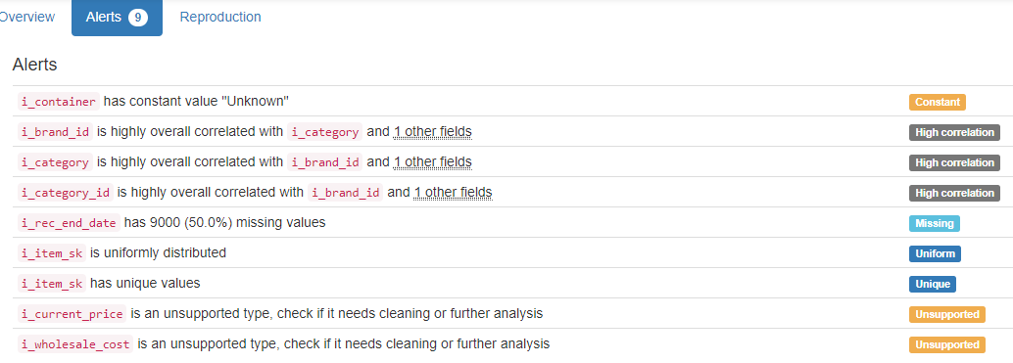

DB.table: tpcds.store_sales – Retail – Type: Synth
Almost 3 million lines are analysed in this database table and 23 columns!
ss_item_sk|ss_ticket_number (Composite Primary Key):
Composite Primary Key format: All 2880404 ID values are unique and valid, and thus suitable for use as a Primary Key.
Alphanumeric range of values: (10000|10035 : 9|99921)

ss_sold_date_sk (id):
Foreign Key format: Error(s) found:
DQI #1 (Missing Data - Completeness):
130093 Blank/Empty/Null/Missing value(s) at index(es): [(11, 'NULL'), (13, 'NULL'), (71, 'NULL'), (92, 'NULL'), (97, 'NULL'), (130, 'NULL'), (134, 'NULL'), (163, 'NULL'), (199, 'NULL'), (206, 'NULL'), ('...', '...'), (2880198, 'NULL'), (2880233, 'NULL'), (2880239, 'NULL'), (2880259, 'NULL'), (2880314, 'NULL'), (2880371, 'NULL'), (2880389, 'NULL'), (2880394, 'NULL'), (2880397, 'NULL'), (2880403, 'NULL')] (displaying only the first and last 10 items)

Note: This is a Foreign Key, so duplicate values are allowed.
Numeric range of values: (2450816.0 : 2452642.0)
References: date_dim.d_date_sk

ss_sold_time_sk (id):
Foreign Key format: Error(s) found:
DQI #1 (Missing Data - Completeness):
129637 Blank/Empty/Null/Missing value(s) at index(es): [(7, 'NULL'), (38, 'NULL'), (64, 'NULL'), (71, 'NULL'), (92, 'NULL'), (130, 'NULL'), (163, 'NULL'), (199, 'NULL'), (208, 'NULL'), (217, 'NULL'), ('...', '...'), (2880239, 'NULL'), (2880259, 'NULL'), (2880278, 'NULL'), (2880295, 'NULL'), (2880307, 'NULL'), (2880357, 'NULL'), (2880378, 'NULL'), (2880389, 'NULL'), (2880394, 'NULL'), (2880403, 'NULL')] (displaying only the first and last 10 items)

Note: This is a Foreign Key, so duplicate values are allowed.
Numeric range of values: (28800.0 : 75599.0)
References: time_dim.t_time_sk

ss_customer_sk (id):
Foreign Key format: Error(s) found:
DQI #1 (Missing Data - Completeness):
129752 Blank/Empty/Null/Missing value(s) at index(es): [(13, 'NULL'), (47, 'NULL'), (64, 'NULL'), (78, 'NULL'), (92, 'NULL'), (97, 'NULL'), (134, 'NULL'), (163, 'NULL'), (188, 'NULL'), (206, 'NULL'), ('...', '...'), (2880244, 'NULL'), (2880257, 'NULL'), (2880259, 'NULL'), (2880307, 'NULL'), (2880314, 'NULL'), (2880347, 'NULL'), (2880357, 'NULL'), (2880371, 'NULL'), (2880394, 'NULL'), (2880403, 'NULL')] (displaying only the first and last 10 items)

Note: This is a Foreign Key, so duplicate values are allowed.
Numeric range of values: (1.0 : 100000.0)
References: customer.c_customer_sk

ss_cdemo_sk (id):
Foreign Key format: Error(s) found:
DQI #1 (Missing Data - Completeness):
129700 Blank/Empty/Null/Missing value(s) at index(es): [(7, 'NULL'), (11, 'NULL'), (13, 'NULL'), (47, 'NULL'), (64, 'NULL'), (78, 'NULL'), (134, 'NULL'), (206, 'NULL'), (217, 'NULL'), (222, 'NULL'), ('...', '...'), (2880180, 'NULL'), (2880198, 'NULL'), (2880233, 'NULL'), (2880239, 'NULL'), (2880257, 'NULL'), (2880347, 'NULL'), (2880371, 'NULL'), (2880389, 'NULL'), (2880394, 'NULL'), (2880403, 'NULL')] (displaying only the first and last 10 items)

Note: This is a Foreign Key, so duplicate values are allowed.
Numeric range of values: (15.0 : 1920797.0)
References: customer_demographics.cd_demo_sk

ss_hdemo_sk (id):
Foreign Key format: Error(s) found:
DQI #1 (Missing Data - Completeness):
129847 Blank/Empty/Null/Missing value(s) at index(es): [(47, 'NULL'), (64, 'NULL'), (130, 'NULL'), (134, 'NULL'), (208, 'NULL'), (232, 'NULL'), (256, 'NULL'), (280, 'NULL'), (381, 'NULL'), (431, 'NULL'), ('...', '...'), (2880244, 'NULL'), (2880295, 'NULL'), (2880314, 'NULL'), (2880339, 'NULL'), (2880347, 'NULL'), (2880371, 'NULL'), (2880389, 'NULL'), (2880390, 'NULL'), (2880394, 'NULL'), (2880403, 'NULL')] (displaying only the first and last 10 items)

Note: This is a Foreign Key, so duplicate values are allowed.
Numeric range of values: (1.0 : 7200.0)
References: household_demographics.hd_demo_sk

ss_addr_sk (id):
Foreign Key format: Error(s) found:
DQI #1 (Missing Data - Completeness):
129975 Blank/Empty/Null/Missing value(s) at index(es): [(7, 'NULL'), (64, 'NULL'), (71, 'NULL'), (92, 'NULL'), (97, 'NULL'), (130, 'NULL'), (134, 'NULL'), (206, 'NULL'), (228, 'NULL'), (256, 'NULL'), ('...', '...'), (2880239, 'NULL'), (2880257, 'NULL'), (2880278, 'NULL'), (2880307, 'NULL'), (2880314, 'NULL'), (2880357, 'NULL'), (2880371, 'NULL'), (2880378, 'NULL'), (2880389, 'NULL'), (2880397, 'NULL')] (displaying only the first and last 10 items)

Note: This is a Foreign Key, so duplicate values are allowed.
Numeric range of values: (1.0 : 50000.0)
References: customer_address.ca_address_sk

ss_store_sk (id):
Foreign Key format: Error(s) found:
DQI #1 (Missing Data - Completeness):
130034 Blank/Empty/Null/Missing value(s) at index(es): [(7, 'NULL'), (13, 'NULL'), (47, 'NULL'), (57, 'NULL'), (64, 'NULL'), (71, 'NULL'), (92, 'NULL'), (97, 'NULL'), (130, 'NULL'), (163, 'NULL'), ('...', '...'), (2880191, 'NULL'), (2880198, 'NULL'), (2880239, 'NULL'), (2880259, 'NULL'), (2880307, 'NULL'), (2880339, 'NULL'), (2880347, 'NULL'), (2880378, 'NULL'), (2880394, 'NULL'), (2880403, 'NULL')] (displaying only the first and last 10 items)

Note: This is a Foreign Key, so duplicate values are allowed.
Numeric range of values: (1.0 : 10.0)
References: store.s_store_sk

ss_promo_sk (id):
Foreign Key format: Error(s) found:
DQI #1 (Missing Data - Completeness):
129484 Blank/Empty/Null/Missing value(s) at index(es): [(7, 'NULL'), (13, 'NULL'), (47, 'NULL'), (64, 'NULL'), (92, 'NULL'), (130, 'NULL'), (163, 'NULL'), (199, 'NULL'), (206, 'NULL'), (208, 'NULL'), ('...', '...'), (2880295, 'NULL'), (2880314, 'NULL'), (2880339, 'NULL'), (2880357, 'NULL'), (2880371, 'NULL'), (2880377, 'NULL'), (2880378, 'NULL'), (2880389, 'NULL'), (2880390, 'NULL'), (2880403, 'NULL')] (displaying only the first and last 10 items)

Note: This is a Foreign Key, so duplicate values are allowed.
Numeric range of values: (1.0 : 300.0)
References: promotion.p_promo_sk

ss_quantity (quantity):
Numerical format: Error(s) found:
DQI #1 (Missing Data - Completeness):
129996 Blank/Empty/Null/Missing value(s) at index(es): [(7, 'NULL'), (11, 'NULL'), (13, 'NULL'), (40, 'NULL'), (71, 'NULL'), (78, 'NULL'), (92, 'NULL'), (97, 'NULL'), (130, 'NULL'), (163, 'NULL'), ('...', '...'), (2880239, 'NULL'), (2880244, 'NULL'), (2880259, 'NULL'), (2880278, 'NULL'), (2880295, 'NULL'), (2880347, 'NULL'), (2880357, 'NULL'), (2880377, 'NULL'), (2880389, 'NULL'), (2880390, 'NULL')] (displaying only the first and last 10 items)

Range of values: (1.0:100.0).

ss_wholesale_cost (cost):
Numerical >=0 format: Error(s) found:
DQI #1 (Missing Data - Completeness):
130023 Blank/Empty/Null/Missing value(s) at index(es): [(38, 'NULL'), (40, 'NULL'), (57, 'NULL'), (71, 'NULL'), (206, 'NULL'), (208, 'NULL'), (217, 'NULL'), (222, 'NULL'), (228, 'NULL'), (256, 'NULL'), ('...', '...'), (2880244, 'NULL'), (2880257, 'NULL'), (2880278, 'NULL'), (2880307, 'NULL'), (2880314, 'NULL'), (2880357, 'NULL'), (2880371, 'NULL'), (2880389, 'NULL'), (2880394, 'NULL'), (2880403, 'NULL')] (displaying only the first and last 10 items)

Range of values: (1.0:100.0).

ss_list_price (price):
Numerical format: Error(s) found:
DQI #1 (Missing Data - Completeness):
130003 Blank/Empty/Null/Missing value(s) at index(es): [(7, 'NULL'), (13, 'NULL'), (38, 'NULL'), (47, 'NULL'), (64, 'NULL'), (71, 'NULL'), (92, 'NULL'), (97, 'NULL'), (130, 'NULL'), (134, 'NULL'), ('...', '...'), (2880244, 'NULL'), (2880259, 'NULL'), (2880278, 'NULL'), (2880314, 'NULL'), (2880339, 'NULL'), (2880347, 'NULL'), (2880357, 'NULL'), (2880390, 'NULL'), (2880397, 'NULL'), (2880403, 'NULL')] (displaying only the first and last 10 items)

Range of values: (1.0:200.0).

ss_sales_price (price):
Numerical format: Error(s) found:
DQI #1 (Missing Data - Completeness):
129666 Blank/Empty/Null/Missing value(s) at index(es): [(7, 'NULL'), (11, 'NULL'), (38, 'NULL'), (64, 'NULL'), (71, 'NULL'), (92, 'NULL'), (97, 'NULL'), (130, 'NULL'), (188, 'NULL'), (199, 'NULL'), ('...', '...'), (2880180, 'NULL'), (2880278, 'NULL'), (2880295, 'NULL'), (2880314, 'NULL'), (2880339, 'NULL'), (2880357, 'NULL'), (2880377, 'NULL'), (2880389, 'NULL'), (2880394, 'NULL'), (2880397, 'NULL')] (displaying only the first and last 10 items)

Range of values: (0.0:199.56).

ss_ext_discount_amt (decimal):
Numerical format: Error(s) found:
DQI #1 (Missing Data - Completeness):
129838 Blank/Empty/Null/Missing value(s) at index(es): [(11, 'NULL'), (13, 'NULL'), (38, 'NULL'), (40, 'NULL'), (47, 'NULL'), (57, 'NULL'), (71, 'NULL'), (130, 'NULL'), (134, 'NULL'), (163, 'NULL'), ('...', '...'), (2880160, 'NULL'), (2880180, 'NULL'), (2880197, 'NULL'), (2880239, 'NULL'), (2880257, 'NULL'), (2880278, 'NULL'), (2880295, 'NULL'), (2880339, 'NULL'), (2880378, 'NULL'), (2880389, 'NULL')] (displaying only the first and last 10 items)

Range of values: (0.0:17588.25).

ss_ext_sales_price (price):
Numerical format: Error(s) found:
DQI #1 (Missing Data - Completeness):
130327 Blank/Empty/Null/Missing value(s) at index(es): [(7, 'NULL'), (38, 'NULL'), (47, 'NULL'), (57, 'NULL'), (64, 'NULL'), (97, 'NULL'), (134, 'NULL'), (163, 'NULL'), (206, 'NULL'), (222, 'NULL'), ('...', '...'), (2880233, 'NULL'), (2880257, 'NULL'), (2880278, 'NULL'), (2880307, 'NULL'), (2880314, 'NULL'), (2880339, 'NULL'), (2880347, 'NULL'), (2880357, 'NULL'), (2880397, 'NULL'), (2880403, 'NULL')] (displaying only the first and last 10 items)

Range of values: (0.0:19562.4).

ss_ext_wholesale_cost (cost):
Numerical >=0 format: Error(s) found:
DQI #1 (Missing Data - Completeness):
130044 Blank/Empty/Null/Missing value(s) at index(es): [(7, 'NULL'), (11, 'NULL'), (13, 'NULL'), (40, 'NULL'), (47, 'NULL'), (57, 'NULL'), (64, 'NULL'), (71, 'NULL'), (78, 'NULL'), (92, 'NULL'), ('...', '...'), (2880191, 'NULL'), (2880194, 'NULL'), (2880239, 'NULL'), (2880244, 'NULL'), (2880257, 'NULL'), (2880347, 'NULL'), (2880371, 'NULL'), (2880378, 'NULL'), (2880390, 'NULL'), (2880403, 'NULL')] (displaying only the first and last 10 items)

Range of values: (1.0:10000.0).

ss_ext_list_price (price):
Numerical format: Error(s) found:
DQI #1 (Missing Data - Completeness):
129933 Blank/Empty/Null/Missing value(s) at index(es): [(13, 'NULL'), (38, 'NULL'), (47, 'NULL'), (57, 'NULL'), (64, 'NULL'), (78, 'NULL'), (92, 'NULL'), (130, 'NULL'), (163, 'NULL'), (188, 'NULL'), ('...', '...'), (2880295, 'NULL'), (2880307, 'NULL'), (2880339, 'NULL'), (2880347, 'NULL'), (2880357, 'NULL'), (2880371, 'NULL'), (2880377, 'NULL'), (2880389, 'NULL'), (2880390, 'NULL'), (2880403, 'NULL')] (displaying only the first and last 10 items)

Range of values: (1.12:19984.0).

ss_ext_tax (tax):
Numerical format: Error(s) found:
DQI #1 (Missing Data - Completeness):
130410 Blank/Empty/Null/Missing value(s) at index(es): [(64, 'NULL'), (71, 'NULL'), (92, 'NULL'), (97, 'NULL'), (134, 'NULL'), (188, 'NULL'), (217, 'NULL'), (222, 'NULL'), (228, 'NULL'), (323, 'NULL'), ('...', '...'), (2880113, 'NULL'), (2880160, 'NULL'), (2880180, 'NULL'), (2880194, 'NULL'), (2880257, 'NULL'), (2880307, 'NULL'), (2880347, 'NULL'), (2880371, 'NULL'), (2880377, 'NULL'), (2880397, 'NULL')] (displaying only the first and last 10 items)

Range of values: (0.0:1749.87).

ss_coupon_amt (decimal):
Numerical format: Error(s) found:
DQI #1 (Missing Data - Completeness):
129838 Blank/Empty/Null/Missing value(s) at index(es): [(11, 'NULL'), (13, 'NULL'), (38, 'NULL'), (40, 'NULL'), (47, 'NULL'), (57, 'NULL'), (71, 'NULL'), (130, 'NULL'), (134, 'NULL'), (163, 'NULL'), ('...', '...'), (2880160, 'NULL'), (2880180, 'NULL'), (2880197, 'NULL'), (2880239, 'NULL'), (2880257, 'NULL'), (2880278, 'NULL'), (2880295, 'NULL'), (2880339, 'NULL'), (2880378, 'NULL'), (2880389, 'NULL')] (displaying only the first and last 10 items)

Range of values: (0.0:17588.25).

ss_net_paid (paid):
Numerical format: Error(s) found:
DQI #1 (Missing Data - Completeness):
129397 Blank/Empty/Null/Missing value(s) at index(es): [(11, 'NULL'), (47, 'NULL'), (57, 'NULL'), (64, 'NULL'), (71, 'NULL'), (78, 'NULL'), (92, 'NULL'), (130, 'NULL'), (188, 'NULL'), (206, 'NULL'), ('...', '...'), (2880314, 'NULL'), (2880339, 'NULL'), (2880357, 'NULL'), (2880371, 'NULL'), (2880377, 'NULL'), (2880378, 'NULL'), (2880389, 'NULL'), (2880394, 'NULL'), (2880397, 'NULL'), (2880403, 'NULL')] (displaying only the first and last 10 items)

Range of values: (0.0:19562.4).

ss_net_paid_inc_tax (paid):
Numerical format: Error(s) found:
DQI #1 (Missing Data - Completeness):
130022 Blank/Empty/Null/Missing value(s) at index(es): [(13, 'NULL'), (47, 'NULL'), (57, 'NULL'), (64, 'NULL'), (71, 'NULL'), (92, 'NULL'), (97, 'NULL'), (130, 'NULL'), (134, 'NULL'), (188, 'NULL'), ('...', '...'), (2880278, 'NULL'), (2880295, 'NULL'), (2880314, 'NULL'), (2880339, 'NULL'), (2880347, 'NULL'), (2880357, 'NULL'), (2880390, 'NULL'), (2880394, 'NULL'), (2880397, 'NULL'), (2880403, 'NULL')] (displaying only the first and last 10 items)

Range of values: (0.0:21192.87).

ss_net_profit (profit):
Numerical format: Error(s) found:
DQI #1 (Missing Data - Completeness):
130267 Blank/Empty/Null/Missing value(s) at index(es): [(7, 'NULL'), (38, 'NULL'), (40, 'NULL'), (71, 'NULL'), (78, 'NULL'), (134, 'NULL'), (199, 'NULL'), (232, 'NULL'), (256, 'NULL'), (258, 'NULL'), ('...', '...'), (2880259, 'NULL'), (2880295, 'NULL'), (2880314, 'NULL'), (2880339, 'NULL'), (2880347, 'NULL'), (2880377, 'NULL'), (2880390, 'NULL'), (2880394, 'NULL'), (2880397, 'NULL'), (2880403, 'NULL')] (displaying only the first and last 10 items)

Range of values: (-9969.53:9731.7).

YDATA Profiling results: It found the same 21 Missing values columns because they contain ALL NULLs. It also found that the Composite PK column 'ss_item_sk|ss_ticket_number' is unique.
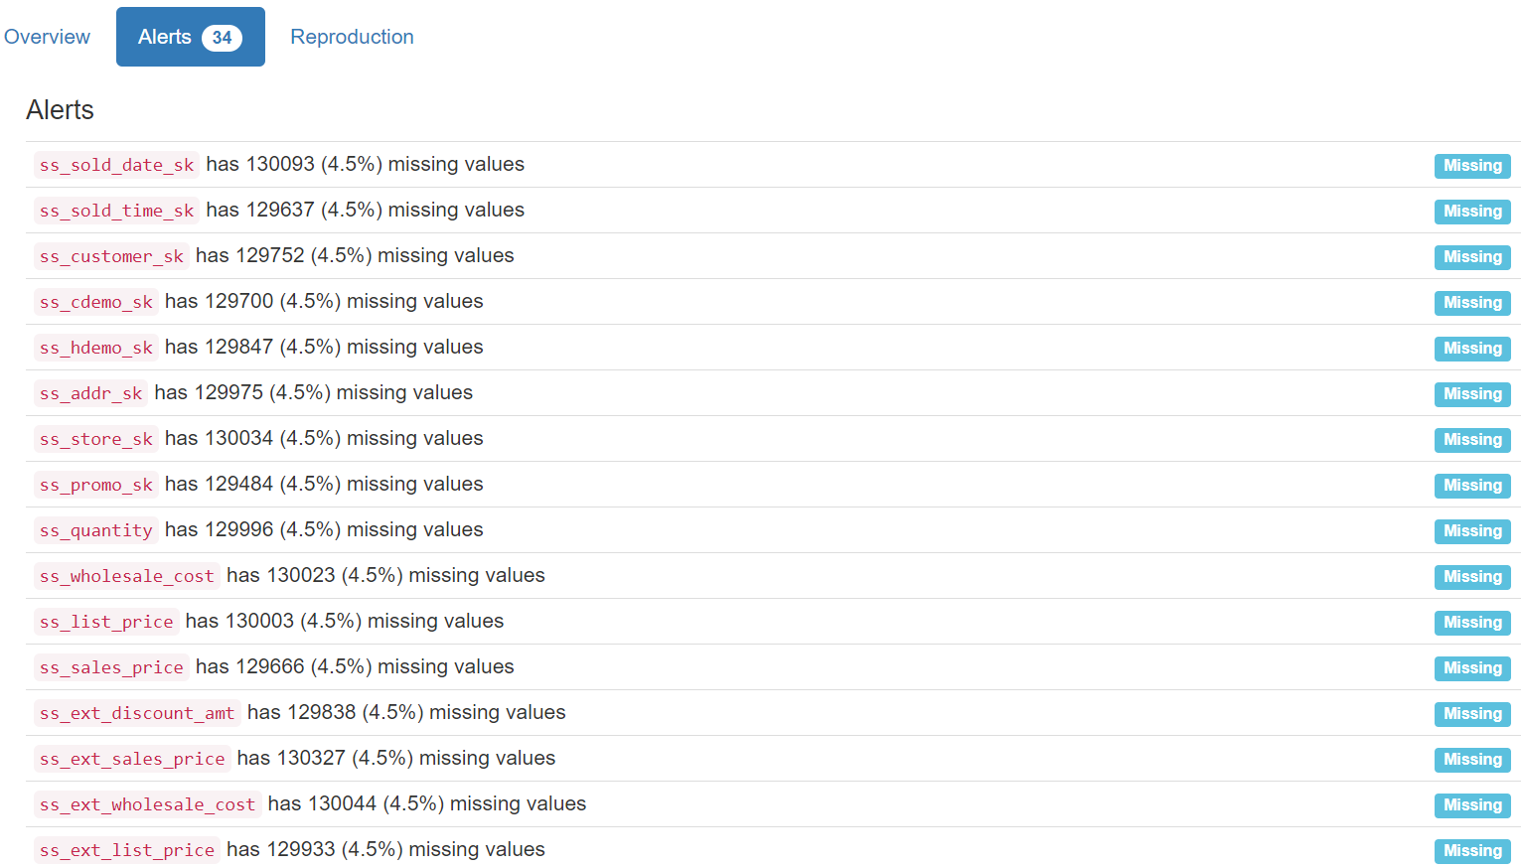
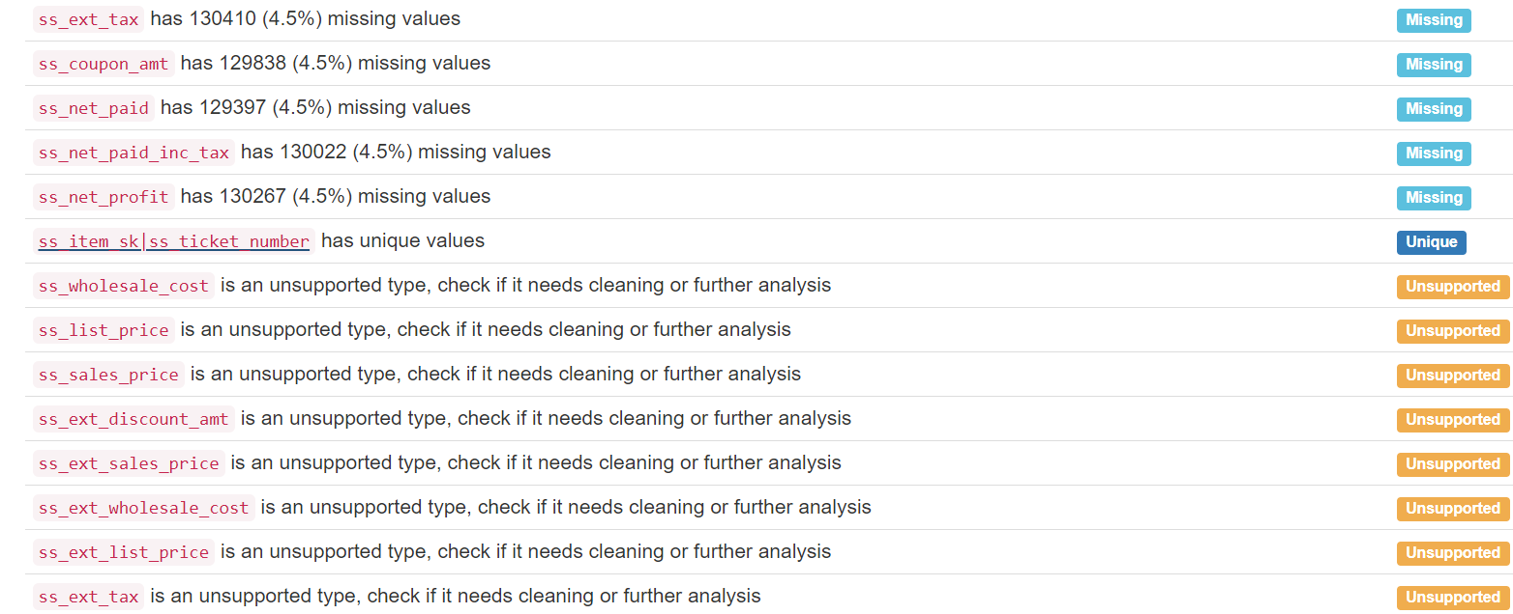
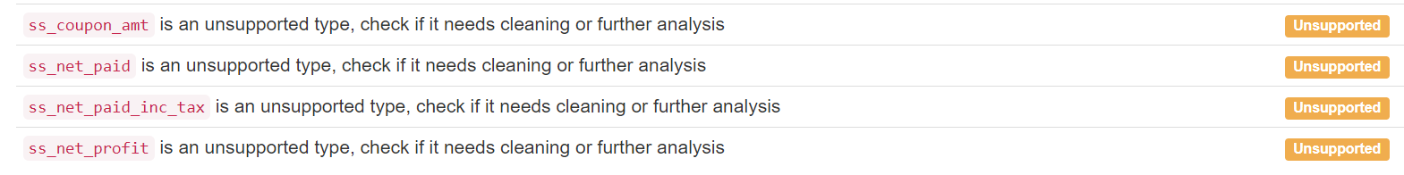

DB.table: trains.cars – Logistic – Type: Synth
id:
Primary Key format: All 63 ID values are unique and valid, and thus suitable for use as a Primary Key.
Numeric range of values: (1 : 63)

train_id (id):
Foreign Key format: All 63 ID values are valid for use as a Foreign Key, and duplicate values are allowed.
Numeric range of values: (1 : 20)
References: trains.id

position:
Categorical format: All 63 values are correctly categorical.

Categorical format with 4 unique value(s):
Category Frequency
1 20
2 20
3 14
4 9

shape:
Categorical format: All 63 values are correctly categorical.

Categorical format with 5 unique value(s):
Category Frequency
rectangle 44
u_shaped 9
bucket 7
hexagon 2
ellipse 1

len (length):
Numerical >=0 format: Error(s) found:
DQI #17 (Wrong Data Type - Consistency):
63 Non-numeric value(s) at index(es): [(0, 'short'), (1, 'long'), (2, 'short'), (3, 'long'), (4, 'short'), (5, 'short'), (6, 'short'), (7, 'long'), (8, 'short'), (9, 'short'), ('...', '...'), (53, 'short'), (54, 'long'), (55, 'short'), (56, 'long'), (57, 'long'), (58, 'long'), (59, 'long'), (60, 'short'), (61, 'long'), (62, 'short')] (displaying only the first and last 10 items)

No valid numerical values found.

sides (side):
String format: All 63 string values are valid.
String range (lexicographical): (double : not_double)

roof:
String format: Error(s) found:
DQI #1 (Missing Data - Completeness):
41 Blank/Empty/Null/Missing value(s) at index(es): [(0, '"none"'), (1, '"none"'), (3, '"none"'), (5, '"none"'), (6, '"none"'), (9, '"none"'), (10, '"none"'), (12, '"none"'), (13, '"none"'), (16, '"none"'), ('...', '...'), (49, '"none"'), (51, '"none"'), (52, '"none"'), (53, '"none"'), (54, '"none"'), (55, '"none"'), (56, '"none"'), (59, '"none"'), (60, '"none"'), (62, '"none"')] (displaying only the first and last 10 items)

String range (lexicographical): (arc : peaked)

wheels (integer):
Numerical format: All 63 values are numerical in the range (2:3).

load_shape (shape):
Categorical format: All 63 values are correctly categorical.

Categorical format with 5 unique value(s):
Category Frequency
rectangle 22
triangle 19
circle 16
hexagon 5
diamond 1

load_num (num):
Numerical format: All 63 values are numerical in the range (0:3).

YDATA Profiling results: It just found out that the PK column 'id' has unique values and is uniformly distributed:
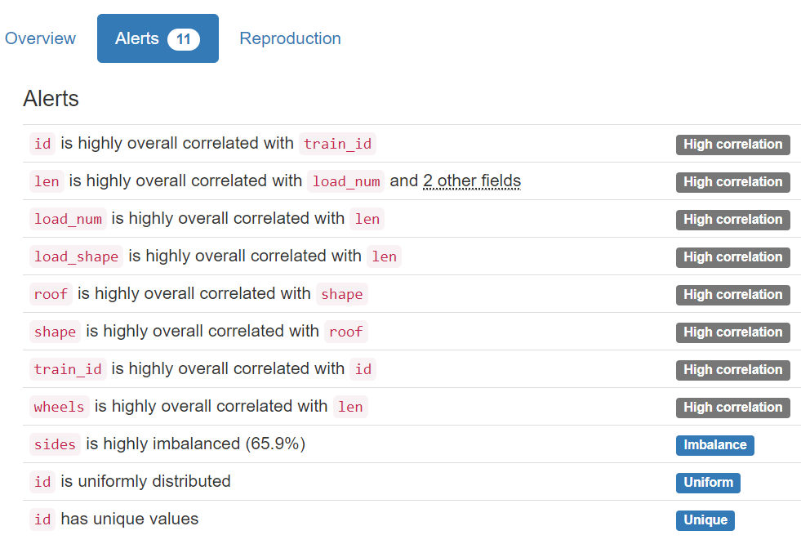

DB.table: UW_std.person – Education – Type: Real
p_id (id):
Primary Key format: All 278 ID values are unique and valid, and thus suitable for use as a Primary Key.
Numeric range of values: (3 : 435)

professor:
Name format: Error(s) found:
DQI #5 (Extraneous Data - Consistency, Uniqueness):
278 Extraneous data value(s) at index(es): [(0, '0'), (1, '0'), (2, '1'), (3, '0'), (4, '1'), (5, '0'), (6, '0'), (7, '0'), (8, '0'), (9, '0'), ('...', '...'), (268, '0'), (269, '0'), (270, '0'), (271, '0'), (272, '0'), (273, '0'), (274, '0'), (275, '0'), (276, '0'), (277, '0')] (displaying only the first and last 10 items)

Frequency Distribution:
professor Frequency
0 216
1 62

Range of Values: (0 to 1)

student:
Name format: Error(s) found:
DQI #5 (Extraneous Data - Consistency, Uniqueness):
278 Extraneous data value(s) at index(es): [(0, '1'), (1, '1'), (2, '0'), (3, '1'), (4, '0'), (5, '1'), (6, '1'), (7, '1'), (8, '1'), (9, '1'), ('...', '...'), (268, '1'), (269, '1'), (270, '1'), (271, '1'), (272, '1'), (273, '1'), (274, '1'), (275, '1'), (276, '1'), (277, '1')] (displaying only the first and last 10 items)

Frequency Distribution:
student Frequency
1 216
0 62

Range of Values: (0 to 1)

hasPosition (position):
Categorical format: All 278 values are correctly categorical.

Categorical format with 5 unique value(s):
Category Frequency
0 226
Faculty 40
Faculty_adj 6
Faculty_aff 3
Faculty_eme 3

inPhase (varchar):
String format: All 278 string values are valid.
String range (lexicographical): (0 : Pre_Quals)

yearsInProgram (years):
Numerical >=0 format: Error(s) found:
DQI #17 (Wrong Data Type - Consistency):
140 Non-numeric value(s) at index(es): [(3, 'Year_2'), (5, 'Year_5'), (6, 'Year_7'), (7, 'Year_10'), (8, 'Year_3'), (9, 'Year_3'), (10, 'Year_1'), (11, 'Year_1'), (12, 'Year_5'), (15, 'Year_1'), ('...', '...'), (265, 'Year_1'), (266, 'Year_3'), (267, 'Year_7'), (269, 'Year_3'), (271, 'Year_5'), (272, 'Year_4'), (274, 'Year_5'), (275, 'Year_2'), (276, 'Year_5'), (277, 'Year_4')] (displaying only the first and last 10 items)

Range of values: (0.0:0.0).

YDATA Profiling results: It just found out that the PK column 'p_id' has unique values:

